 | Root Causes Fishbone Activity

Purpose: This exercise can help a team identify the most significant factors that influence the key themes that emerged from the Learning Walkthrough evidence. By naming these potential root causes, a school or district can be better poised to focus its efforts on the areas that will provide the greatest leverage for change.

Directions: (Using the attached “fishbone” template)

- Write the problem in the box at the “head” of the fish.

- Identify major categories and write them in the boxes. (The diagram has four ribs and boxes, but you may have fewer or more than that. The first time you use this tool, try to use four.)
- Categories may vary depending on the problem. Examples include: students, families, systems and processes, content and curriculum, teachers, school supports, and district supports.

- For each major category, brainstorm possible causes. Write them next to the appropriate “rib” of the fish. Keep in mind key guidelines for brainstorming:
- Let questions flow freely. Generate as many as possible, saying the first thing that comes to your mind. Do not censor your ideas.
- Share brainstormed questions without discussing them. The point of this exercise is to generate questions, not to evaluate or sort them (yet).
- Bolder, unexpected questions are best. Break out of old patterns.
- Even if your idea is similar to something else that has been said, say it anyway. It will keep the creative energies going.
- Do not debate, discuss, sort, or evaluate ideas at this time; do not even say “great idea!”
- Make sure everyone contributes.

Participants may come up with possible causes that do not fit easily into one of the previously identified categories. This can indicate a need to identify a new category or broaden an existing category. Do not discard an idea solely because it does not fit into a previously identified category. The purpose of the major categories is to provide a structure to guide the brainstorming. Categories should be used to inspire, rather than restrict, participants’ thinking.

In the early stages of the process, participants often use this activity as an opportunity to vent frustrations and criticisms. This can be acceptable in the beginning, but be sure to steer them in a more constructive direction as the activity progresses.

- Analyze each possible cause identified to determine whether it is a root cause by asking:
- Would the problem have occurred if the cause had not been present?
- Would the problem reoccur if the cause were corrected?

If the answer to both of these questions is “no,” you have found a likely root cause.

- Circle root causes. Cross off ideas that are not root causes.

- As a group, identify 1–3 root causes that are within the realm of control of the school. These will be the focus of further action planning.
Example of Completed Fishbone Diagram
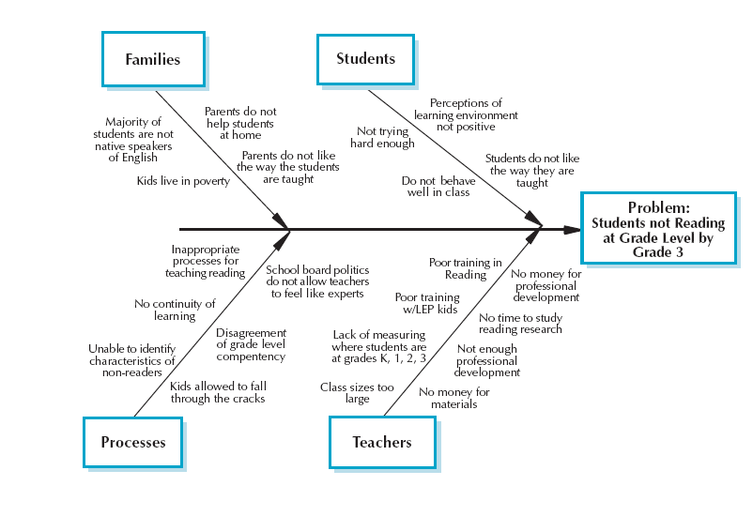
Fishbone Diagram Template
Problem:

These brainstorming guidelines are drawn from two sources: Moving Beyond Icebreakers, by Stanley Pollack and Mary Fusoni (2005, ww.teenempowerment.org), and Facilitation at a Glance, 2nd Edition, by Ingrid Bens (2008, www.participative-dynamics.com).

