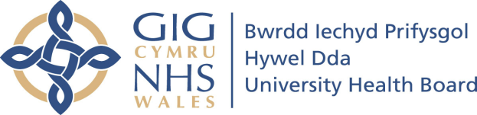
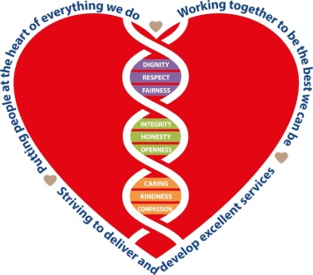

Staff Exit Interview Questionnaire

We are sorry you are leaving the Health Board and wish you well for the future. The Workforce & OD Department is monitoring the reasons why our staff leave their posts in order to identify and address any areas of concern and ways to improve. We would be grateful if you would take the time to complete this form with your Line Manager. If you would prefer to have the interview conducted by a member of Workforce & OD team please contact: Rob Blake, Senior Organisational Development Manager at robert.blake2@wales.nhs.uk

Employee Name (optional) |  | Job Title
ESR Number  (if known) |  | Date of interview
Department |  | Start Date
Fulltime/Part-time/Bank |  | Leaving Date
On which hospital site do you work

Professional Group

Admin & Clerical |  | Estates & Ancillary
Allied Health Professional |  | Healthcare Scientist
Additional Clinical Services |  | Medical & Dental
Add Professional Scientific & Technical |  | Nursing/Midwives

Age Range

Under 24 |  | 45 – 54
25 – 34 |  | 55 – 64
35 – 44 |  | 65 +

What are the reasons for leaving?

Select one or more:

Salary |  | Better benefits
Improved work/life balance |  | Change of career
Family and/or personal |  | Retirement
Conflict with other employees |  | Other
If other please specify

Please rank the following:

 | About HDUHB - Organisation | Strongly  Disagree |  |  | Disagree |  |  | Neutral | Agree |  |  | Strongly Agree
1 | The Health Board valued my work.
2 | It was a good and positive environment to work in.
3 | I was kept up to date with organisational developments via internal communication methods.
What do you think can be improved about the Department or HDUHB?

 | About HDUHB Values | Strongly  Disagree |  |  | Disagree |  |  | Neutral | Agree |  |  | Strongly Agree
4 | I am aware of the NHS Wales Core Principles.
5 | I am aware of HDUHB Organisation Values and Behaviours Framework.
6 | The Values and Behaviours Framework was embedded within my Department.
7 | I did not experience discrimination (eg racial, sexual, and religious) from management.
8 | I did not experience discrimination (eg racial, sexual, and religious) from colleagues.
9 | I did not experience harassment bullying or abuse from management.
10 | I did not experience harassment bullying or abuse from colleagues.
What are your suggestions for improving how the organisation can embed the values into our culture?

 | ▌Senior Management | Strongly  Disagree |  |  | Disagree |  |  | Neutral | Agree |  |  | Strongly Agree
11 | I knew who my senior managers were.
12 | They were role models for the Organisational Values.
13 | They encouraged feedback and suggestions.
14 | They maintained equitable treatment for all employees.
15 | They provided recognition for achievement.
16 | They provided constructive feedback.
What are your suggestions or improvements for management?

 | ▌Supervisor / Line Manager | Strongly  Disagree |  |  | Disagree |  |  | Neutral | Agree |  |  | Strongly Agree
17 | They had sufficient knowledge of the job.
18 | I experienced regular opportunities to meet and discuss performance i.e. supervisions or 121s.
19 | They were open to suggestions.
20 | They recognised and acknowledged my achievements and contributions.
21 | They regularly discussed my objectives and performance via the PADR/appraisal process and I found it purposeful.
22 | They clearly communicated management decisions and how they would affect my work.
23 | They maintained a professional relationship with me.
24 | They behaved to the excellence standard outlined in the Organisation’s Values and Behaviours Framework.
What are your suggestions or improvements to your Supervisor?

 | ▌The Job itself | Strongly  Disagree |  |  | Disagree |  |  | Neutral | Agree |  |  | Strongly Agree
25 | I looked forward to going to work.
26 | There were sufficient opportunities for advancement.
27 | My workload was manageable.
28 | Sufficient resources and staff were available to cover the work.
29 | My colleagues listened and appreciated my contribution.
30 | My skills were effectively used.
31 | I had access to adequate training and development programs.
32 | I encountered no violence or aggression in the course of my work
What do you think can be improved about the job?

 | ▌Remuneration & Benefits | Strongly  Disagree |  |  | Disagree |  |  | Neutral | Agree |  |  | Strongly Agree
33 | My wages were paid correctly and on time.
34 | I am aware of the staff benefits offered.
35 | The staff benefits are good.
36 | Work-life balance was promoted and practiced.
What other benefits could Hywel Dda Health Board offer?

 | ▌ Health & Wellbeing | Strongly  Disagree |  |  | Disagree |  |  | Neutral | Agree |  |  | Strongly Agree
37 | Health & well-being was promoted within my workplace.
38 | I am aware of the HDUHB Staff Psychological Health & Well-being service.
39 | I am aware of their service page & online resources.
40 | I have used the service myself.
41 | I found the service helpful.
42 | My needs as an individual employee were given due consideration.

 | ▌Occupational Health Service |  | Strongly  Disagree |  |  |  |  |  | Disagree |  |  |  |  |  | Neutral |  | Agree |  |  | Strongly Agree
43 | I was encouraged to take part in physical activity.
44 | I am aware of the HDUHB Occupational Health service.
45 | I am aware of their service page & online toolkit.
46 | I have used the service myself.
47 | I found the service helpful.

 | ▌Return to HDUHB | Strongly  Disagree | Disagree | Neutral | Agree | Strongly Agree

48 | I would consider returning to employment with HDUHB.
49 | I would consider returning to HDUHB as a Volunteer.
50 | I would recommend HDUHB as an employer.

Thank you for completing this information. Your responses will be treated in the strictest confidence and will inform a management report with trends/themes identified. In cases of extreme concern/patient safety we will have to disclose information to the relevant parties but individual names will not be disclosed. Please return the completed form to: exitinterview.HR.HDD@wales.nhs.uk or Rob Blake, Senior Organisational Development Manager, Hafan Derwen robert.blake2@wales.nhs.uk

