WANTED!

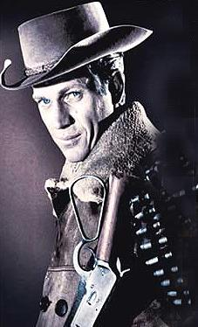

$ 1,000
Dead or Alive!
Call 920-982-9878

