

An 8(a) Janitorial and related building service company

Capability Statement

[**http://www.eagleproclean.com**](http://www.eagleproclean.com/)

Eagle Pro Clean

*I am very pleased to send you the latest copy of The Harkins Header, which features your company inside the front cover as having excelled on one or more of our projects.*

*We are proud of our commitment to quality and excellence, and commend you and your management team for your dedication to those principles.*

*Please pass on our congratulations for a job well done to your project team. All of us at Harkins Builders look forward to many more successful projects with your firm in the future.*

***HARKINS BUILDERS, INC.***

***Richard M. Lombardo President/CEO***

**Socio-Economic Certifications:**

We are Socio -Economic ***8(a) Certified*** as, ***Hispanic American Owned***, ***Minority-Owned business, SWaM***, and ***Small Business***. We are active members of the ***BSCAI (Building Services Contractors Association International) IWCA, (International Window Cleaning Association), CABSC (Capitol Association of Building Service Contractors)*** and following their ethical and safety guideline in our performances.

**Work Area**

DC - DISTRICT OF COLUMBIA MD - MARYLAND VA – VIRGINIA

***FDA***

MD Bldg 61 New Hampshire Ave.

Final Clean 1,100 SqFt Finished Office bldg Int/Ext Wind & Atrium

***QUANTICO BASE***

The Basic School P370 - P-546 - P-555-619- P547-565

OCS Headquarter - Mess Hall P-625

***GSA***

Tenant at Founders Square: Janitorial/Final Cleaning tenant build out Offices- Int Windows

***FDA***

MD Bldg 32

Janitorial/Final Cleaning 1,400 Finished Office bldg Int/Ext Wind & Atrium

***GSA FDA CBER***

Labs at White Oak Janitorial/Final Cleaning Offices + Int/ext Windows 1,100.000 SqFt office Bldng

Commercial

700 sixth street Washington DC- Janitorial/Final Cleaning 12 Floors Core Building- Interior Ext Windows

Mason Inn Hotel Janitorial/Final Cleaning. George Mason Hotel @ Conference center

700 Second Street NE Wah DC Janitorial/Final Clean Station Place Buildings 3 and 2 - SEC

***Eagle Pro Clean*** is an 8(a) certified company and a U.S Green Building Council Member. Established in 2006 by Oleg Otero. Close customer relations and adjusting to customer's

needs has made Eagle Pro Clean a fast growing company. We provide janitorial and related building maintenance services. We are a solution oriented company dedicated to ensuring that our clients receive only the highest degree of service while getting the best value for their money.

Our promise to you is 100% Satisfaction Guarantee. we offer, Commercial, Retail, general building maintenance, Final Construction Cleaning, Facilities management services, Warehousing, Garage and side walk pressure wash, Landscaping and grounds maintenance, Floor maintenance, plus any janitorial and related building maintenance services. Our specialist technicians use the most- advanced equipment and environmental friendly "Green" products.

**PAST GOVERNMENT PERFORMANCE**

**PROFILE AND CORE COMPETENCIES**

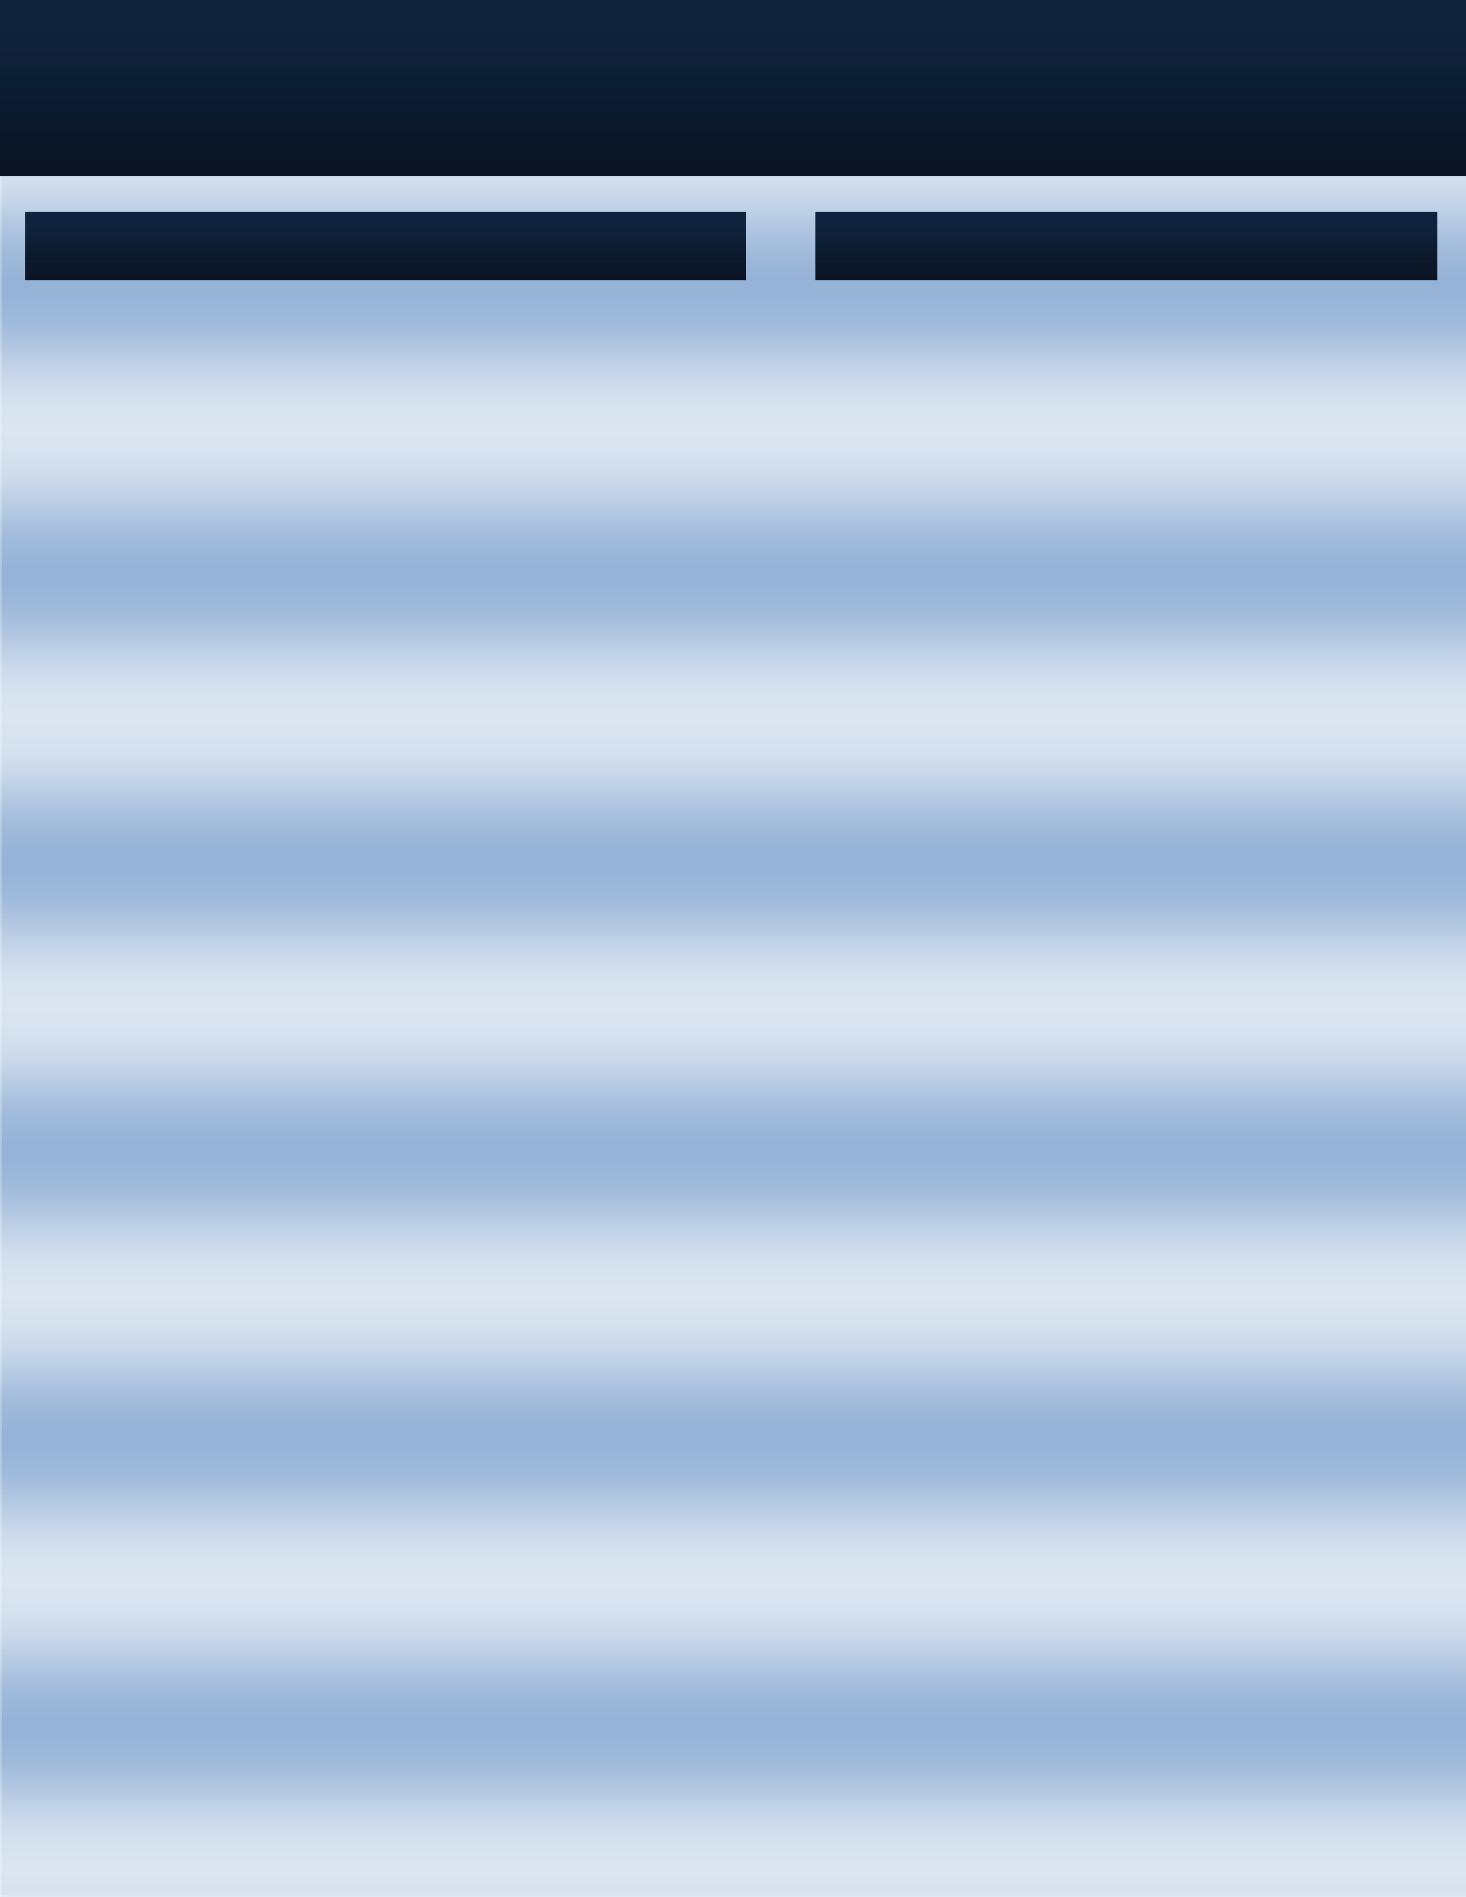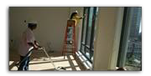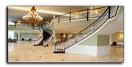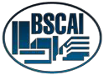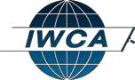

***Eagle Pro Clean*** Is Located in Stafford VA, with Services

in Virginia, Washington DC and Maryland. We are Socio-

The difference comes with our attitude towards the customer and our

standard of performance. Having been in this business for more than 7 years we apply our experience so that the customer feels a lot less hassle. There will always be issues but our Account Managers take immediate control of the situation thus resolving the matter in a professional manner

Economic

Certified

as: Hispanic American Owned,

Minority-Owned business, Small Business

We offer Commercial, Retail, Janitorial services, Final

Construction Cleaning, Garage /side walk pressure wash

cleaning, Carpet and Upholstery Cleaning,

Building services/maintenance

and

Other

***Eagle Pro Clean*** is an Eco Friendly Building service company. We strive

to perform Green Cleaning. (***Cleaning to protect health without harming the environment***). The goal is to reduce pollutants spread throughout your facility and to promote indoor air quality.

***Our Mission***

To be the leading provider of the highest quality Building services solutions by achieving satisfaction delivered through competency and professional integrity.

***Our Vision***

Become the benchmark in the integrated building services service by sample

***CAGE:* 6D2L2**

***DUNS:* 785120622**

***NAICS CODES:***

**Primary NAICS Code**

**561720**

**561730**

**561740**

**238330**

**Work Area**

DC - DISTRICT OF COLUMBIA MD - MARYLAND VA – VIRGINIA

**Secondary NAIC Codes**

**236210**

**238310**

**236220**

**Contacts**

Oleg Otero

**611420**

**491110**

**493110**

Ph:

Fax:

e-mail: Web:

703-499-2064

1-866 225 2443

[**olegotero@eagleproclean.com**](mailto:olegotero@eagleproclean.com)[**www.eagleproclean.com**](http://www.eagleproclean.com/)

**541513**

**238390**

**493190**

**561110**

**493110**

**561990**

**561210**

**561499**

**484220**

**COMPANY DATA**

**DIFFERENTIATOR**