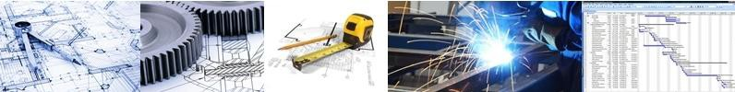

**CAPABILITY STATEMENT**

**Innovative Engineering and Project Management Solutions**

Any industry! No job is too small!

**Downstream Consulting** is a group of multidisciplinary, consulting engineers providing engineering and technical services with a strong focus on safety, sustainability and innovation.

Our Principals and Associates have extensive experience across all engineering disciplines with combined experience of over hundred years.

We bring in combined local and global knowledge for the benefit of Australian industries as per the local conditions and Australian industry regulations. **We put clients first.**

**Services**

We provide engineering consultancy and execute project and engineering management for small to medium projects. Downstream Consulting will build an appropriate engineering capability for your technical requirements.

We provide following services:

**Engineering, Design and Analysis**

Civil and Structural

Design of foundations and buildings (industrial and residential) Earthworks and structural design

Analysis of existing structures 3D model development

Peer review (all disciplines)

Mechanical and Piping

Mechanical, piping and pump calculations Plant design 2D and 3D Analysis Pressure vessels

Materials handling Rotating equipment

Electrical, Instruments and Control

Electrical equipment design and selection Power reticulation and distribution

Substation, switchboards and switch-rooms design

Process and Metallurgical

Process flow sheet development

Metallurgical test work development and supervision

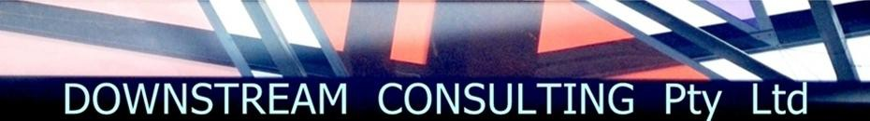

Process design

**Management**

Project Management

Study and Project management

Project cost estimate development and review Project reviews and due diligence

Risk and quality management Contract management

PMC or Owner’s engineering Commissioning management Operational readiness Construction management Project economic evaluation

Project Controls

Cost management Planning and scheduling Change management Project reporting

Quality management and control

Improvement services

Business process improvements

Develop and implement business management processes Database development and management

**Benefits**

•

•

•

Maximise value for your money through efficient engineering and project delivery Quick response time

Optimally engineered and clearly defined options, costing and suggestions making investment decisions on new engineering projects, expansions modifications of existing installations

No surprises – predictable project outcomes

Smooth interface and minimum disruption with your existing operations

for or

•

•

We will hand-pick multi-tasking individuals or develop small engineering and project teams to produce innovative, cost effective solutions for your technical requirements.

Contact us to develop your scope of services and estimate to execute the work at:

John Ganser:

+61 (0) 417 971 681

Email: [contact@downstreamconsulting.com.au](mailto:contact@downstreamconsulting.com.au)

Jigar Sheth:

+61 (0) 403 413 889

Web:

[www.downstreamconsulting.com.au](http://www.downstreamconsulting.com.au/)