Magyar Posta Zrt.

Magyar Posta Zrt.’s

instructions on the correct addressing of letter-mail items

and on preparation for dispatch, and conditions of

suitability for automated processing

Version number: 3.4

Budapest, December 2017

Page: 1 / 34

Magyar Posta Zrt.

Table of Contents

1. Item preparation 3

1.1. Correct packaging 3
1.1.1 Good packaging material 3

1.1.2 The packaging should not be 3
1.1.3 The paper cover should have the following properties: 3
1.2 Addressing 4
1.2.1 Domestic items 4
1.2.2 International letters 8

1.2.3 Front of large items suitable for bulk mailing 9
1.2.4 Front of item complying with invoice image defined in Act CLXXXVIII of 2013 12
2 Defining items suitable for automated processing 13

2.1 Standard formats suitable for automated processing 14
2.2 Non-standard formats suitable for automated processing 14
2.3 Sealing items 14
2.3.1 Correct sealing of items 14
2.3.2 Incorrect sealing of items 15
2.4 Front of domestic items 15

2.4.1 Front of small and medium-sized items 15
2.5 The five main sections of the front of an item 15
2.5.1 Sender (and consolidator) address data 16

2.5.2 Indicia area 17
2.5.3 Area for other, primarily postal, markings 18
2.5.4 Address area 19
2.5.5 Space reserved for bar code in postal processing 20
2.5.6 Specifications for positioning advertisements on the front of an item 20

2.6 Window envelope 21
2.7 Postcards, picture postcards 24
2.7.1 Front of postcards, picture postcards 24
2.8 Addressing techniques 25
2.9 Machine-addressed domestic envelopes 26

2.9.1 Main parameters of address data 26
2.9.2 Layout of front of envelopes suitable for machine addressing 26
2.9.3 Items not suitable for automated processing 28
2.9.4 Specifications for address labels 29
2.10 Specifications for bill payment cheques used as the address text of window

envelopes 29
2.11 Specifications for the completion of advice of delivery forms for official documents,
domestic advice of delivery forms and e-advice of delivery forms 30
2.11.1 Postal checking of advice of delivery forms 33
3 Further information 34

Page: 2 / 34

Magyar Posta Zrt.

- Item preparation

1.1. Correct packaging

The first step when preparing a postal item is the selection of the appropriate packaging material. The primary objective of the packaging is to protect the internal content. Good packaging always adapts to the nature, characteristics, shape and weight of the content, and provides suitable protection for and prevents access to the content without being obviously damaged, thereby ensuring the discretion and confidentiality of business and private correspondence.

1.1.1 Good packaging material

is strong and flexible,

is clean and light in colour,

does not interfere with the legibility of the front of the item or impede postal handling,

is suitable for affixing stamps, various postal markings and labels easily and permanently,

has a homogeneous surface, and

surrounds the item as tightly as possible without bending the content.

1.1.2 The packaging should not be

shiny, fluorescent or translucent, and

the surface should not be printed with shiny ink and should not contain a watermark.

1.1.3 The paper cover should have the following properties:

Envelope or paper cover

 | Paper properties | Unit | Required value
 | Minimum weight per | g/m² | For envelopes min. 80
 | square metre
 | Writability | mm | 0.4 - 1.0
 | Smoothness | (Bekk) sec | 20-60
 | Contamination | pcs/m² | Max. 400 pcs 0.1-0.5 mm² in
 |  |  | size
 | Whiteness (degree) | % | at least 80
 | Opacity | % | at least 85
 | Luminescence | - | None or only traces
 | Surface absorption | g/m² | For envelopes maximum 40
 | (Cobb60)
Figure 1: Paper cover

In addition, the envelope may be made of better quality paper than 80 g/m² (e.g. 100 g/m² offset).

Page: 3 / 34

Magyar Posta Zrt.

1.2 Addressing

1.2.1 Domestic items

When addressing domestic items, the data of the addressee must be given in compliance with the law, the General Terms and Conditions for Postal Services and the Hungarian rules of addressing in the following order:

Name or designation of addressee(s) (in the case of a building society, this may include the address of the property concerned), or on a mail item addressed to a post office box instead of the name or designation of the addressee a password or fancy name may appear based on a written contract with the addressee.

Destination (name of town), and after this the district number of the town may be indicated if applicable.

Precise address [(street name and type (út, utca, krt., tér, etc.) followed by the building number, stairway number, floor number, door number, Land Registry number¹ (hrsz), or in the absence of these, indicating the room.)] For items addressed to post office boxes, the post office box number.

Postcode. The postcode for the administrative address, or for items addressed to a post office box the postcode of the post office operating the post office box or the special postcode.

1.2.1.1 Addressed to a geographical address
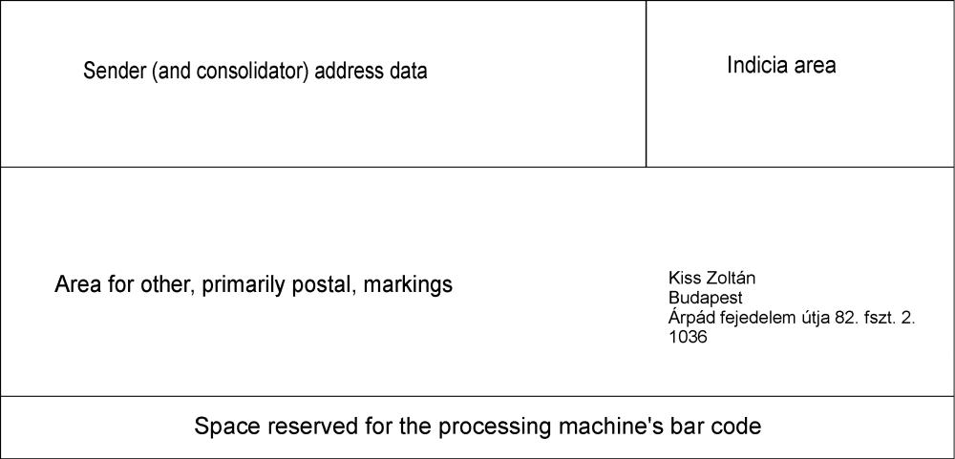

Figure 2: Addressed to a geographical address; the person in this sample is fictitious

- We wish to advise you that if you use our universal service, and you indicate the Land Registry number instead of the precise address data when addressing the letter mail item, we may attempt to deliver the item, but we cannot be held responsible in case of its unsuccessful delivery.

Page: 4 / 34

Magyar Posta Zrt.

1.2.1.2 Addressed to a post office box
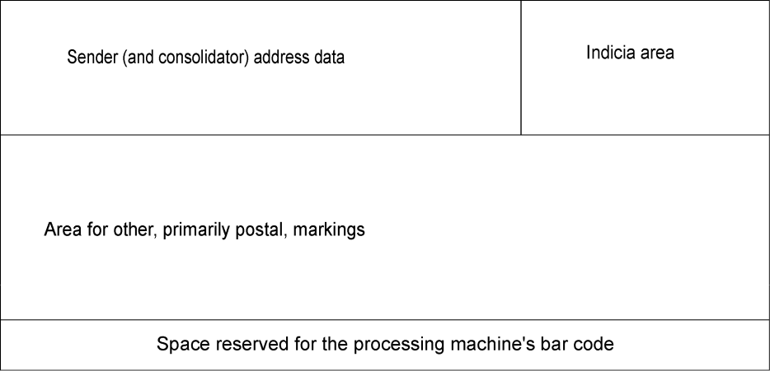

Kovács István
Budapest
Pf. 123.
1376

Figure 3: Addressed to a post office box; the person in this sample is fictitious

1.2.1.3 Addressed to a Land Registry number
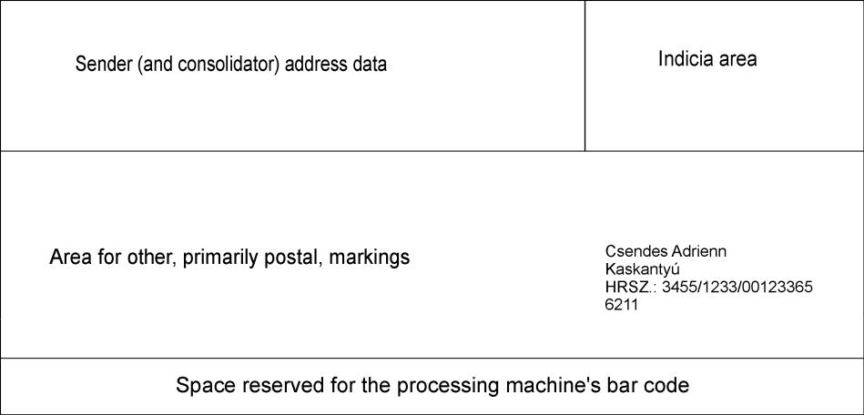

Figure 4: Addressed to a Land Registry number; the person in this sample is fictitious

1.2.1.4 Addressed to a special postcode
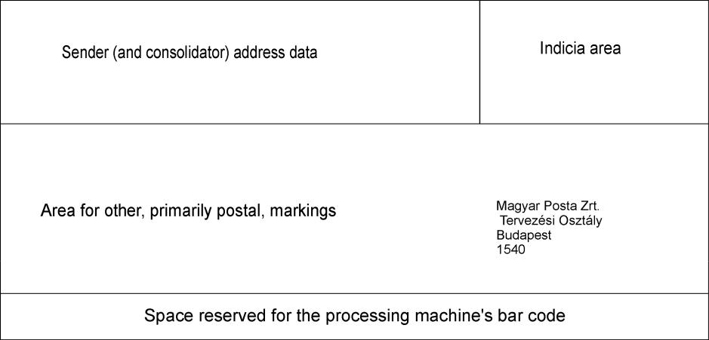

Figure 5: Addressed to a special postcode; the department in this sample is fictitious

Page: 5 / 34

Magyar Posta Zrt.

1.2.1.5 Hand-addressed domestic envelope

The item must be clearly, precisely and legibly addressed using Roman letters and Arabic figures to mark the address data on the item cover.

Please give the sender’s data in the top left corner of the front of the envelope so that the item may be returned if it cannot be delivered.

For handwritten addresses we recommend the use of block capitals of a uniform size ensuring that the characters do not touch each other.

The address data should be written on the front of the envelope in parallel with the length of the envelope leaving a band of at least 15 mm from the bottom empty.

The address data should be given using regular line spacing and without omitting lines.

Guide lines should not be used when writing the address.

1.2.1.6 Addressing by a consolidator

If a postal service contract is made with a postal consolidator, the following must be done:

The consolidator and the person of the client must be both indicated as the sender on the item in all cases.

The address of the consolidator or the client must be marked as the return address on the item in all cases. The client’s address may be marked on the item as the address for return delivery if the written contract between the consolidator and Magyar Posta includes this and on this basis the consolidator authorises the client in writing to receive items.

In order to exactly identify the sender and the client, Magyar Posta expects the item to be marked with the names of the respective parties next to the titles or the clear abbreviation of the titles “Feladó” (Sender) or “Konszolidátor” (Consolidator) and “Megbízó” (Client) (Figure 6).

If the requirements for identifying the person of the sender and the client are not fulfilled by marking these titles, Magyar Posta will regard the person clearly marked in the first place in the area containing the sender’s address details and other notes as the sender (Figure 7).

Title-based sender’s address:

The word “Feladó” or “Fa.” (sender) or “Konszolidátor” or “Konsz.”

(consolidator) should appear before the name of the consolidator company;

The word “Megbízó” or “Megb.” should appear before the name of the client; Return address, which is the address of the consolidator or the client.

Page: 6 / 34

Magyar Posta Zrt.
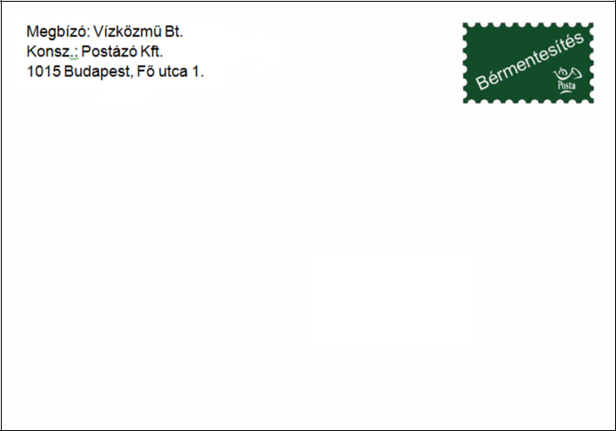

Kovács István
Szolnok

Pf. 28.
5001

Figure 6: Title-based sender’s address; the person and companies in this sample are fictitious

Ranked sender’s address:

In first place the name of the consolidator In second place the name of the client

Return address, which is the address of the consolidator or the client

Kovács István

Szolnok

Pf. 28.

5001

Figure 7: Ranked sender’s address; the person and companies in this sample are fictitious

Page: 7 / 34

Magyar Posta Zrt.

Sender’s address when using a franking machine used by a consolidator

Kovács István
Szolnok
Pf. 28.
5001

Figure 8: Addressing when using a franking machine used by a consolidator; the person and companies in this sample are fictitious

1.2.2 International letters

When addressing items going abroad, the data of the addressee should be given in the following order:

- name of addressee

- precise address (street name, building number and, if applicable, the stairway number, floor and door number)

- the address postcode and the destination town of the item in one line

  - the name of the destination country (this must be indicated in Hungarian but in order to ensure the smooth forwarding of the mail item in international traffic and its successful delivery it is useful to give it in English as well).

Only one postal address for both the sender and the addressee may appear on international items.

The address data must be written without underlining and without leaving empty lines between the town and the other lines of the address.

The address must be written in Roman script and Arabic numerals and, if in the destination country script or numerals other than Roman script and Arabic numerals are used, the address must be written both in the script and numerals used in the country and in Roman script and Arabic numerals. The name of the

Page: 8 / 34

Magyar Posta Zrt.

destination town and the destination country must be written in capital letters together with the correct postcode.

In the address of “Poste restante” items, after the name of the addressee, the post office where the item is to be collected (name, postcode and destination country) should be given as the address. “Poste restante” should be written in bold letters on the front.

If the addressee is a post office box holder, the name of the destination town, the postcode of the postal service point providing the post office box and the number of the post office box must be indicated. On mail items sent to a post office box, instead of the name or designation of the addressee, a password or fancy name may appear based on a written contract with the addressee.

1.2.3 Front of large items suitable for bulk mailing

1.2.3.1 Front of large items (landscape orientation) suitable for bulk mailing
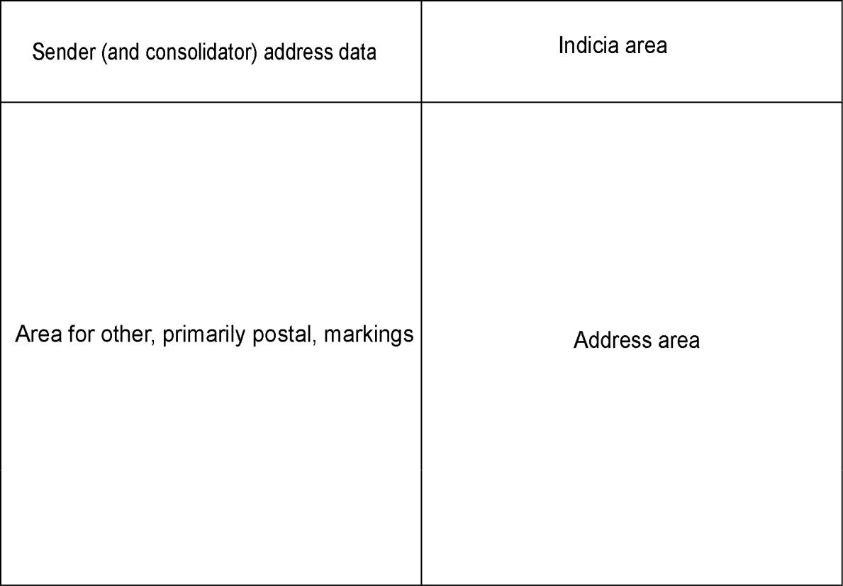

Figure 9: Front of large items (landscape) suitable for bulk mailing

Size limit: (largest size deliverable to a letter box) 324 x 229 x 24 mm Identical address block positioned in the address area if possible
Machine addressing

Left justified address block

Identical at least 10 point font

Uniform normal or 1.5 line spacing

Clear zone of at least 5 mm around the address block

For address labels, positioning with less than 6° skew

Page: 9 / 34

Magyar Posta Zrt.

1.2.3.2 Front of large items (portrait orientation) suitable for bulk mailing

Figure 10: Front of large items (portrait) suitable for bulk mailing

Size limit: (largest size deliverable to a letter box) 324 x 229 x 24 mm Identical address block positioned in the address area if possible
Machine addressing

Left justified address block

Identical at least 10 point font

Uniform normal or 1.5 line spacing

Clear zone of at least 5 mm around the address block

For address labels, positioning with less than 6° skew

Page: 10 / 34

Magyar Posta Zrt.

1.2.3.3 Addressing the front of an item with a plastic film cover

The plastic film cover should have the following properties:

Low and high density polyethylene (LDPE and HDPE)

 | Material properties | Unit |  | Required
 |  |  |  | value
 | Thickness: | µm |  | LDPE min. 30
 |  |  |  | HDPE min. 25
 | Longitudinal stretching strength | N/mm ² |  | LDPE min. 20
 |  |  |  | HDPE min. 40
 | Lateral stretching strength | N/mm ² |  | LDPE min. 15
 |  |  |  | HDPE min. 30
 | Longitudinal stretch |  |  | LDPE 150 %
 |  |  |  | HDPE 200 %
 | Lateral stretch |  |  | LDPE 300 %
 |  |  |  | HDPE 400 %
 | Friction coefficient for a clean |  |  | LDPE ≤ 0,3
 | layer |  |  | HDPE ≤ 0,3
Figure 11: Properties of plastic film suitable for item packaging

Specifications for the plastic film cover of medium-sized and large items:

The cover should be resistant to external physical effects and internal effects exerted by the content (e.g. the contents should not pierce the weld or the covering).

The cover should surround the item as tightly as possible without bending the contents (the cover should not be more than 20 mm larger than the contents of the item).

If the cover contains a protruding part, it is important for the address and the weld of the film not to be on the same side.

The plastic film cover should ensure that the postmarks and postal markings printed directly on the surface are applied without smudging.

The cover should be sealed by welding, and sealing with a stapler or other adhesive material is not appropriate.

Specifications for the layout of the address block:
Identical address block positioned in the address area if possible Machine addressing

Left justified address block

Identical at least 10 point font

Uniform normal or 1.5 line spacing

Clear zone of at least 5 mm around the address block

For address labels, positioning with less than 6° skew

Only the addressee’s data should appear on the label and other information

(sender’s data, franking mark) must be indicated separately.

Page: 11 / 34

Magyar Posta Zrt.

If the addressee’s and sender’s data, and notes for any potential additional and supplementary service(s) are also given on the label, a rectangular label of at least 70 mm x 100 mm is required to ensure that the address of the sender and the address of the addressee are clearly legible and separated.

1.2.4 Front of item complying with invoice image defined in Act CLXXXVIII of
2013

The front of the window envelope of items complying with the invoice image defined in Act CLXXXVIII of 2013 on the standard invoice image of utility providers must be laid out in the manner described in the Act and particular care must be taken during laying out to positioning that ensures that the address data are legible in the window of the envelope. In respect of such items Magyar Posta applies the guidelines given in these Instructions in accordance with the relevant provisions of Act CLXXXVIII of 2013.

Page: 12 / 34

Magyar Posta Zrt.

- Defining items suitable for automated processing

A check of suitability for automated processing may only be requested by the sender of the item, or the sender’s agent or the producer of the item.

Only items that comply with the specifications set out in these Instructions in all respects are suitable for automated processing.

To test non-registered items at least 10 sample pieces with different addresses, fictional if so desired, must be sent to Magyar Posta’s Technology and Control Department at the National Logistics Centre (hereinafter “Test Unit”; postal address: OLK Bevizsgáló Labor, Budaörs 1000). The minimum amount is to be interpreted separately for each weight category for registered and non-registered items.

The items sent for checking must have the same format (weight, sealing, addressing, envelope profile, material, franking mark, etc.) as the items intended for posting.

The Test Unit checks the item samples within 3 working days following the receipt of the order and the samples at the latest.

The sender/producer may initiate checking the samples by completing the form entitled “Order for checking the suitability of bar code postal identifiers and the suitability of mail items for automated processing”. The form is available from the postal contact person or the Test Unit, or may be downloaded from Magyar Posta’s website through the link for “Forms related to letters/Order for testing bar code postal identifiers. For the specific contact details of the Test Unit, see point 3 of this document.

A report will be made of the inspection, which confirms the suitability or advises of the non-compliance of the items for automated processing. The report states the type of item checked (non-registered, registered), its category (standard or other letter), its size and its weight.

If the item checked is not the same as the item to be posted, the discount on suitability for automated processing will not be applicable.

For registered items with advice of delivery both the front of the item and the advice of delivery form must be suitable for automated processing.

Page: 13 / 34

Magyar Posta Zrt.

2.1 Standard formats suitable for automated processing

 |  |  |  |  | Code |  |  |  | Size (mm) |  |  |  | Tolerance (mm)
 |  |  |  |  |  | LC/6 |  |  | 114 x 162 |  |  |  |  | ± 1.5
 |  |  |  |  | LA/4 (DL) |  |  |  | 110 x 220 |  |  |  |  | ± 1.5
 |  |  |  |  | LC/5 and TC/5 |  |  |  | 162 x 229 |  |  |  |  | ± 1.5
 |  |  |  |  | C6/C5 |  |  |  | 114 x 229 |  |  |  |  | ± 1.5
Recommended size of aperture |  |  |  |  |  |  |  |  |  | 45 x 90
 |  |  |  |  |  |  |  |  | (but at least
 |  | for window envelopes
 |  |  |  |  |  |  |  |  |  | 35 x 90)
 | Postcards, picture postcards |  |  |  |  | A/6 |  |  | 105 x 148) |  |  |  |  | ± 1.5
 |  | Figure 12: Standard formats suitable for automated processing
2.2 Non-standard formats suitable for automated processing
 |  |  |  | Length |  |  | Height |  |  | Thickness |  |  |  | Weight
 | Small and medium- |  |  | 125-255 mm |  |  | 85-176 mm |  |  | (up to LC/5 size) |  |  |  | 2-100 g
 |  | sized items |  |  |  |  |  |  |  | 0.15 - 6 mm
Figure 13: Non-standard formats suitable for automated processing

2.3 Sealing items

2.3.1 Correct sealing of items

Letters must be sealed by adhering the full length of the sealing flap of the envelope.

It is essential to ensure that over-wetting or excess adhesive on the sealing flap does not cause envelopes next to each other to stick together.

The edges of the adhesive sealing flap should be covered evenly with adhesive to a width of at least 5 mm along the full length of the flap with the exception of at most the last 10 mm from the fold at each end of the flap.

If adhesive tape is used, it should be positioned along the full length of the flap without coming into contact with the front.

Adhesive spread using hot-melt technology may not be used. This is in order to protect Magyar Posta’s machinery.

Page: 14 / 34

Magyar Posta Zrt.

2.3.2 Incorrect sealing of items

If the item is sealed not with the envelope’s own sealing flap (i.e. using staples, binder clips, paper clips, brass fasteners, etc.).

If the sealing flap is not sealed along its full length using its own adhesive.

If, due to the inappropriate quality of the adhesive material, it is not possible to seal the item along its full length.

2.4 Front of domestic items

2.4.1 Front of small and medium-sized items
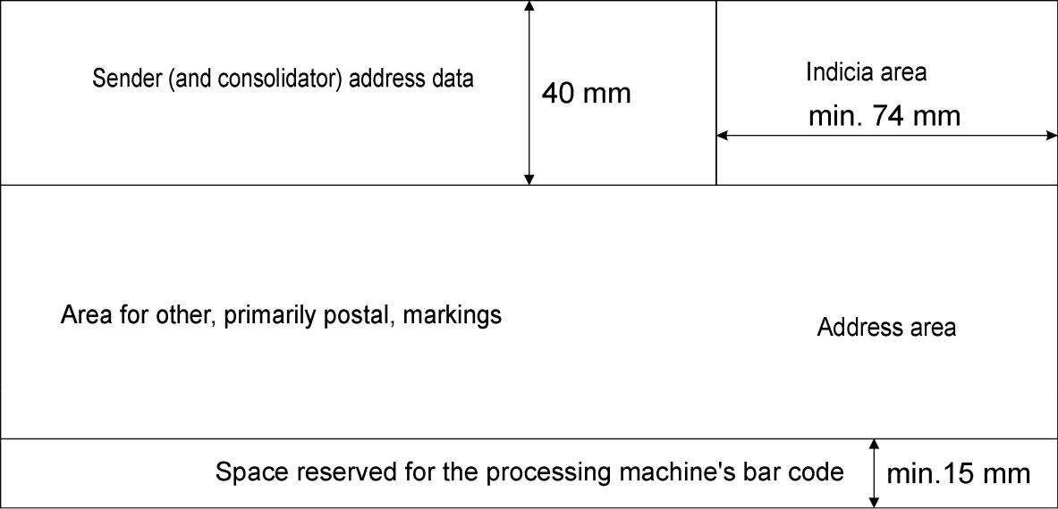

Figure 14: Front of small and medium-sized items

Magyar Posta handles items posted in small and medium-sized envelopes weighing over 100 g whose layout complies with all other conditions for automated processing as items suitable for bulk mailing and the sender thus becomes entitled to the current tariff for automated processing published in the General Terms and Conditions for Postal Services.

2.5 The five main sections of the front of an item

Sender (and consolidator) address data (marked green in Figure 15).

Indicia area for franking marks or affixing postage stamps (marked green in Figure 16).

Area for other, primarily postal, markings (marked green in Figure 17). Area for the addressee’s address data (marked green in Figure 18).

Space reserved for bar code in postal processing (used in the automated processing system) (marked green in Figure 19).

Page: 15 / 34

Magyar Posta Zrt.

2.5.1 Sender (and consolidator) address data
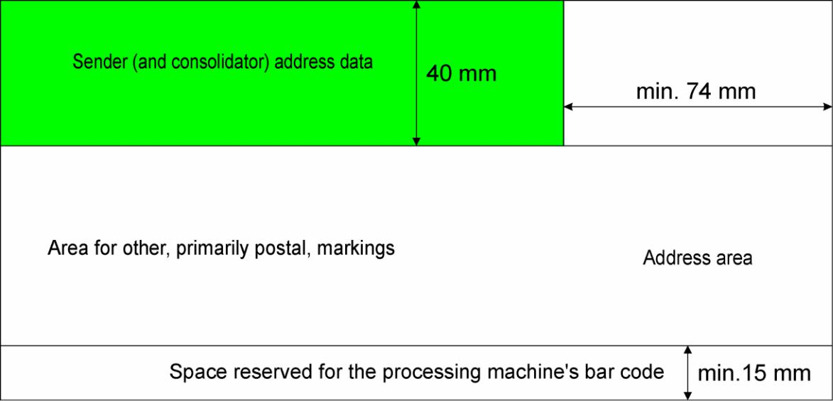

Figure 15: Area for the sender’s address on small and medium-sized items

The sender’s data may only be positioned in a 40 mm wide area from the upper edge of the item in the top left-hand corner of the front of the envelope.

When posting under a postage on credit contract, the name and postal address of the sender must be indicated in every case.

If the size of the front permits, the sender may note here the reference number of the document sent or its internal case number ensuring that this does not interfere with the legibility of the address.

Except for items containing a tender proposal, the sender’s data must include:

- the sender’s name (person’s name or company name),

    - the sender’s postal address, which may be an establishment or a post office box

A logo or company sign may also be placed in the sender’s address data area provided this does not extend into other areas of the front.

It is important that among the sender’s data the correct address for correspondence is given as your partners will use this address when replying.

The sender’s data may also appear in the aperture of a window. In this case the window may only be positioned in the top left corner on the front of the envelope ensuring that there is a clear zone around it (space free of characters, lines and any other printed element).

Page: 16 / 34

Magyar Posta Zrt.

2.5.2 Indicia area
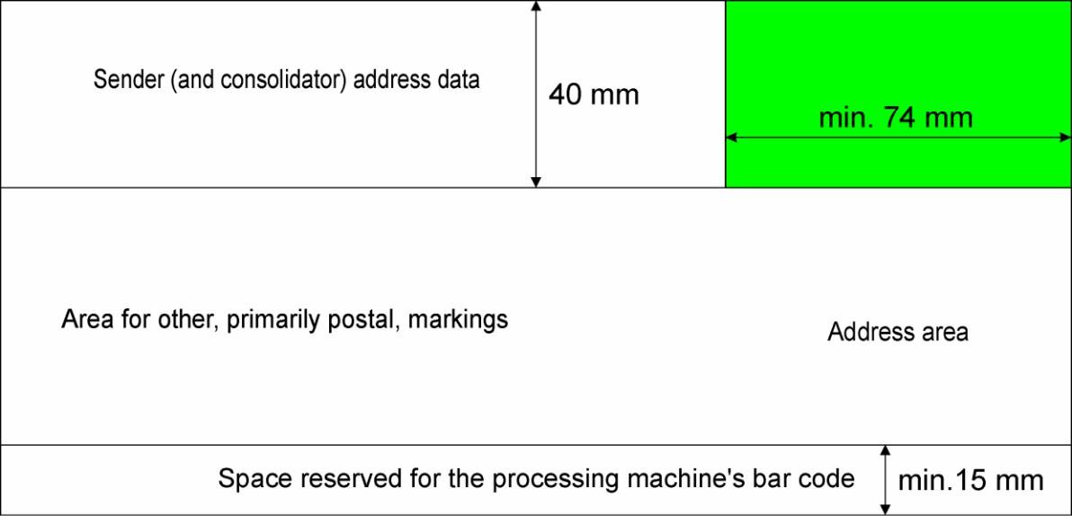

Figure 16: Indicia area of small and medium-sized items

Always position postage stamps and other marks indicating the method of paying postage in the top right corner on the front of the envelope in the manner described in the General Terms and Conditions for Postal Services.

The stamps and franking marks may not overhang the indicated area. An advertising text may not be positioned in the indicia area.

Non-postal stamps, charity or service labels, stamp impressions or drawings which could be mistaken for postage stamps, postal franking indicia or postal markings may not be placed on the front of the envelope but only on the back.

Page: 17 / 34

Magyar Posta Zrt.

2.5.3 Area for other, primarily postal, markings
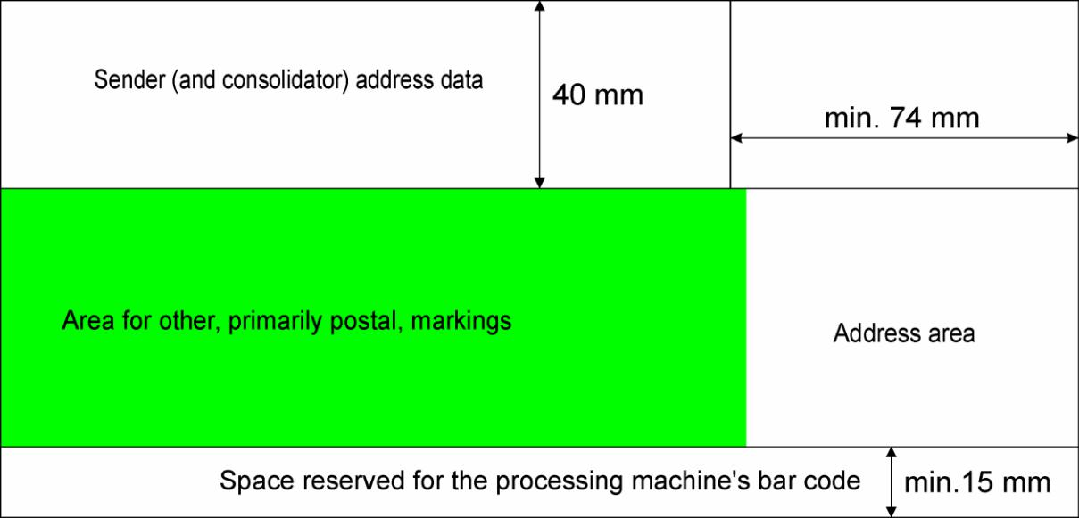

Figure 17: Area for postal markings on small and medium-sized items

The lower left area on the front of items (or the lower right area for envelopes with a window on the left) is for positioning markings of additional and/or supplementary services required for an item as well as postal item identifiers.

Any such markings should be positioned at least 15 mm from the bottom edge of the item and must not hang into the space reserved for the postal processing bar code.

There must be a clear zone at least 5 mm wide between the area for other markings and the address area.

Other marks may not be positioned in the indicia area (except by own franking machine and in the case of an advertising slogan), in the address area, in the space reserved for the bar code and in the space to the right of the address area.

The entire surface of the back of the item may be used for indicating advertising text.

Page: 18 / 34

Magyar Posta Zrt.

2.5.4 Address area
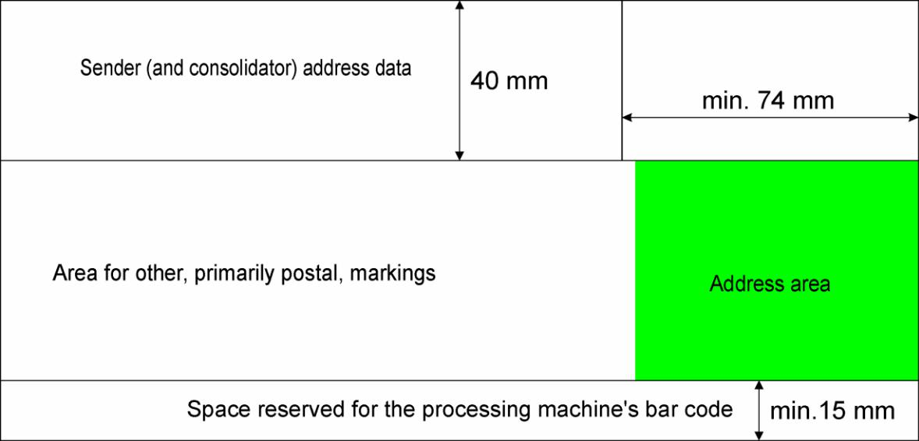

Figure 18: Address area of small and medium-sized items

The addressee’s data are entered in the address area. The address area should be positioned if possible in the lower right on the front of the envelope. The addressee’s address block must be positioned in the lowest address area on the right-hand side of the item. No text or pictures may be positioned below and in the area to the right of the address area.

If the address area is positioned on the left, the area on the right of the envelope will be for other markings. The requirement for left-hand side positioning is the same as that for the right, only the other way round.

The elements of the address data must be positioned beneath one another. Only the addressee’s name may, if need be, appear in more than one line.

The skew of the address or the label bearing the address data may not exceed

6°.

The address may appear directly on the envelope, on a label adhered to the envelope by its full surface or, in the case of a window envelope, on the contents of the item through the aperture in a legible manner.

The address area may not contain an advertisement, stamp impression or postage stamp.

The front of the envelopes should not contain guide lines printed to aid marking the address or blank boxes for marking the postcode.

Page: 19 / 34

Magyar Posta Zrt.

2.5.5 Space reserved for bar code in postal processing
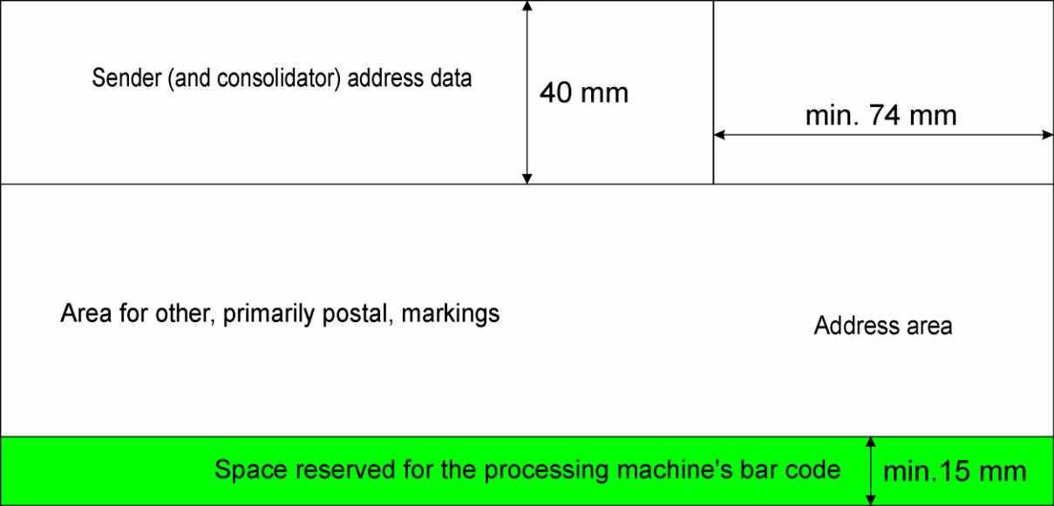

Figure 19: Space for processing bar code on small and medium-sized items

In every case a 15 mm high zone must be left clear for marking the bar code. The automated processing system prints the code required to direct the item in this space. The space reserved for the processing machine’s bar code must be white or a homogeneous light colour across the entire length of the item.

2.5.6 Specifications for positioning advertisements on the front of an item

The entire surface of the back of letter-mail items may be used for advertising text and graphics whose contents comply with the provisions of Act XLVIII of 2008 on the basic requirements of and certain restrictions on commercial advertising activity (the Advertising Act).

The specifications of positioning advertisements on the front of a letter-mail item are as follows:

Advertising text and graphics may be positioned in the sender (and consolidator) address data area provided there is sufficient free space for them next to the sender’s data.

Advertising text may not be positioned in the indicia area.

Advertising text and graphics may only be positioned in the area for other, primarily postal, markings if they do not interfere with the postal markings and item identifiers and leave sufficient free space for such markings and identifiers to be positioned.

Advertisements may not be positioned in the address area.

The space reserved for the processing machine’s bar code must be left free in all cases.

Page: 20 / 34

Magyar Posta Zrt.

An advertisement placed on the front of an item preferably should not contain address data.

If it is absolutely essential that the advertisement contain address data, please write the address data in 8 point font and position them in a way that they are not in line with the addressee’s address data.

Do not use advertising text and graphics whose content are of a political, provocative or obscene nature, or that are outside accepted social norms or harm Magyar Posta’s business interests, or which may be confused with postage stamps, postal franking indicia, other postal markings and/or postal item identifiers, or do not comply with the provisions of Act XLVIII of 2008 on the basic requirements of and certain restrictions on commercial advertising activity (the Advertising Act).

2.6 Window envelope
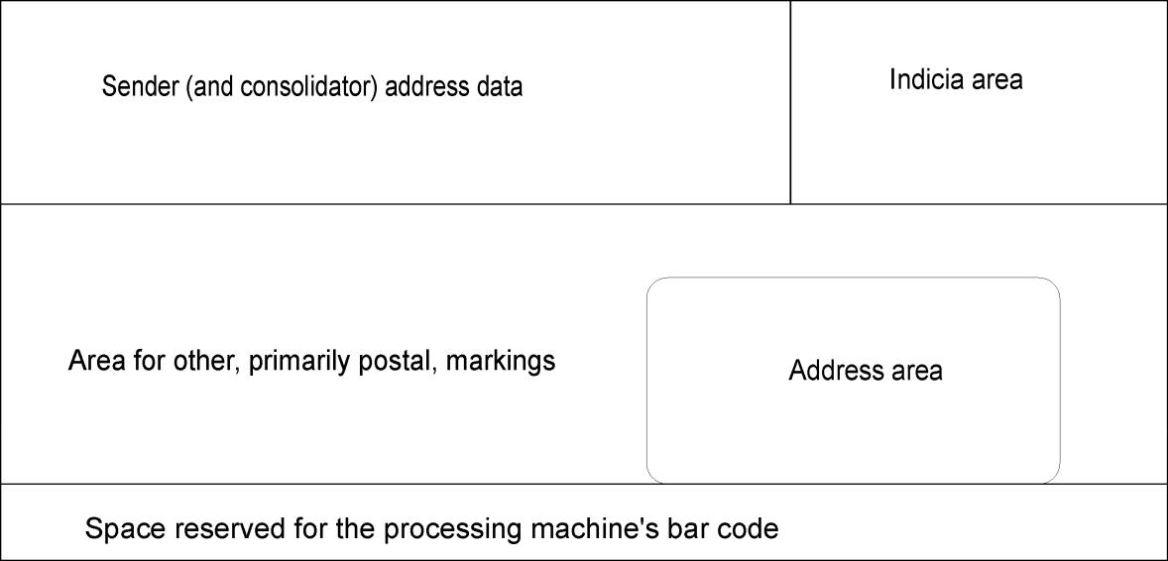

Figure 20: Front of a window envelope

The aperture must be positioned over the address area. The window must be positioned on the side of the envelope with an unbroken surface, i.e. which has no sealing flap.

The aperture may not be surrounded by a coloured border or frame. If the envelope is coloured, a white border at least 5 mm wide must completely surround the aperture. (Figure 21)

There must be a clear zone at least 5 mm wide between the aperture and the graphics on all sides of the window.

The window should form a closed surface with the envelope, and the transparent material should be affixed to the base paper of the envelope so that there is no gap at the edge of the window.

The material of the window should be at least 80% transparent to ensure that the address data beneath it is legible.

Page: 21 / 34

Magyar Posta Zrt.

The corners of the aperture must be right angles. For landscape orientation the longest side of the window must be parallel with the length of the envelope. For large items with portrait orientation, the window may also be positioned crosswise so that the longest side of the window is parallel with the width of the envelope.

The size of the window should be large enough to ensure that the address data remain fully legible even in the event of the movement of the content.

As an address block with a coloured background may impair the legibility of the address data, the area of the insert bearing the address data should be white.

For non-registered letter-mail items the bar code customer identifier used by the sender should be positioned 5 mm from the address block.

For registered items a bar code customer identifier may only appear in the aperture of the window alongside the postal bar code item identifier if there is a 5 mm distance between the two.

For registered items there must be a 5 mm wide clear zone between the bar code item identifier and the address block. (Figure 22)

For registered items a window size should be chosen which is large enough to ensure that the address data and the bar code item identifier appearing in the aperture remain fully legible even in the event of the movement of the content. (The use of a 45x90 mm window is recommended.)
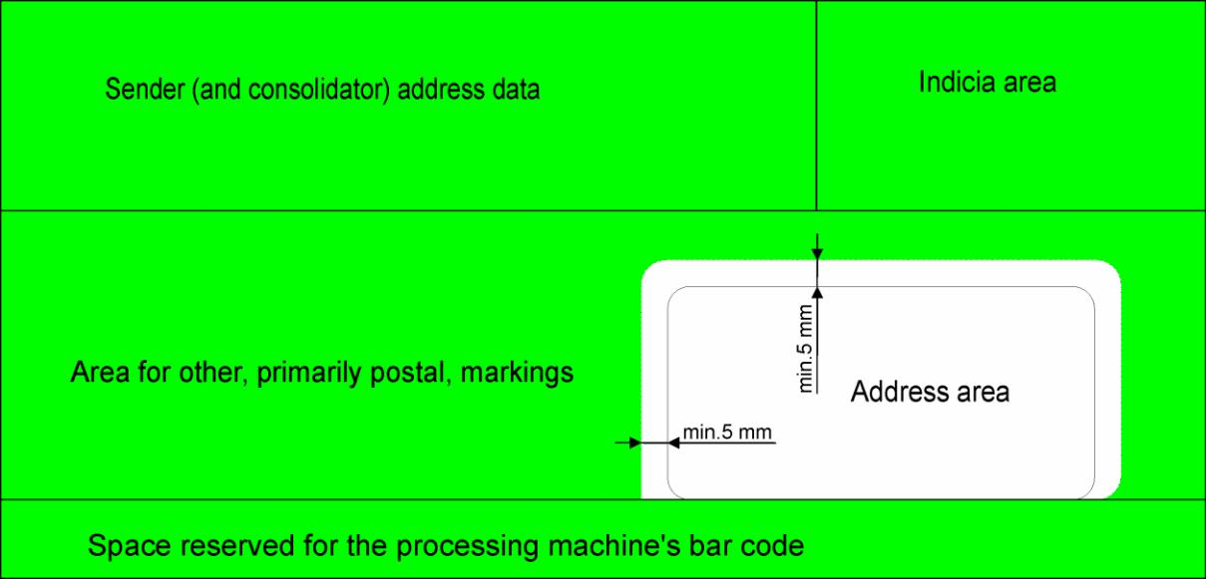

Figure 21: Front of a coloured window envelope

Page: 22 / 34

Magyar Posta Zrt.
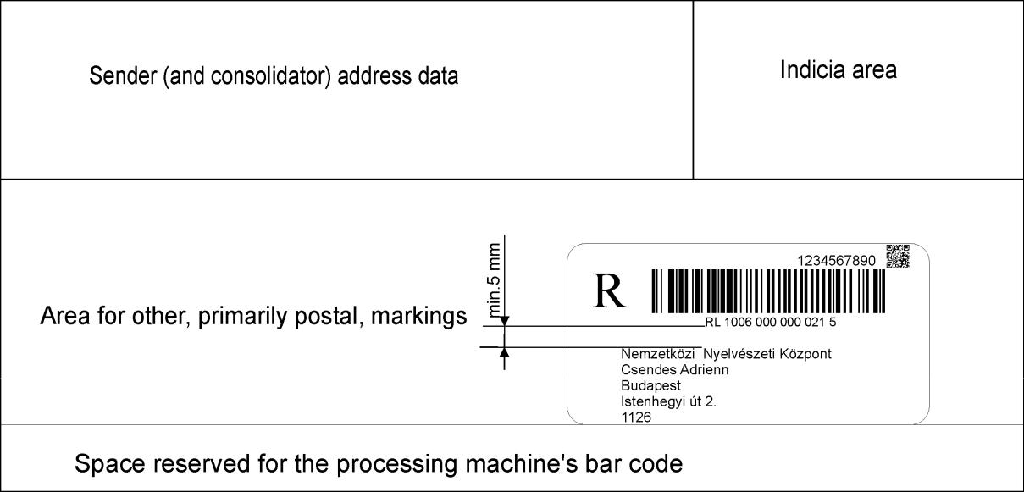

Figure 22: Front of a registered window envelope; the person in this sample is fictitious

Page: 23 / 34

Magyar Posta Zrt.

2.7 Postcards, picture postcards

Postcards, picture postcards

 | Paper | Unit | Required value
 | minimum weight | g/m² | for postcards min. 160
 | per square metre
 | surface absorption | g/m² | maximum 30
 | (Cobb60)
Figure 23: Technical specifications for the material of postcards

The technical properties for the writability, smoothness, contamination, whiteness, opacity and luminescence of postcards are the same as the data indicated for paper covers.

The material of postcards should be so-called postcard card and picture postcards should not be made of photographic paper.

2.7.1 Front of postcards, picture postcards
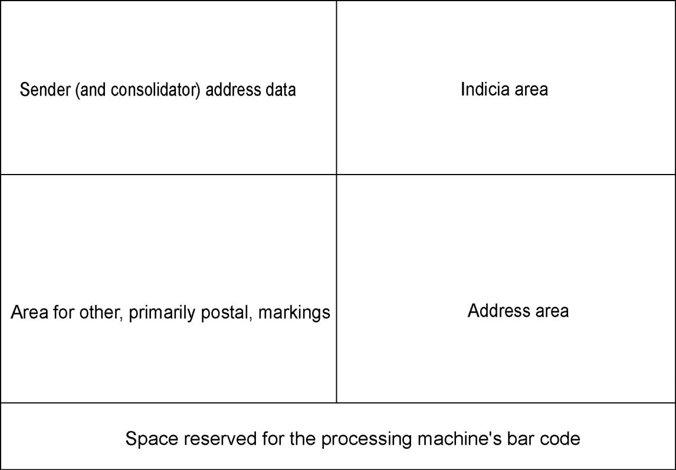

Figure 24: Layout of the front of a postcard

Page: 24 / 34

Magyar Posta Zrt.

To the right of the vertical dividing line on the front of the postcard are the areas reserved for the address data and for indicia (franking marks, stamps).

A white space 15 mm high from the bottom edge of the postcard must be left blank along the full length of the front of the postcard for the postal processing bar code.

The address data should be marked or adhered on a label in the space above the area reserved for the postal processing bar code. The label may not hang into the area reserved for the postal processing bar code.

A 5 mm wide clear zone must be left between the address and the other markings (graphics) indicated on the postcard.

A 5 mm free band must be left around all sides of the address area.

The sender’s data may be positioned in a 40 mm high area measured from the top edge of the postcard.

Postcards and picture postcards of other shapes (such as circular or triangular) or made of a different material may only be posted in an envelope.

2.8 Addressing techniques

The name of the town should be marked in its official form according to the

Hungarian place name gazetteer (Helységnévtár) without any suffixes.

The name or serial number of an area of a town (e.g. “tanya” or “puszta”) or a district may be shown after the name of the town using Roman or Arabic numerals.

At least one space must divide individual elements of an address, that is the street name, house number and other details such as floor, and in the case of post office box addresses a space must be used between the name and the post office box number, in other words clear breaks must be left. Exceptions to this are between the house number and other details such as floor number when a full point “.” may also be used as a divider.

Abbreviations: the word “utca” may be abbreviated as “u.” and “körút” as “krt.” The words “útja”, “sétány”, “tér”, “tere” may not be abbreviated.

For items addressed to a post office box, the post office box number and the postcode of the postal service outlet providing the post office box should be given as the address in this order. In this case please do not give the address of the establishment. On items addressed to a post office box instead of the name of the addressee – according to a written agreement between the sender and Magyar Posta – an alias or fancy name may also be used. If the addressee has a special postcode, besides the name of the addressee and the town, only the special postcode needs to be marked.

Apart from the addressee’s name, the address data of items addressed to a postal service outlet to be delivered there (“Poste restante”) should contain the name and postcode of the postal service outlet where the item is to be delivered. A list of postal service units designated for the delivery of poste restante items is published in Magyar Posta’s General Terms and Conditions for Postal Services, and assistance may be obtained from our customer service and on our website (www.posta.hu).

Page: 25 / 34

Magyar Posta Zrt.

In the address of mail items addressed to places in an inhabited area outside urban areas and items to be delivered through a rural drop point, in addition to the name of the addressee, the town, the postcode, the number of the rural drop point and, if known by the sender, the number of the letter box must be given.

For registered items and items posted free of charge, except if they contain a tender proposal, the sender’s data as the return address must appear in the top left corner of the front of the item in all cases. When marking the sender’s address data, the delivery address must be indicated as the postal address, which may be an own post office box address or the postal address of an establishment. As far as possible, please use a post office box address if you are a post office box holder.

2.9 Machine-addressed domestic envelopes

2.9.1 Main parameters of address data

Parameter |  |  |  |  | Value, property
 |  |  | Lines |  | continuous
 |  |  | Line thickness |  | normal
 |  |  | Character
 |  |  | density |  | normal or 10% expanded
 |  |  | Line spacing |  | single or 1.5 line spacing
 |  |  | Skew |  | maximum 6°
 |  |  | Types |  | Arial, Univers

Minimum 10 point font
_{Size} but using a 12 point font is

recommended (without bold,
strike through or italics)

Figure 25: Main parameters of address data

2.9.2 Layout of front of envelopes suitable for machine addressing

The address data should be given using at least 10 point letters, with normal or expanded letter spacing, in black (recommended font: Arial, Univers). Unless the law provides otherwise, font types with serifs or touching characters (e.g. Times New Roman) should not be used for addresses. Only use one font at a time.

If the characters touch each other (e.g. krt, ft, KA), we recommend that the character spacing be expanded.

Guide lines, underlining, highlighting, bold or italic fonts, graphic fonts or pseudo-writing or handwriting imitation fonts may not be used for addressing.

Wide, condensed, over-elaborate and inverted font types may not be used for addressing.

The entire address should be printed using single or at most 1.5 line spacing.

The address data should be given using regular line spacing and without omitting lines.

Page: 26 / 34

Magyar Posta Zrt.

Guide lines should not be used when writing the address.

On the front of the item the “internal identifier” (customer identifier, date of sending, bar code customer identifier) must be positioned at least 5 mm from the address block of the item (Figure 26).

Each element of the address (addressee’s name, town, street name together with building number, postcode) must appear in a separate line below one another. Only the addressee’s name may, if need be, appear in more than one line.

The printed address should be good quality and clearly legible to the naked eye. The printing of the characters must be full, sharp and even. The printed characters may not be smudged, incomplete (lacking ink) or blurred.

Black printing ink must be used for the address data.

The address may not be corrected, struck through or overwritten. The address block of the item must be left justified.

The letter characters must form continuous lines. (With matrix printers the characters are formed of dots which do not touch each other.)

The background of the address may not be gloss.

A company logo may not be used instead of the name of a company.

It is practical to choose an envelope that the contents fit as snugly as possible.

Except for window envelopes, an item whose cover (envelope or plastic film) is at most 20 mm longer or wider than its content is suitable for automated processing. The contents of window envelopes should be of sufficient size to ensure that the whole of the address block remains legible in the aperture even in the event of the maximum movement of the contents.

Only envelopes and postcards with four right angles and flat surfaces are suitable for automated processing.

Page: 27 / 34

Magyar Posta Zrt.
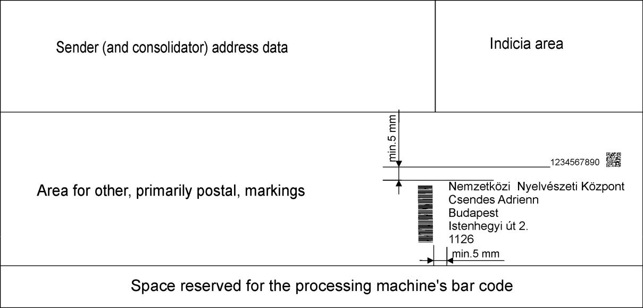

Figure 26: Positioning of other customer identifiers around the address block; the person in this sample is fictitious

2.9.3 Items not suitable for automated processing

Address data marked with bold, serif, underlined or italic letters, or varying line spacing.

Touching characters in the address block (e.g. krt, ft, KA). The address data of a window envelope is covered.

The address data is written without accents.

A “0” appears in front of a building number in the address block (e.g. Kossuth u. 07).

The address data are not given in accordance with the Hungarian place name gazetteer “Magyarország Helységnévtára” published by the Central Statistical Office.

The type of street (út, utca, tér, etc.) is omitted from the precise address. The space required for the processing machine’s bar code is not provided.

A clear zone of at least 5 mm above and to the left of the address block is not provided. A graphic design, marking or identifier appears below or to the right of the address block.

Folded items posted without an envelope or not sealed on all sides. Items tied with string.

Damaged, creased or stuck together items. First day or special cancellation items.
Previously processed items.

Items containing stiff objects (e.g. samples).

Page: 28 / 34

Magyar Posta Zrt.

Items that are not rectangular.

Items containing a protuberant article that do not have a flat surface. International letter-mail items.

Letter-mail items addressed by hand because the identical features of the characters and thus the identical layout of the address cannot be guaranteed for all items.

The material the cover is made of is not sufficiently strong or is badly sealed. The cover is more than 20 mm larger than the contents.

Plastic film cover or shiny, non-absorbent covering material.

2.9.4 Specifications for address labels

Only the addressee’s data should appear on the label and other information (sender’s data, franking mark) must be indicated separately. If this is not possible:

The sender’s data should be shown in 8 or 9 point letters.

All other data on the label must be positioned at least 5 mm from the address data.

Please mark the internal identifier (date of posting, bar code customer identifier, customer identifier code) above the address data or next to the address data on the left or right leaving a space of at least 5 mm from the address.

The skew of the label must not exceed 6°.

The specifications of the layout of the address are the same as those for machine-addressed domestic envelopes.

The whole of the label should be firmly affixed to the surface and it should not interfere with other postal information.

The whole of the label bearing the address data must be affixed to the front of the item.

The label may not overhang the area reserved for the processing machine’s bar code.

2.10 Specifications for bill payment cheques used as the address text of window envelopes

For items that contain a bill payment cheque, the use of the text on the cheque as the address for a window envelope is to be avoided if there are red guide lines and lines used to separate the digits of the postcode.

If the text on the cheque is to be used as the address for a window envelope of an item intended for automated processing by machine, the address area of the cheque may not contain guide lines or red squares for stating the postcode. The box “Befizető neve, címe” (Payer’s name, address) on the cheque provides the actual address of the item. The specifications for completing this are as follows:

The specifications for the layout of the address are the same as those for machine-addressed envelopes.

Page: 29 / 34

Magyar Posta Zrt.

The address block must be positioned at least 5 mm from the left edge of the red frame of the box “Befizető neve, címe” (Payer’s name, address) and there must be at least 1/6” (~4 mm) between the postcode and the bottom of the frame.

Please mark the internal identifier (date of posting, bar code customer identifier, customer identifier code) above the address data next to the text “Befizető neve, címe” 4 mm from the address block.

2.11 Specifications for the completion of advice of delivery forms for official documents, domestic advice of delivery forms and advice of delivery forms for using the e-advice of delivery service

The specifications for the layout and positioning of the address of advice of delivery forms for official documents, domestic advice of delivery forms and advice of delivery forms for using the e-advice of delivery service are as follows:

When completing the “A tértivevény visszaküldési címe” (Return address for advice of delivery) box on domestic advice of delivery forms and advice of delivery forms for official documents, the address data must be written leaving spaces of 5 mm from the left of the frame of the box, from the text at the top of the frame “A tértivevény visszaküldési címe” and from the bottom of the frame.

On domestic advice of delivery forms and advice of delivery forms for official documents, the address data in the box “Küldemény címzettjének, neve, címe:”

(Name and address of the addressee of the mail item) must be written in 8 to 10 point font.

Please mark the address data in the “Return address for advice of delivery” box on domestic advice of delivery forms and advice of delivery forms for official documents paying attention to the following:

  - the font should be at least 10 points and at most 12 points,

  - Arial (not serif) should be used,

  - the address block should be left justified,

  - do not use guide lines,

  - do not leave blank lines between the address elements,

  - the line spacing for the address data should be single or at most 1.5,

  - there should be a clear zone of at least 5 mm around the address block (as shown in Figures 27, 28 and 29),

  - the letter characters must be continuous lines and no break due to lack of ink is permitted. The address block should be free of ink or other contamination that may impede character recognition,

  - the address of an establishment or post office box should be given as the return address,

  - extraneous data not pertaining to the address (e.g. telephone number, fax number, VAT number, etc.) should not be marked in the address,
  - the address data should appear in the following order:

- name of the addressee to return the advice of delivery form to
- town

- precise address or, if addressed to a post office box, the number of the post office box

Page: 30 / 34

Magyar Posta Zrt.

o postcode or, if addressed to a post office box, the postcode of the post office operating the post office box or special postcode
  - only the addressee’s name may appear in more than one line.

When completing this section, do not go beyond the area within the box.

Advice on completing the “Küldeményazonosító” (item identifier) box is given in the publication “Technical guide for the production by the sender of unique bar code identifiers for registered letter-mail items”.

On the domestic advice of delivery form please mark any internal identifier (date of posting, bar code customer identifier, customer identifier code) in the “Ügyfél saját jelzése” (Customer’s own mark) box, or in the space above the return address data leaving a space of 5 mm from the address data. On the official document advice of delivery form please mark the internal identifier above the return address data leaving a space of 5 mm from the address data. The following samples (Figures 27, 28 and 29) show examples of cases where the customer’s own marks do not fit in the space intended for this purpose.

The space reserved for code marks at the bottom of both the domestic advice of delivery form and the official document advice of delivery form must be white and left blank.
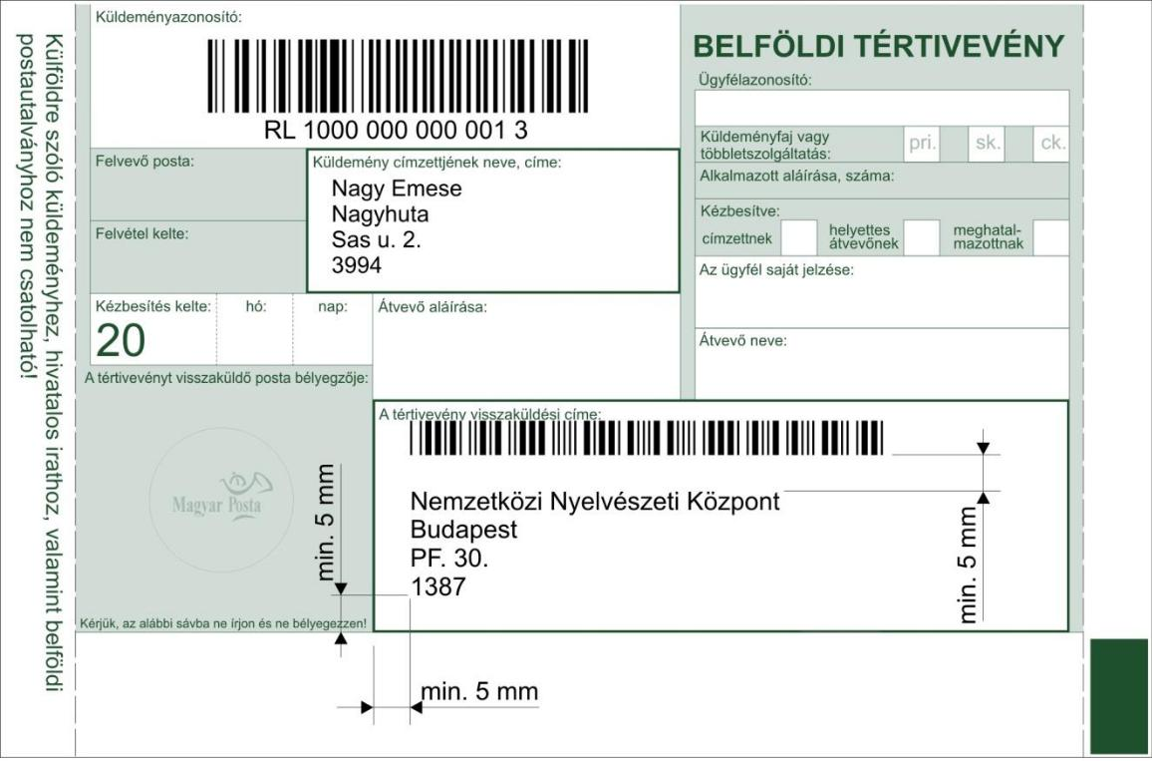

Figure 27: Sample address for a domestic advice of delivery form; the person in this sample is fictitious

Page: 31 / 34

Magyar Posta Zrt.
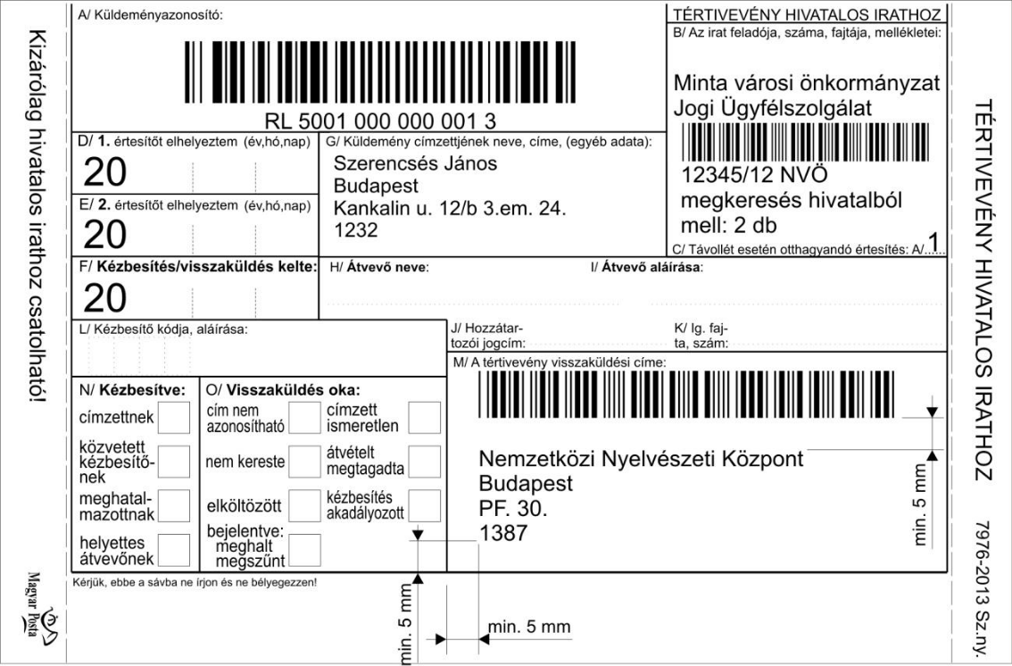

Figure 28: Sample address for an official document advice of delivery form; the person in this sample is fictitious
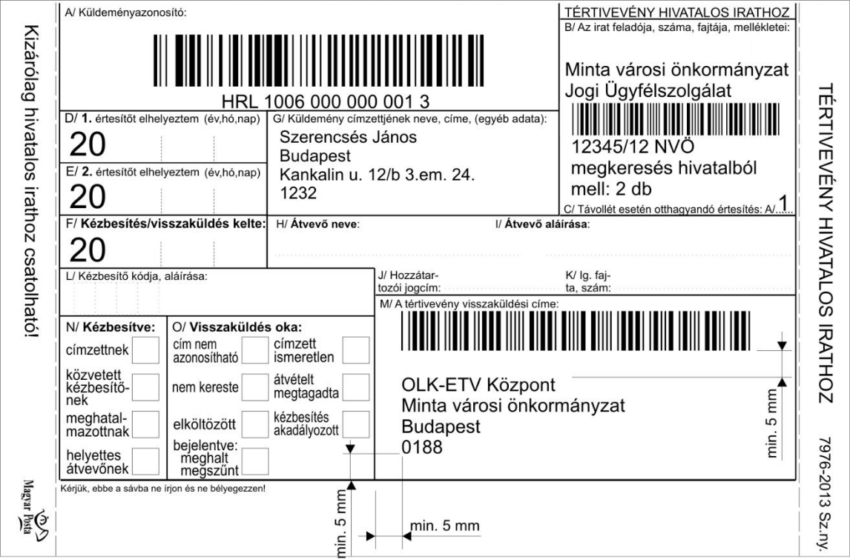

Figure 29: Sample address for an advice of delivery form for an official document for the e-advice of delivery service; the person in this sample is fictitious

Page: 32 / 34

Magyar Posta Zrt.

2.11.1 Postal checking of advice of delivery forms

Checking the advice of delivery form is in the joint interest of the producer, the user of the service and Magyar Posta. Mass production and issuing the forms may only commence with the approval of Magyar Posta and after notification of approval has been received.

If the test is required by the customer using the domestic advice of delivery service:

50 completed samples (with the boxes of the forms completed) must be submitted to Magyar Posta Zrt.’s Technology and Control Department at the National Logistics Centre (Test Unit - Budaörs 1000). The Test Unit checks whether or not the samples are suitable for automated processing. Both the advice of delivery forms and the individual boxes should comply with the relevant requirements of completion.

If the test is required by the producer producing the domestic advice of delivery forms:

In this case, after the above testing of the 50 completed sample forms, a test run on the printers’ machinery is also necessary, for which the producer must present the printer’s proof of the advice of delivery form and 1,500 finished samples to EPDB Nyomtatási Központ Zrt. (1117 Budapest, Budafoki út 107-109), for approval prior to mass production and issuing the forms.

Page: 33 / 34

Magyar Posta Zrt.

- Further information

If you require more information, please visit our website (http://www.posta.hu), or contact our customer service by phone on +36-1-767-8282 or by e-mail at ugyfelszolgalat@posta.hu.

You may contact the Testing Laboratory at

Magyar Posta Zrt. National Logistics Centre
Technology and Control Department Address: Budaörs, Gervay Mihály u. 9-11
Postal address: OLK Bevizsgáló Labor, Budaörs 1000

Tel.: 36-1/421-7272, 36-1/767-7537
Fax: (36-23) 445-938
Mobile phone: (36-30) 770-7272
E-mail: bevizsgalo@posta.hu

Page: 34 / 34

