Machineable Mail Advisor: Short and Long (S/L) Envelopes

Thank you for using the Machineable Mail Advisor. We hope you enjoy the convenience and creative flexibility that it brings to the machineable mail design process.

In this package, you’ll find

- Instructions on how to use these templates

- A “Do-it-Yourself Checklist” that outlines the key requirements for Machineable Mail

- Design templates for the items you’ve selected
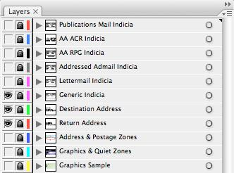

Using these templates in Adobe Illustrator™ (AI)

Please check the website periodically to make sure you have the latest version of this template.

The Adobe Illustrator template is driven by layers. In AI, go to Window-Layers if the layers palette is not already displayed.

Simply click on the eye icon of a layer to show or hide the layer.

Template features

Indicia layers
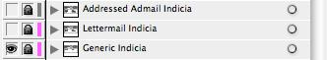

A variety of postal indicia are included on separate layers. Select the appropriate layer/indicia required for your mailing.

Destination Address layer & Return Address layer
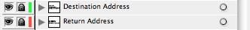

You can edit the addresses on these layers as required.

Address and Postage Zones layer

This layer outlines the areas set out for the placement of addresses and postage.

The addresses must appear within the areas outlined.

Graphics and Quiet Zones layer

This layer outlines the areas set out for the placement of text or image/graphics and Quiet Zones which must be kept free of graphics and text (other than address information).

Graphics Sample layer

This layer contains an example of graphics/text and colours applied to the mail item.

After making edits or layer changes, simply save the file or export it to any preferred file type. Your artwork is ready for your next mailing campaign!

More templates can be downloaded at www.canadapost.ca/mmadvisor

Disclaimer

The Machineable Mail Advisor was developed to help Customers design envelopes, self-mailers and cards that meet Canada Post’s machineable specifications.

By delineating the areas that are reserved for addressing and bar-coding, the tool is also meant to highlight and provide Customers with the opportunity to leverage the areas available for customization. The Advisor is based on Canada Post’s Machineable Postal Standards and outlines the basic design requirements for machineable items. For complete requirements, Customers must consult the Machineable Postal Standards guide.

This tool allows users to download a mail template and then modify certain elements using the design software of their choice. However, if Customers alter the size or layout of a template, it may render the item out of specification, potentially disqualifying it from the expected services and/or applicable rates. Such modifications may also impact envelope/card manufacturing or postage costs. It is the Customer’s responsibility to ensure that final printed envelopes, self-mailers, and/or cards meet all requirements.

Canada Post has made reasonable efforts to ensure that the Machineable Mail Advisor is accurate at the time of release; however, the Corporation accepts no liability for any potential inaccuracies or omissions.

™ Trademark of Adobe Systems Inc.
Machineable Mail Advisor: Short and Long (S/L) Envelopes

Do-it-Yourself Checklist For Creating Machineable Standard / Short and Long (S/L) Envelopes and Self-mailers – Addressed Admail™, Publications Mail™ and Incentive Lettermail™

WHEN CREATING YOUR STANDARD / SHORT AND LONG (S/L) ENVELOPES AND | REFERENCE
SELF-MAILERS, FOLLOW THESE STEPS… | REFERENCE
Step 1: Ensure Your Mail Items are Machineable

 | The size and weight meet the following requirements: |  |  |  |  |  |  |  |  | section 1
 | DIMENSIONS |  | LENGTH |  | WIDTH |  | THICKNESS |  | WEIGHT
 | Min. |  | 140 mm |  | 90 mm |  | 0.18 mm |  | 3 g
 | Min. |  | (5.6 in) |  | (3.6 in) |  | (0.007 in) |  | (0.11 oz)
 | Max. |  | 245 mm |  | 156 mm |  | 5 mm |  | 50 g
 | Max. |  | (9.6 in) |  | (6.1 in) |  | (0.2 in) |  | (1.75 oz)
 | The aspect (length to width) ratio meets the following requirements: |  |  |  |  |  |  |  |  | section 1
 | • a minimum of 1.3
 | • a maximum of 2.6.
 | Items have sufficient strength: |  |  |  |  |  |  |  |  | section 2.1
 | • envelopes: paper weight is a minimum of 75 gm²
 | • self-mailers: paper weight is a minimum of 90 gm².
 | Items have sufficient flexibility and firmness: |  |  |  |  |  |  |  |  | section 2.2
 | • flexibility: items can easily bend around a circular surface with a radius of 140 mm
 | • firmness: items do not sag more than 22 mm in the middle when supported at each end.
 | NOTE: For enclosures requirements, please refer to section 2.2.1.1.
 | Items are properly sealed: |  |  |  |  |  |  |  |  | section 2.3.1
 | • items are closed and sealed with adhesive (no staples, clasps, buttons, string or other similar devices are |  |  |  |  |  |  |  |  | section 2.4.4
 | used). |  |  |  |  |  |  |  |  | section 2.4.5
 | Step 2: Ensure Your Mail Items are Readable
 | The destination address is parallel to the longest edge (horizontal address orientation) and |  |  |  |  |  |  |  |  | section 7.1.1
 | within the Address Zone located:
 | • 40 mm from the top
 | • 19 mm from the bottom
 | • 15 mm from the left and right edges.
 | The proof of payment is located on the same side as the destination address in the upper right |  |  |  |  |  |  |  |  | section 7.2
 | corner, within the Postage Zone:
 | • if paid by indicia: 40 mm high by 74 mm long
 | • if paid by meter impression: 40 mm high by 100 mm long.
 | NOTE: Exceptions apply to Publications Mail items.
 | The return address is parallel to the longest edge (horizontal address orientation) and within |  |  |  |  |  |  |  |  | section 7.3
 | the Return Address Zone:

- If located on the front: in the upper left corner, within 40 mm from the top edge and at least 100 mm from the right edge

- If located on the back: near the top edge, centered between the left and right edges.

The Quiet Zones within and around the address block are left clear of printing, images and dark | section 8.1.1
colours: | section 8.1.2
- 13 mm on the left side of the address block

- 6 mm above the top line of the address block

- the entire area to the right of the address block

- the entire area below the address block

- if a window envelope is used, the complete address is visible and the Quiet Zones are respected.

Machineable Mail Advisor: Short and Long (S/L) Envelopes

Do-it-Yourself Checklist For Creating Machineable Standard / Short and Long (S/L) Envelopes and Self-mailers – Addressed Admail™, Publications Mail™ and Incentive Lettermail™ continued

 |  |  | WHEN CREATING YOUR STANDARD / SHORT AND LONG (S/L) ENVELOPES AND |  | REFERENCE
 |  |  |  | SELF-MAILERS, FOLLOW THESE STEPS… | REFERENCE
 | The Quiet Zones for barcoding are left clear of printing, images and dark colours: |  |  |  | section 8.2
 | • on the front side of the item: the area 19 mm high by 150 mm long measured from the bottom
 |  | right edge
 | • on the back side of the item: the area 15 mm high by 140 mm long measured from the bottom left
 |  | edge.
 | For items paid by meter impression, the Quiet Zone within the Postage Zone is left clear of |  |  |  | section 8.3
 | printing, images and dark colours:
 | • the area 40 mm high by 100 mm long in the upper right corner.
 | The address printing meets the following requirements: |  |  |  | section 9.1
 | • fonts are black or another dark colour on a white or light colour background |  |  |  | section 9.1.1
 | • upper case characters are used (recommended, but not mandatory)
 | • all the characters in the address block are printed in the same font at the same height
 | • laser or inkjet print is used and all characters are clear and well defined
 | • no punctuation is used
 | • no bold, underlined, italic, or other decorative/script fonts are used
 | • the entire address is left justified
 | • address format meets the standards outlined in the Addressing Guidelines section of the Canada Postal
 |  | Guide.
 | NOTE: Please refer to section 9.1.1 for recommended and acceptable fonts.
 | The paper used for the outer covering is: |  |  |  | section 10.1
 | • non-glossy, or has a very light matte coating
 | • | not overly bright
 | • opaque enough to prevent any printing or graphics from showing through the envelope
 | • smooth, without any raised areas
 | • | non-reflective
 | • clear of dark fibres, background patterns, textures or watermarks
 | • clear of fluorescent ink.
 | NOTE: Please refer to section 10.1 for physical requirements of paper. If using window envelopes, all windows |  |  |  | section 10.2
 |  | are covered with transparent materials that meet the requirements outlined in section 10.2.
 | The placement of graphics: |  |  |  | section 11.1.1
 | • Graphics, images and dark colours appear only outside the Quiet Zones.
 | Step 3: Assess Your Mail Items Before Printing
 | The machine read rate must meet a 95% threshold: |  |  |  | section 12
 | Canada Post recommends using its free evaluation service to assess the machineability and readability of
 | mail items. For details or to arrange an assessment, please contact a Commercial Service Network (CSN)
 | representative at 1.866.757.5480.
 | NOTE: The machine read rate target is not applicable to Incentive Lettermail Presort.

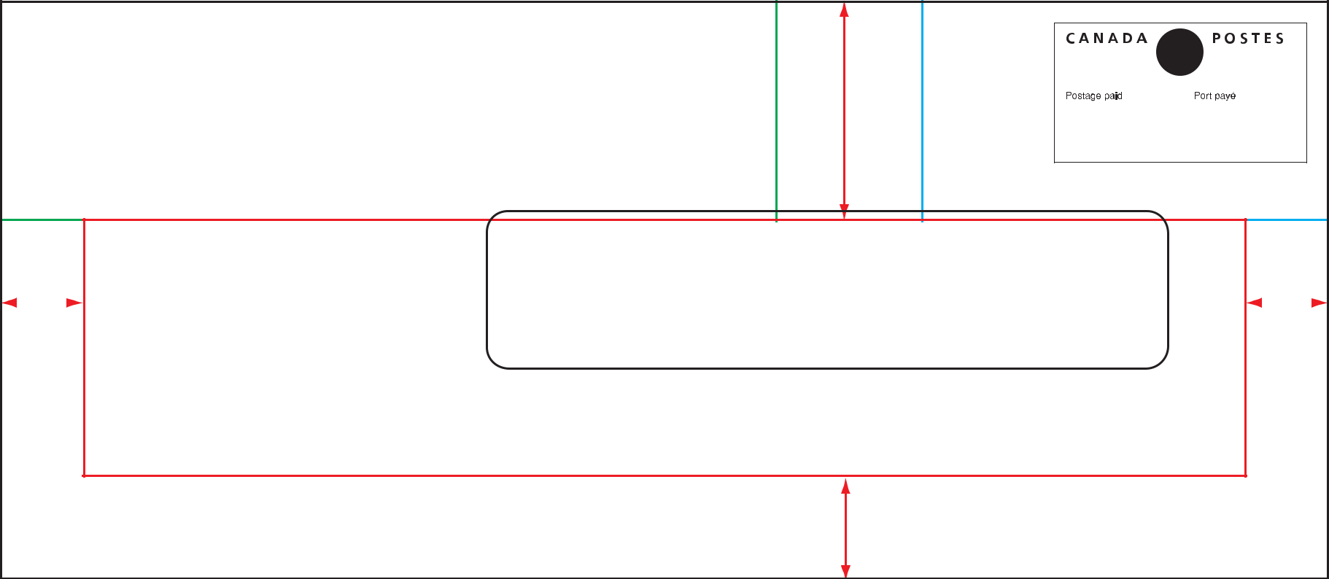
B THOMPSON
35 BRACO ST
OTTAWA ON K2L 1B6

40 mm

Return Address Zone

Postage Zone

40 mm from top / at least 100 mm from right

40 mm from top / 74 mm from right

 | Destination Address Zone | JOHN JONES
 |  | MARKETING DEPT
 |  | 10-123 1/2 MAIN ST NW
 |  | MONTREAL QC H3Z 2Y7
15 mm |  | MONTREAL QC H3Z 2Y7 | 15 mm

19 mm

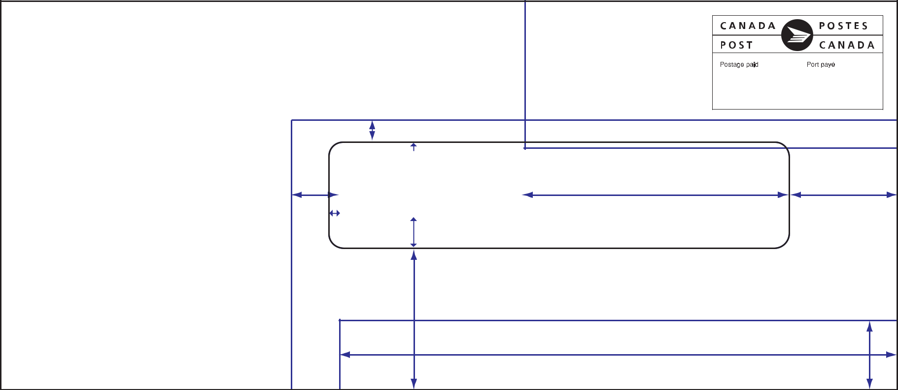
B THOMPSON
35 BRACO ST
OTTAWA ON K2L 1B6 |  |  |  |  | Quite Zone
 |  |  |  |  | for Stamp
 |  |  |  |  | and Meter only
 |  | 6 mm
 |  |  | 3 mm min.
 |  | JOHN JONES |  |  | Window | Quiet Zone
Graphics Zone |  | MARKETING DEPT |  |  | Window | Quiet Zone
Graphics or text can be placed | 13 mm | 10-123 1/2 MAIN ST NW |  |  | 10 mm | The entire area to
anywhere outside the Quiet Zones | 13 mm | MONTREAL QC |  | H3Z 2Y7 | 10 mm | The entire area to
 |  | 3 mm min. | 3 mm min. |  | min. | the right of the
 |  |  |  |  |  | destination address
 |  |  | The entire area below the destination address
 |  |  |  |  | Bar Code Area | 19 mm
 |  |  |  |  | 150 mm

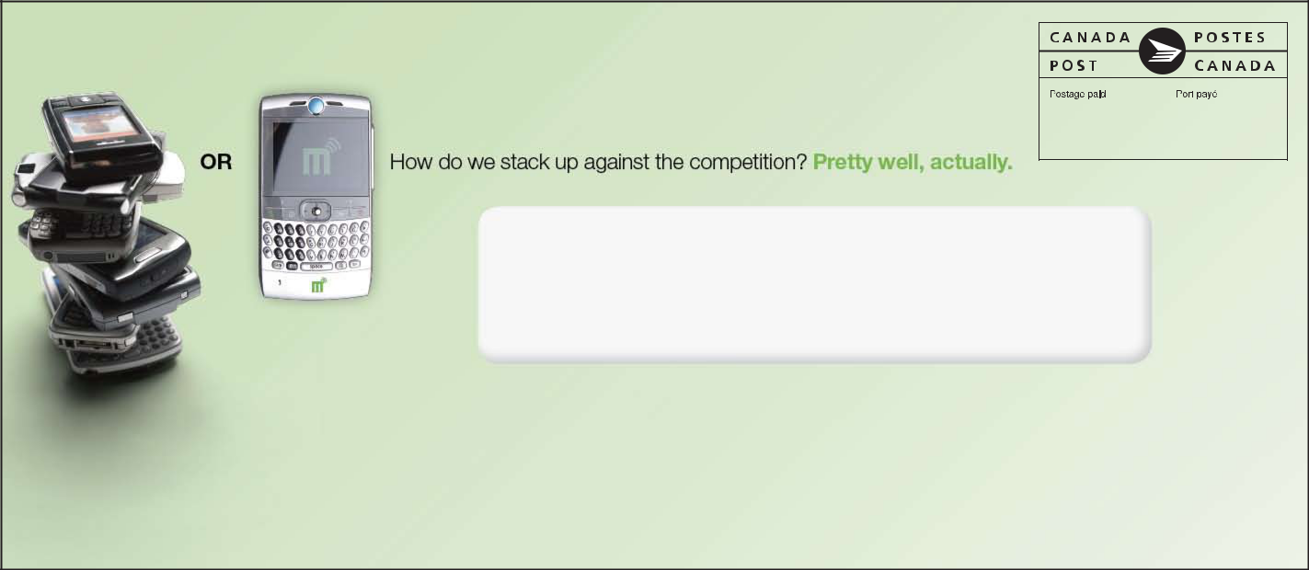
- THOMPSON 35 BRACO ST OTTAWA ON K2L 1B6

JOHN JONES

MARKETING DEPT

10-123 1/2 MAIN ST NW

MONTREAL QC H3Z 2Y7
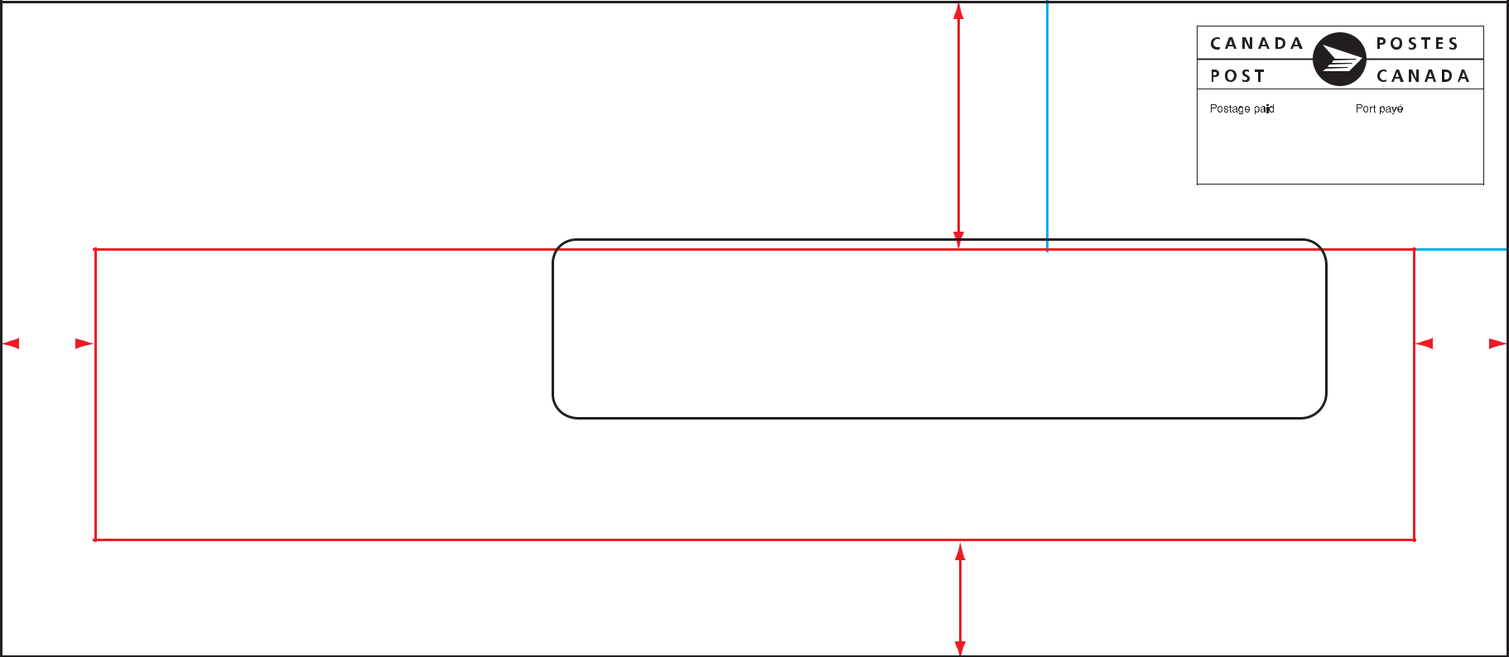
40 mm

Postage Zone

40 mm from top / 74 mm from right

 | Destination Address Zone | JOHN JONES
 |  | MARKETING DEPT
 |  | 10-123 1/2 MAIN ST NW
 |  | MONTREAL QC H3Z 2Y7
15 mm |  | MONTREAL QC H3Z 2Y7 | 15 mm

19 mm

Graphics Zone

Graphics or text can be placed anywhere outside the Quiet Zones

 |  |  |  | Quite Zone
 |  |  |  | for Stamp
 |  |  |  | and Meter only
 | 6 mm
 |  | 3 mm min.
 | JOHN JONES |  |  | Window | Quiet Zone
 | MARKETING DEPT |  |  | Window | Quiet Zone
13 mm | 10-123 1/2 MAIN ST NW |  |  | 10 mm | The entire area to
13 mm | MONTREAL QC |  | H3Z 2Y7 | 10 mm | The entire area to
 | 3 mm min. | 3 mm min. |  | min. | the right of the
 |  |  |  |  | destination address
 |  | The entire area below the destination address
 |  |  |  | Bar Code Area | 19 mm
 |  |  |  | 150 mm
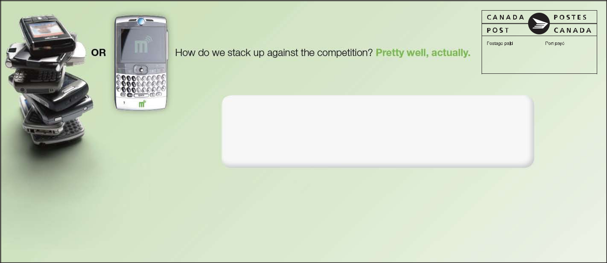

JOHN JONES

MARKETING DEPT

10-123 1/2 MAIN ST NW

MONTREAL QC H3Z 2Y7
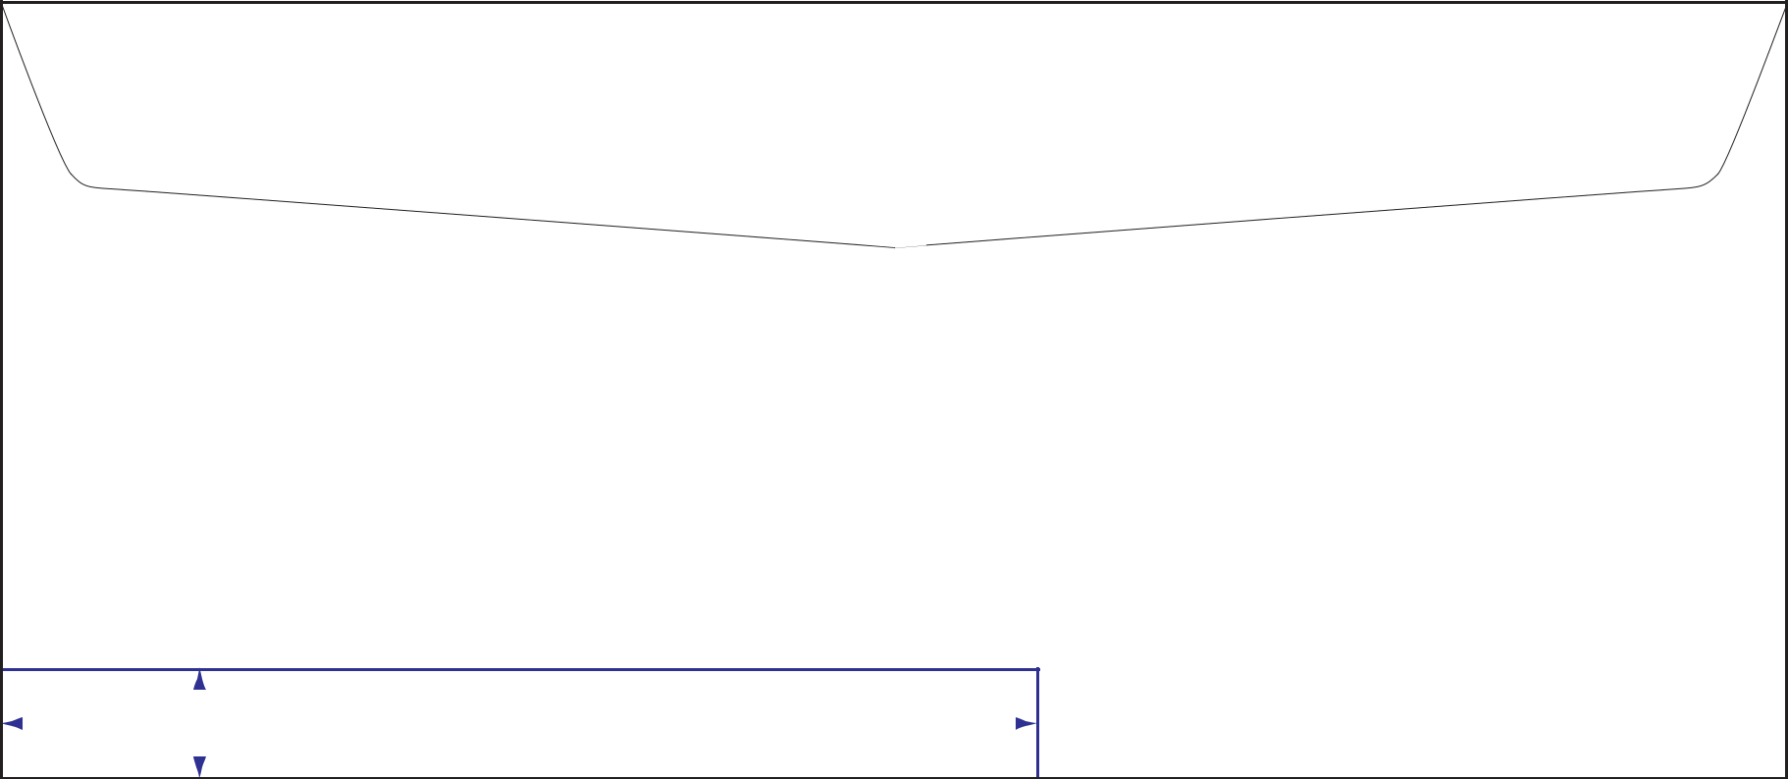

 |  | Zone
 |  | Quiet
 |  | the
 |  | outside
 | Zone | anywhere
 | placed
Graphics | be
Graphics | can
text
or
Graphics

15 mm |  | Bar Code Area | Quiet Zone
 |  | 140 mm


B THOMPSON
35 BRACO ST
OTTAWA ON K2L 1B6

 |  | Zone
 |  | Quiet
 |  | the
 |  | outside
 | Zone | anywhere
 | placed
Graphics | be
Graphics | can
text
or
Graphics

15 mm |  | Bar Code Area | Quiet Zone
 |  | 140 mm

- THOMPSON 35 BRACO ST
OTTAWA ON K2L 1B6

