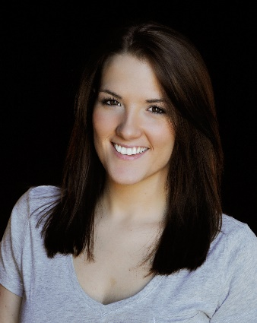

**Rachel Jenack**

(315) 212-7789

rjenack23@yahoo.com

**Height:** 5 ft .5 in.

**Weight:** 138 lbs

**Eyes:** Brown

**Hair:** Dark Brown

**THEATER:**

American College Theater Festival Irene Ryan Nominee UNH - Region 1

“So Tell Me About This Guy” Angie SUNY Potsdam

The Vagina Monologues SUNY Potsdam

“Transfigured Night” Valerie Radcliffe SUNY Potsdam

**TV/RADIO SPOTS:**

(List available upon request)

**FILM:**

“EXIT” Lead Don Mandigo

**SPECIAL SKILLS:**

Certified Bartender (RSA Certified – NSW Sydney, Australia); Basketball, Softball, Swimming (breaststroke, freestyle); Singing (soprano & alto); Tour Guide (New York Power Authority); Basketball Referee

**EDUCATION:**

SUNY Potsdam Major: Communications (Speech); Minor: Acting

New York Film Academy Acting Certificate Program Los Angeles, CA

Voice Training Garth Bardsley