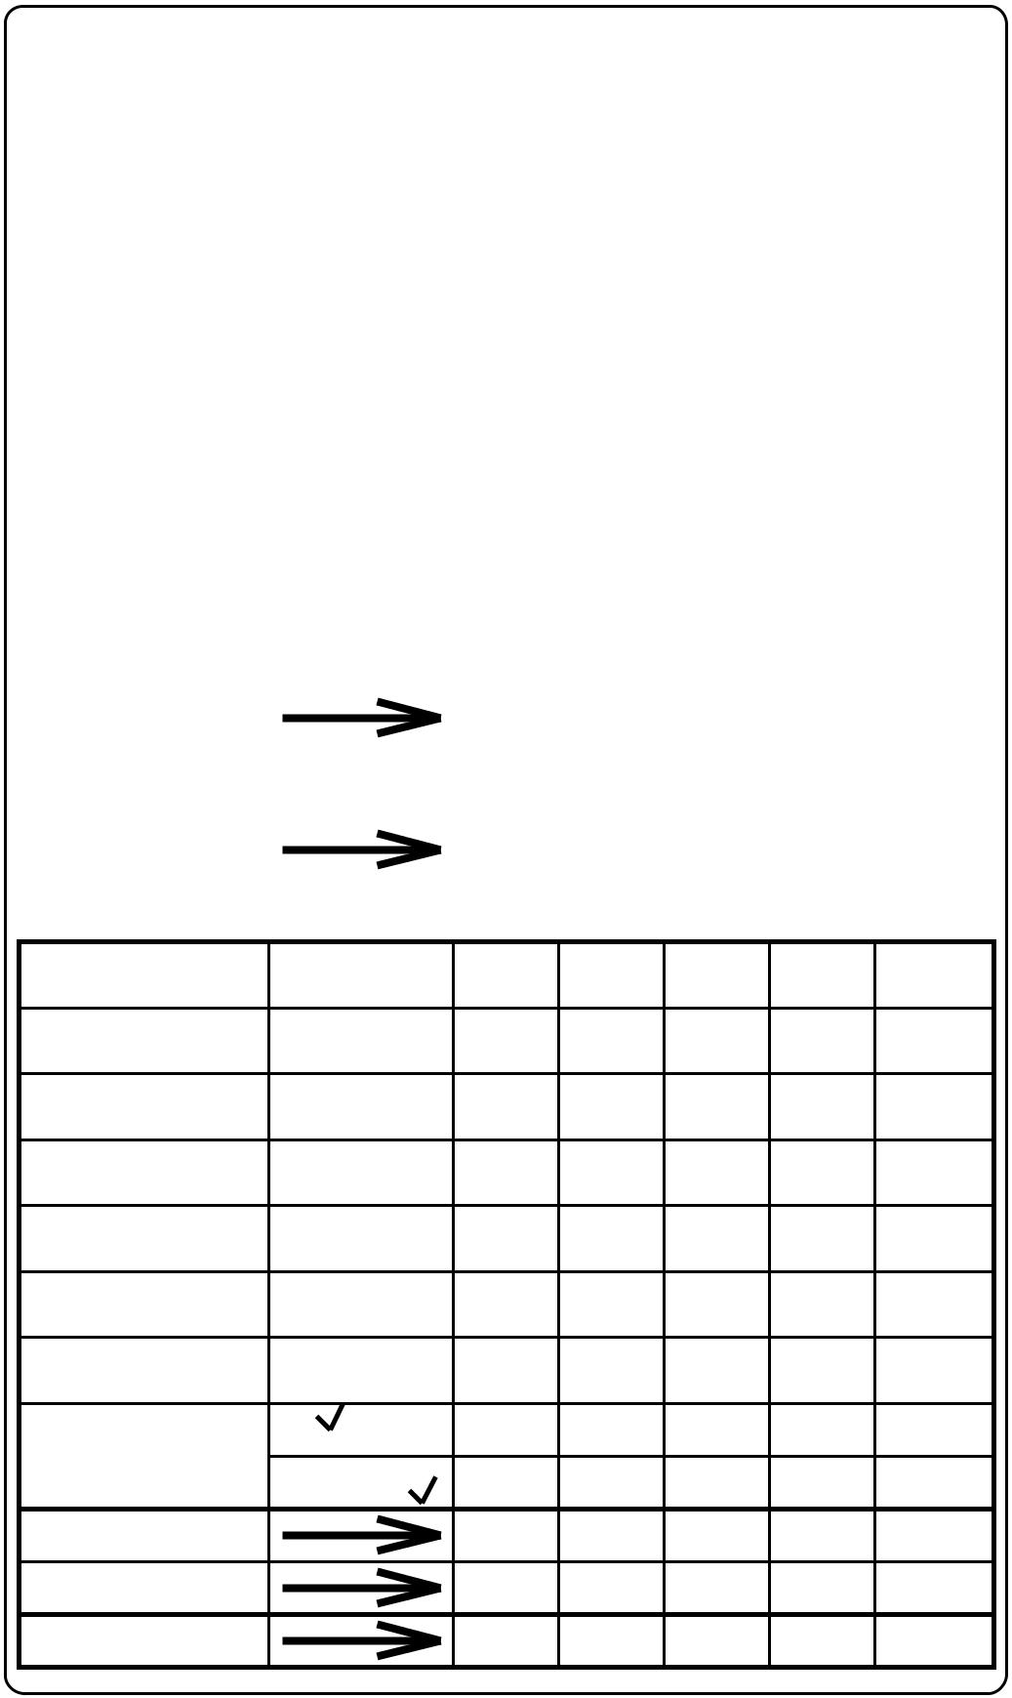
Yahtzee |  |  |  |  |  |  | Player’s Name
 |  |  |  |  |  | SCORE CARD
 | UPPER SECTION |  |  |  |  |  | HOW | GAME |  |  |  | GAME |  |  |  | GAME |  |  |  | GAME |  |  |  | GAME
 |  |  |  |  |  |  | TO SCORE | #1 |  |  |  | #2 |  |  |  | #3 |  |  |  | #4 |  |  |  | #5
 |  |  |  |  |  |  | Count and
 | Aces |  | . |  | = 1
 |  |  |  |  |  |  | add only
 |  |  |  |  |  |  | Aces
 |  |  |  |  |  |  | Count and
 | Twos |  | . | . | = 2
 |  |  |  |  |  |  | add only
 |  |  |  |  |  |  | Twos
 |  |  |  |  |  |  | Count and
 | Threes |  | .. |  | = 3
 |  |  |  |  |  |  | add only
 |  |  | . |  |  |  | Threes
 |  |  |  |  |  |  | Count and
 |  |  | .. |  | = 4
 |  |  |  |  |  |  | add only
 | Fours |  | .. |  |  |  | Fours
 |  |  |  |  |  |  | Count and
 | Fives |  | .. |  | = 5
 |  |  |  |  |  |  | add only
 |  |  | .. |  |  |  | Fives
 |  |  |  |  |  |  | Count and
 | Sixes |  | .. |  | = 6
 |  |  |  |  |  |  | add only
 |  |  |  |  |  |  | Sixes
 | TOTAL SCORE
 | _{BONUS} If total score |  |  |  |  |  | SCORE 35
 |  |  | is 63 or over
 | TOTAL |  | Of Upper
 |  |  | Section
 | LOWER SECTION
 | 3 of a kind |  |  |  |  |  | Add Total
 |  |  |  |  |  |  | Of All Dice
 | 4 of a kind |  |  |  |  |  | Add Total
 |  |  |  |  |  |  | Of All Dice
 | Full House |  |  |  |  |  | SCORE
 |  |  |  |  |  |  | 25
 |  |  | (Sequence) |  |  |  | SCORE
 |  |  |  |  | of 4
 | Sm Straight |  |  |  |  |  | 30
 |  |  | (Sequence) |  |  |  | SCORE
 | Lg. Straight |  |  |  | of 5 |  | 40
 |  |  |  |  | 5 of |  | SCORE
 | YAHTZEE _{a kind} |  |  |  |  |  | 50
 | Chance |  |  |  |  |  | Score Total
 |  |  |  |  |  |  | Of All 5 Dice
 | YAHTZEE |  |  |  |  |  | FOR
 |  |  |  |  |  |  | EACH BONUS
 | BONUS |  |  |  |  |  | SCORE 100
 |  |  |  |  |  |  | PER
 | TOTAL |  | Of Lower
 |  |  | Section
 | TOTAL |  | Of Upper
 |  |  | Section

GRAND TOTAL

Yahtzee |  |  |  |  |  |  | Player’s Name
 |  |  |  |  |  | SCORE CARD
 | UPPER SECTION |  |  |  |  |  | HOW | GAME |  |  |  | GAME |  |  |  | GAME |  |  |  | GAME |  |  |  | GAME
 |  |  |  |  |  |  | TO SCORE | #1 |  |  |  |  | #2 |  |  |  | #3 |  |  |  | #4 |  |  |  | #5
 |  |  |  |  |  |  | Count and
 | Aces |  | . |  | = 1
 |  |  |  |  |  |  | add only
 |  |  |  |  |  |  | Aces
 |  |  |  |  |  |  | Count and
 | Twos |  | . | . | = 2
 |  |  |  |  |  |  | add only
 |  |  |  |  |  |  | Twos
 |  |  |  |  |  |  | Count and
 | Threes |  | .. |  | = 3
 |  |  |  |  |  |  | add only
 |  |  | . |  |  |  | Threes
 |  |  |  |  |  |  | Count and
 |  |  | .. |  | = 4
 |  |  |  |  |  |  | add only
 |  |  | ..
 | Fours | .. |  |  |  |  | Fours
 |  |  |  |  |  |  | Count and
 | Fives |  | . |  | = 5
 |  |  |  |  |  |  | add only
 |  |  | .. |  |  |  | Fives
 |  |  |  |  |  |  | Count and
 | Sixes |  | .. |  | = 6
 |  |  |  |  |  |  | add only
 |  |  |  |  |  |  | Sixes
 | TOTAL SCORE
 | _{BONUS} If total score |  |  |  |  |  | SCORE 35
 |  |  | is 63 or over
 | TOTAL |  | Of Upper
 |  |  | Section
 | LOWER SECTION
 | 3 of a kind |  |  |  |  |  | Add Total
 |  |  |  |  |  |  | Of All Dice
 | 4 of a kind |  |  |  |  |  | Add Total
 |  |  |  |  |  |  | Of All Dice
 | Full House |  |  |  |  |  | SCORE
 |  |  |  |  |  |  | 25
 |  |  | (Sequence) |  |  |  | SCORE
 |  |  |  |  | of 4
 | Sm Straight |  |  |  |  |  | 30
 |  |  | (Sequence) |  |  |  | SCORE
 | Lg. Straight |  |  |  | of 5 |  | 40
 |  |  |  |  | 5 of |  | SCORE
 | YAHTZEE _{a kind} |  |  |  |  |  | 50
 | Chance |  |  |  |  |  | Score Total
 |  |  |  |  |  |  | Of All 5 Dice
 | YAHTZEE |  |  |  |  |  | FOR
 |  |  |  |  |  |  | EACH BONUS
 | BONUS |  |  |  |  |  | SCORE 100
 |  |  |  |  |  |  | PER
 | TOTAL |  | Of Lower
 |  |  | Section
 | TOTAL |  | Of Upper
 |  |  | Section
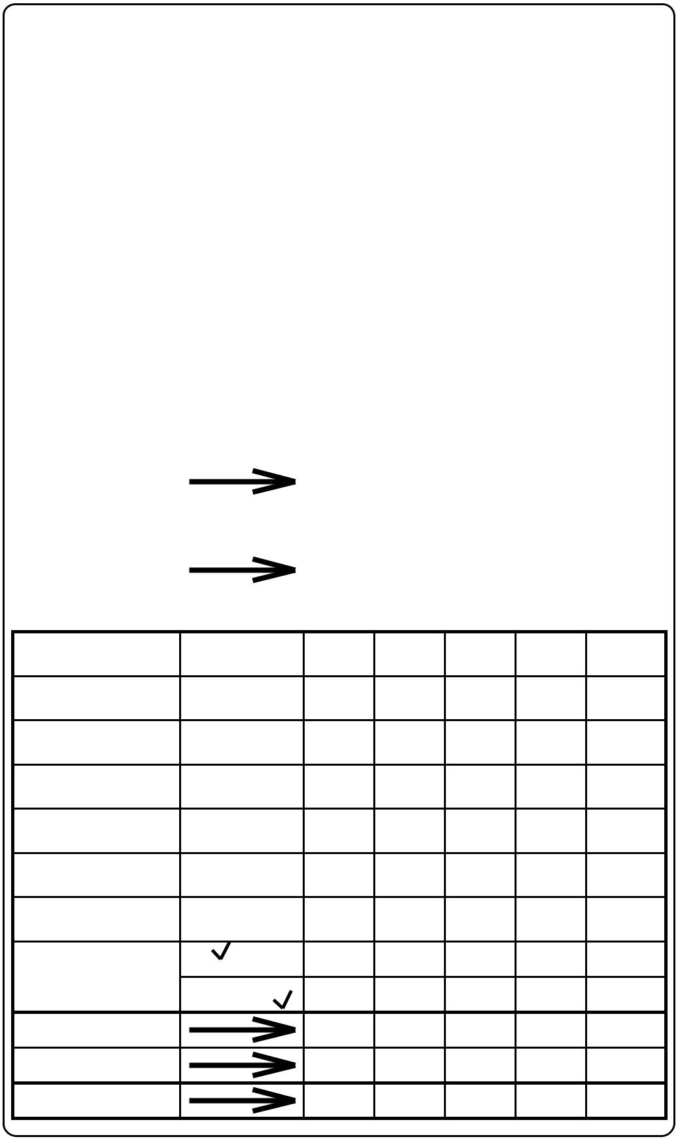

GRAND TOTAL

