Thank You Letter For Job Offer Sample Templates [2020]

23+ Thank You Letter For Job Offer Sample Templates [2020]
Written by Sara Cerim in Free Printables

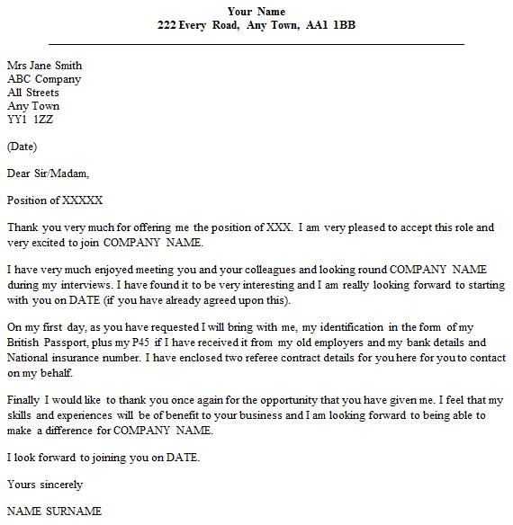
Are you the one waiting for your offer letter for an interview that you attended? Here is something that you should do as soon as you receive the job.
Sending a thank you letter to your hiring manager on account of your selection takes you one step closer to the management and also enhances your image in the organization.
Perhaps, it is not an easy task to draft one thank-you letter error-free but we make it possible with ready-to-use thank-you letter templates. In this post, we would tell you how to draft a thank you letter and accept the offer politely. We shall also tell you how to reject the job professionally.
#1
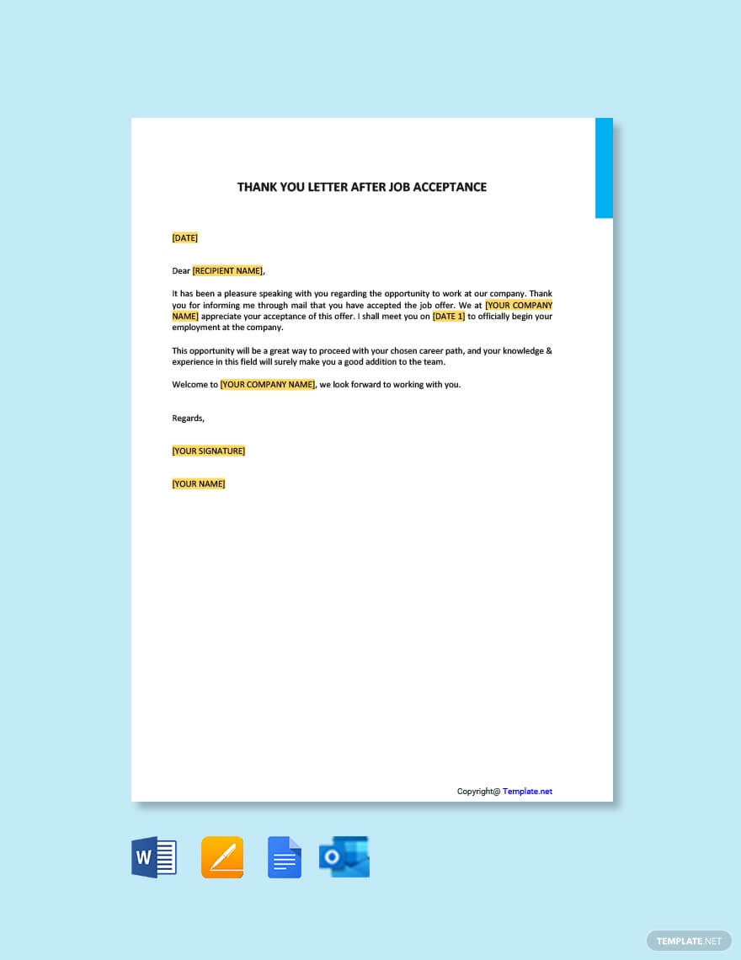
DOWNLOAD NOW
#2
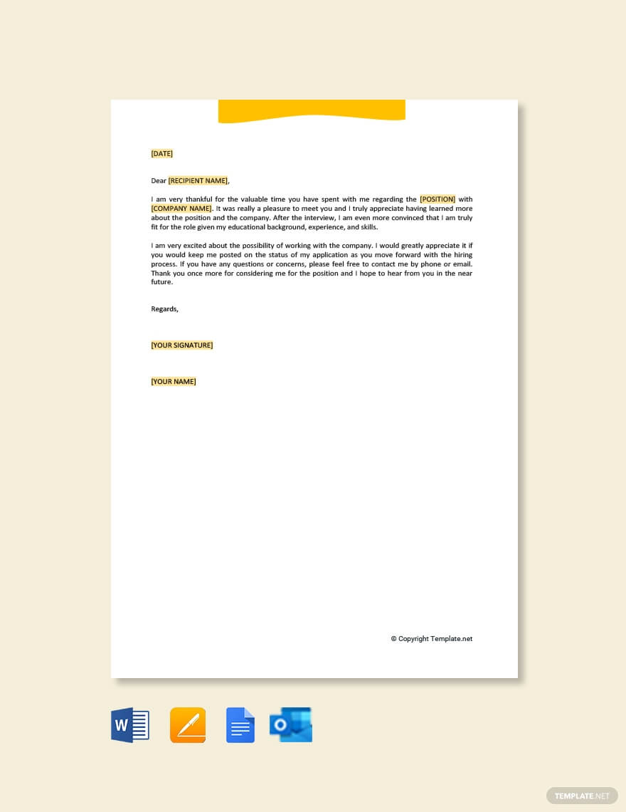
DOWNLOAD NOW
#3
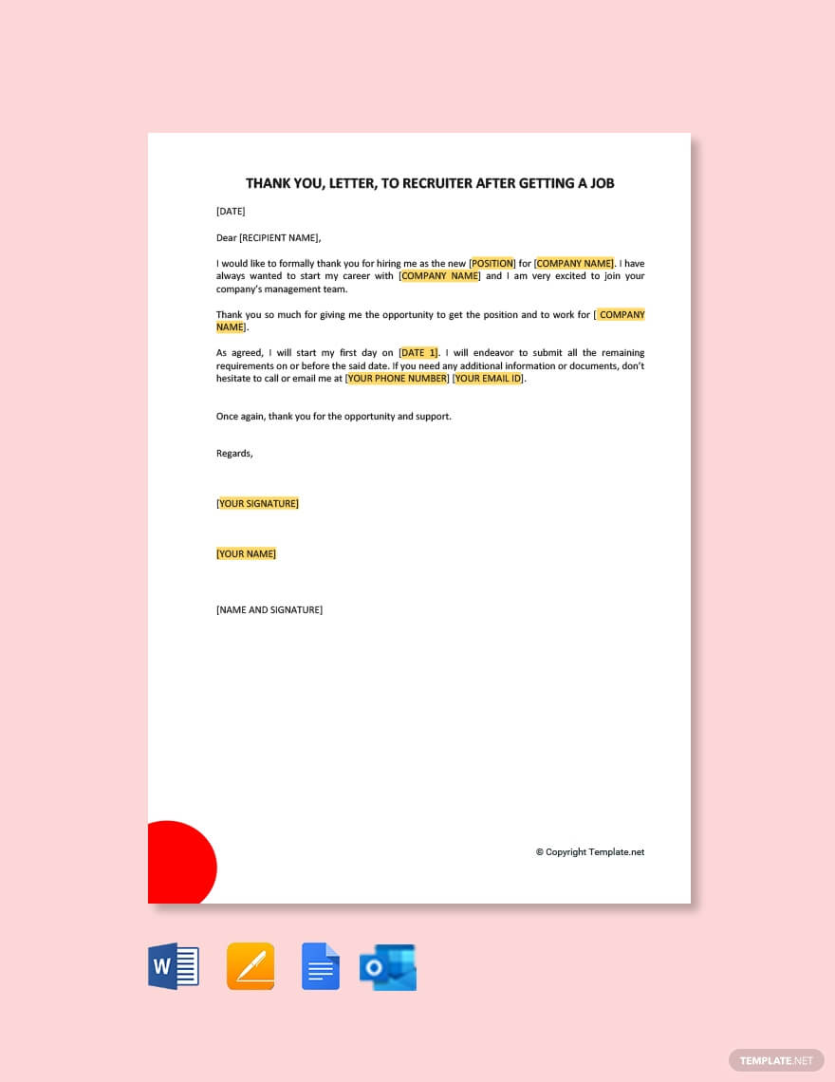
DOWNLOAD NOW

Sample Job Offer Thank You Letters
The company that accepts your candidature sends your position, salary, terms and conditions and the joining date. The meeting information is shared in the same email and you need to respond to this information.
Here is a sample letter amongst many free letters templates listed below:-
JANE DOE
123 Main Street | 111-111-1111 | janedoe@email.com
01/01/2019
John Smith
Hiring Manager
The Good Company
3456 Park Ave.
Somewhere, USA 10000
Dear John Smith :
Thank you sincerely for offering me an opportunity to work at The Good Company. I appreciate the time and effort spent by your team to interview me and review my application.
I regret to inform you that I’m unable to accept this position. Although I’m impressed by The Good Organisation and your team, I do not feel that this position aligns with my future career goals. I hope that there may be future opportunities with The Good Company that better fit my needs.
Thank you again for the time and consideration in making this decision and I hope we can connect again in the future.
Sincerely,
Jane Doe

