Plant Fact Sheet

AWEOWEO

Chenopodium oahuense (Meyen) Aellen

Plant Symbol = CHOA

Contributed by: USDA NRCS Hawaii Plant Materials Program
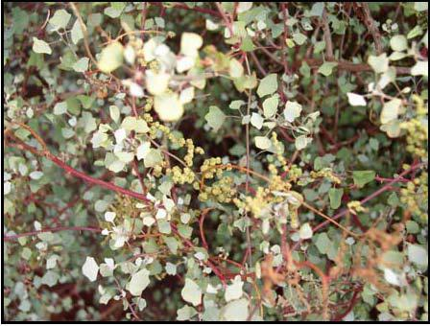

David Duvauchelle
USDA NRCS 2003

Alternate Names
Aheahea, ahea, ahewahewa, alaweo, alaweo huna (Niihau), kahaihai, goosefoot, pigweed, lamb’s quarters

Uses

Conservation:

The potential uses for aweoweo include ecosystem restoration, erosion control, and enhancing diversity in riparian and other communities.

Wildlife Habitat:

On Moku Manu, Oahu, sooty terns and red -foot boobies use ‘aweoweo as cover and also its dead branches for nests.

Hawaiian Cultural:

During ancient Hawaiian times, Aweoweo wood was used to make shark hooks and its leaves were cooked and eaten like spinach.

Status

Please consult the PLANTS Web site and your State Department of Natural Resources for this plant’s current status (e.g. threatened or endangered species, state noxious status, and wetland indicator values).

Description and Adaptation

A weakly scented shrub, the aweoweo can reach 5 -20m in height. Its leaves are 3-lobed and somewhat fleshy. Leaves are also pubescent with the bottom half more pubescent and a lighter green as well. Flowers are small on leafless panicles producing seeds that are dark-brown and about 0.8mm in diameter.

Aweoweo is endemic to the Hawaiian Islands. It can be found on the northwestern Hawaiian islands of Lisianski, Laysan, French Frigate Shoals, Necker, and Nihoa. It is also found throughout the main Hawaiian Islands, but according to the Manual of the Flowering Plants of Hawaii (1999), aweoweo has not been observed to be occurring naturally on the island of Kahoolawe. Aweoweo is adapted to dry habitats of coastal and dry forests and can also be found in subalpine shrublands as well, ranging in elevation from 0 – 2,520 meters.

Distribution: Please consult the Plant Profile page for this species on the PLANTS Web site.

Establishment

Aweoweo can be propagated either by seed or by vegetative cuttings. Dibble tubes with sterile planting medium are recommended for starting cuttings. Seedlings should be started in 200-cell flats and then transplanted to dibble tubes. Seeds germinate within 5-10 days. Propagules should be ready to plant in the field by 5-6 months after starting in a shade-house. It is recommended that they be placed in direct sunlight about a month before planting. Irrigation is recommended for the first 6 months after planting in the field at which time the plants should be able to survive simply on natural rainfall.

Management

Aweoweo is a hardy plant that requires very little management. It is well adapted to low rainfall situations having a very high drought tolerance. It can also tolerate nutrient depleted soils as well. Aweoweo does very well under cultivation as well. With the addition of moisture and fertilizer supplements, shrubs are able to grow with relatively high vigor.

Pests and Potential Problems

There are no known pests that are detrimental to the aweoweo life cycle.

Studies show that cultivated aweoweo produces seed with very low germination rates. This is overcome by the fact that it produces a large amount of seed. It is speculated that because aweoweo produces seed throughout the year, the majority of the seed harvested might be immature.

Cultivars, Improved, and Selected Materials (and area of origin)

Makakupaia Germplasm Aweoweo – Molokai, Hawaii
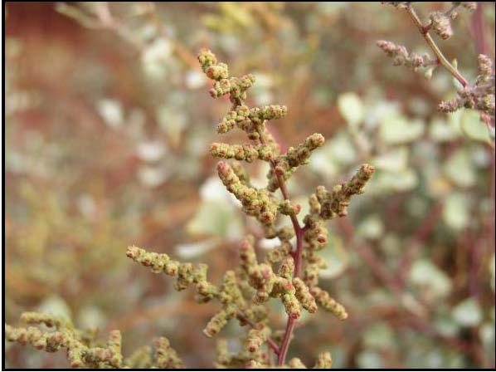

David Duvauchelle

USDA NRCS 2003

Prepared By:

David Duvauchelle - Natural Resource Specialist
USDA NRCS Plant Materials Center
Hoolehua, Hawaii

Citation

Duvauchelle, D. 2009 Plant fact sheet for aweoweo (Chenopodium oahuense (Meyen) Aellen ). USDA-Natural Resources Conservation Service, Hawaii Plant Materials Center, Hoolehua, Hawaii 96729

Published November, 2009

Edited:

For more information about this and other plants, please contact your local NRCS field office or Conservation District < http://www.nrcs.usda.gov/>, and visit the PLANTS Web site <http://plants.usda.gov> or the Plant Materials Program Web site <http://plant-materials.nrcs.usda.gov>

USDA IS AN EQUAL OPPORTUNITY PROVIDER AND EMPLOYER

