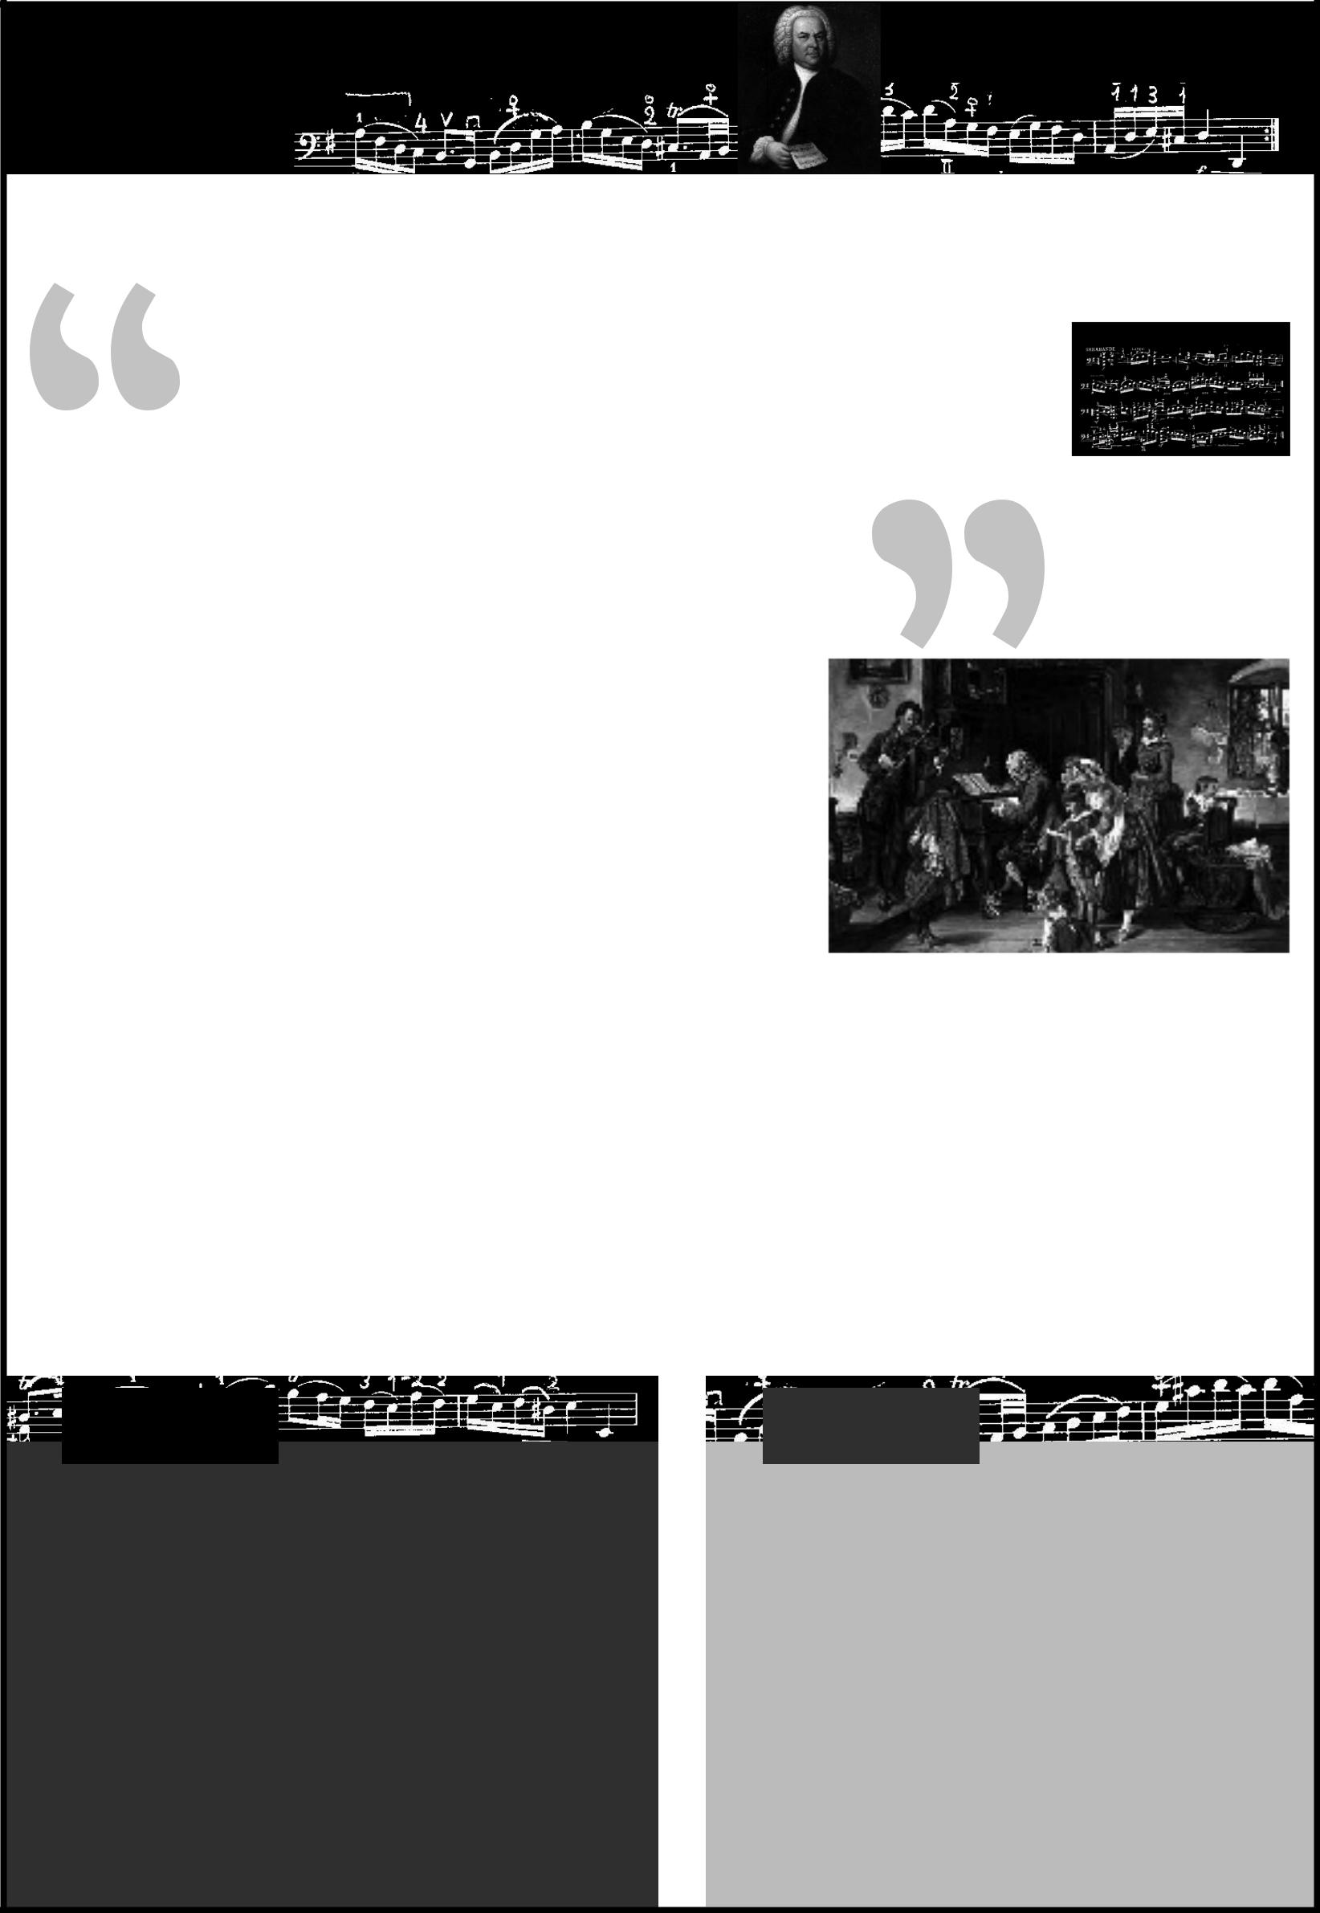
1 JS Bach Fact Sheet

You’ve heard his music on the radio. You’ve heard it in shopping centres and on T.V. advertisements.

You may even have heard it performed by a rock band. Would it surprise you to learn that the brilliant musician in question was born over 300 years ago? His name is Johann Sebastian Bach and he is one of the greatest composers of classical music the world has ever known.

JS Bach was born in Germany in 1685 and came from a family full of famous musicians. His ideal early childhood was struck by tragedy when both his parents died within a year of each other before his tenth birthday. He went to live with his brother who taught him to play the organ and before long, his career began to flourish. Although we know Bach as a famous composer, he was best known in his day as a skilled violinist, organist and harpsichordist (a keyboard instrument which preceded the piano).

Bach lived during the Baroque era, a term which describes the

fancy and complex style of music and art produced around the late 1600’s and early 1700’s. He wrote in all the

popular musical forms of the day, depending on where he was working at the time. Whilst working as a church musician he wrote many of his famous cantatas, which are long musical works to be played and sung during

church services. These works demonstrate his deep religious beliefs, which were a very important part of his life

and music. When he was employed as a court musician, Bach wrote many beautiful instrumental works for his royal employers, including sonatas, suites and concertos for a wide variety of instruments.

Bach’s final job was working as Musical Director for the city of Leipzig. Here he was incredibly busy composing and directing music for four churches and two choirs as well as producing any music needed for special occasions. He was fortunate to have a wife who was skilled at copying music very quickly, as there were no photocopiers around back then!

Fast Facts

Name: Johann Sebastian Bach

Dates: 1685-1750

Country of birth: Germany

Historical Era: Baroque Contemporary Composers: Handel,
Vivaldi

Contemporary Artists: Rembrandt

Other People/Events: Isaac Newton,

George Washington, Voltaire, invention of the steam boiler

Fun Fact

A recording of Bach’s music is floating in outer space! In 1977, the spacecraft Voyager 1 and 2 were launched to probe areas of outer space never before explored. On board was a “Golden Record,” a collection of the very best examples of human life and achievement, intended as a greeting to any form of life that may find it. Three recordings of Bach’s music were chosen to be included in this “Who’s Who” of human history.

Printable Music Lesson Plans - Great Composers - Fact Sheet 1 © 2009 Fun Music Company

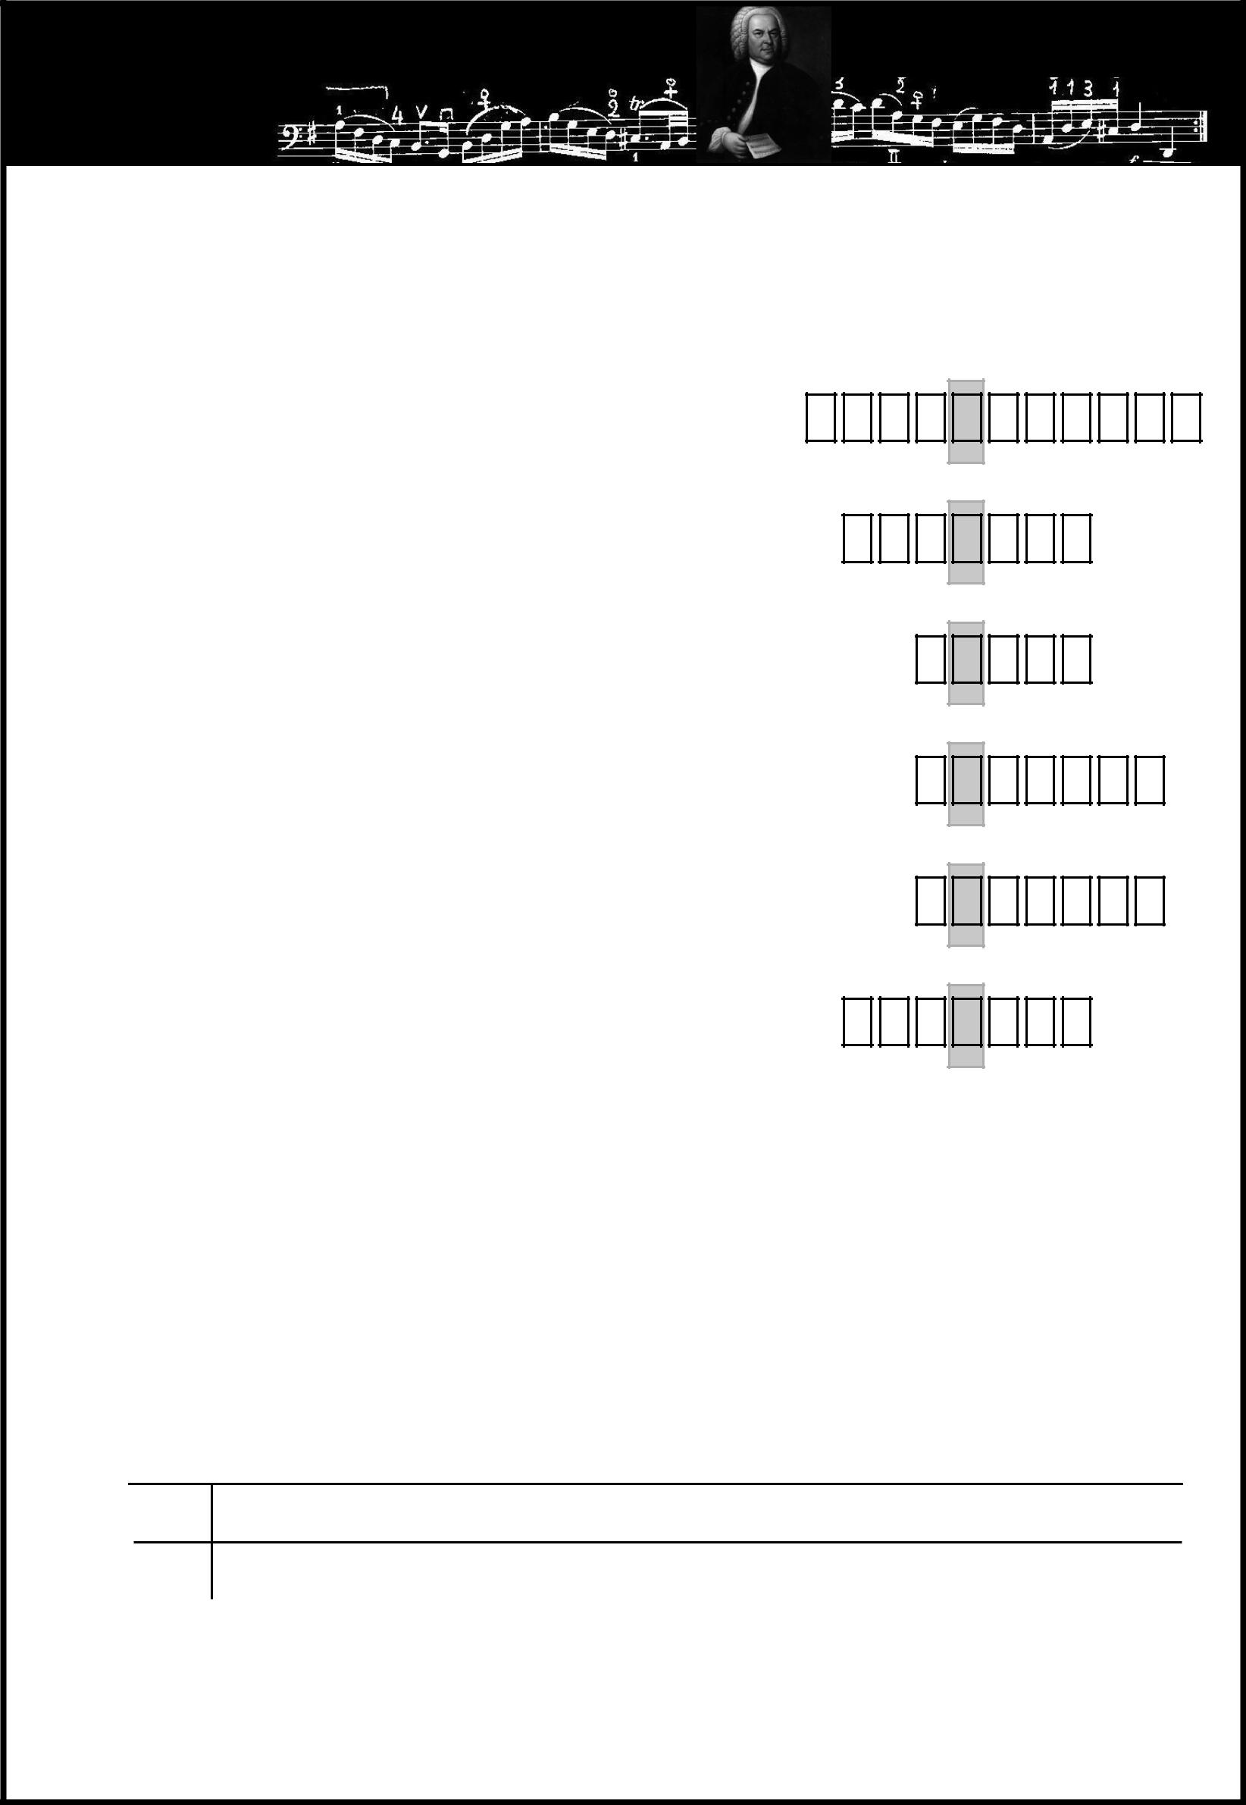
1 JS Bach fun sheet

Do you know what the name “Bach” means when translated into English?

Find out by writing the correct answers and reading the word formed by the shaded boxes. (All the information you need is in the Fact Sheet)

1 The name of the keyboard instrument which preceded the piano

2 The form of music written to be performed in a church service

3 One of the instruments Bach played

4 The town where Bach served as Musical Director

5 The name of the style of music written in the late 1600s-early 1700s

6 The country of Bach’s birth

Crack the Code

What did Bach’s employer, Duke Wilhelm Ernst do when Bach announced that he was looking for a new job?

___ ___ |  |  |  |  |  | ___ ___ ___ ___ |  |  |  |  |  |  |  |  |  |  | ___ ___ ___ |  |  |  |  |  |  | ___ |  | ___ ___ |  |  |  |  |  | ___ ___ |  |  |  |  |  | ___ ___ |  |  | ___ ___
 |  | H DE |  |  |  |  | b |  | DE |  |  | n |  |  | T |  |  | ^{AB}e C |  |  |  |  |  |  | H |  | T |  | O |  |  |  | q |  |  | u |  | c |  | b |  |  | O n
 |  | Code Key |  |  |  |  | ED |  |  |  | W |  |  | H |  |  |  |  |  |  |  |  |  |  |  |  |  |  |  |  |  |  |  |  |  |  |  |  |  |  |  |  | W
 | e |  | C |  | h |  |  |  | m |  |  |  |  |  |  | c |  | w |  | x |  | F |  |  | n |  | O |  |  |  | Q |  | u |  | b |  | T |  |  |  |  |  |  |  | X |  | P
 |  | AB |  |  |  |  |  |  |  |  |  |  |  |  |  |  |  |  |  |  |  |  | M |  |  |  |  | q |  |  |  |  |  |  |  |  |  |  | U | ^ |  |  |  |  |  |  |  | y
 | A | B C |  |  | D |  | E |  | F | G |  |  |  | H |  | I |  | J |  | K |  | L | M |  | N |  | O | P |  |  | Q |  | R |  | S |  | T |  | U | V |  |  | W |  | X |  | Y | Z

Printable Music Lesson Plans - Great Composers- Fun Sheet 1 © 2009 Fun Music Company

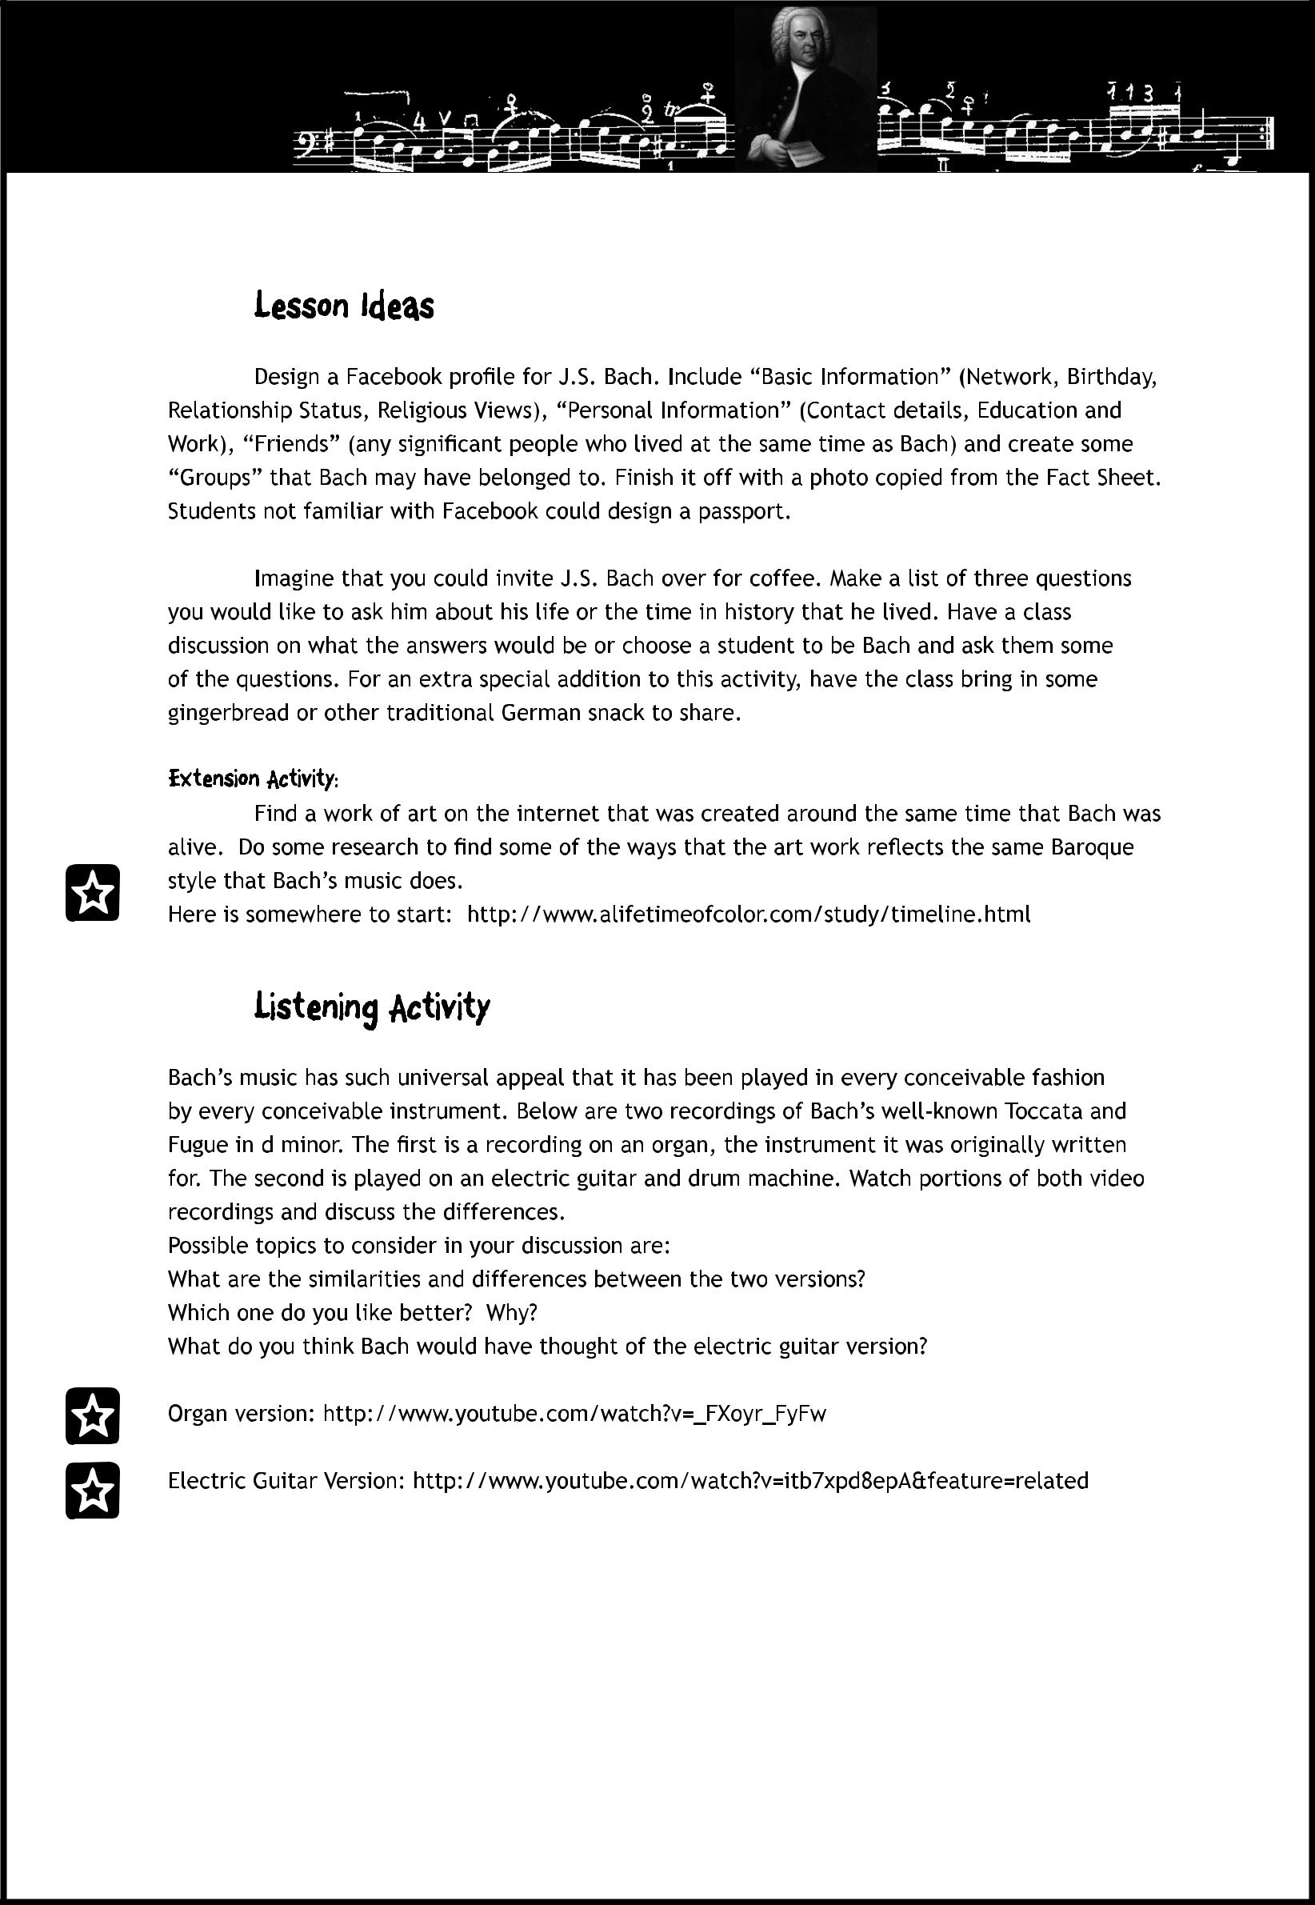

© 2009 Fun Music Company

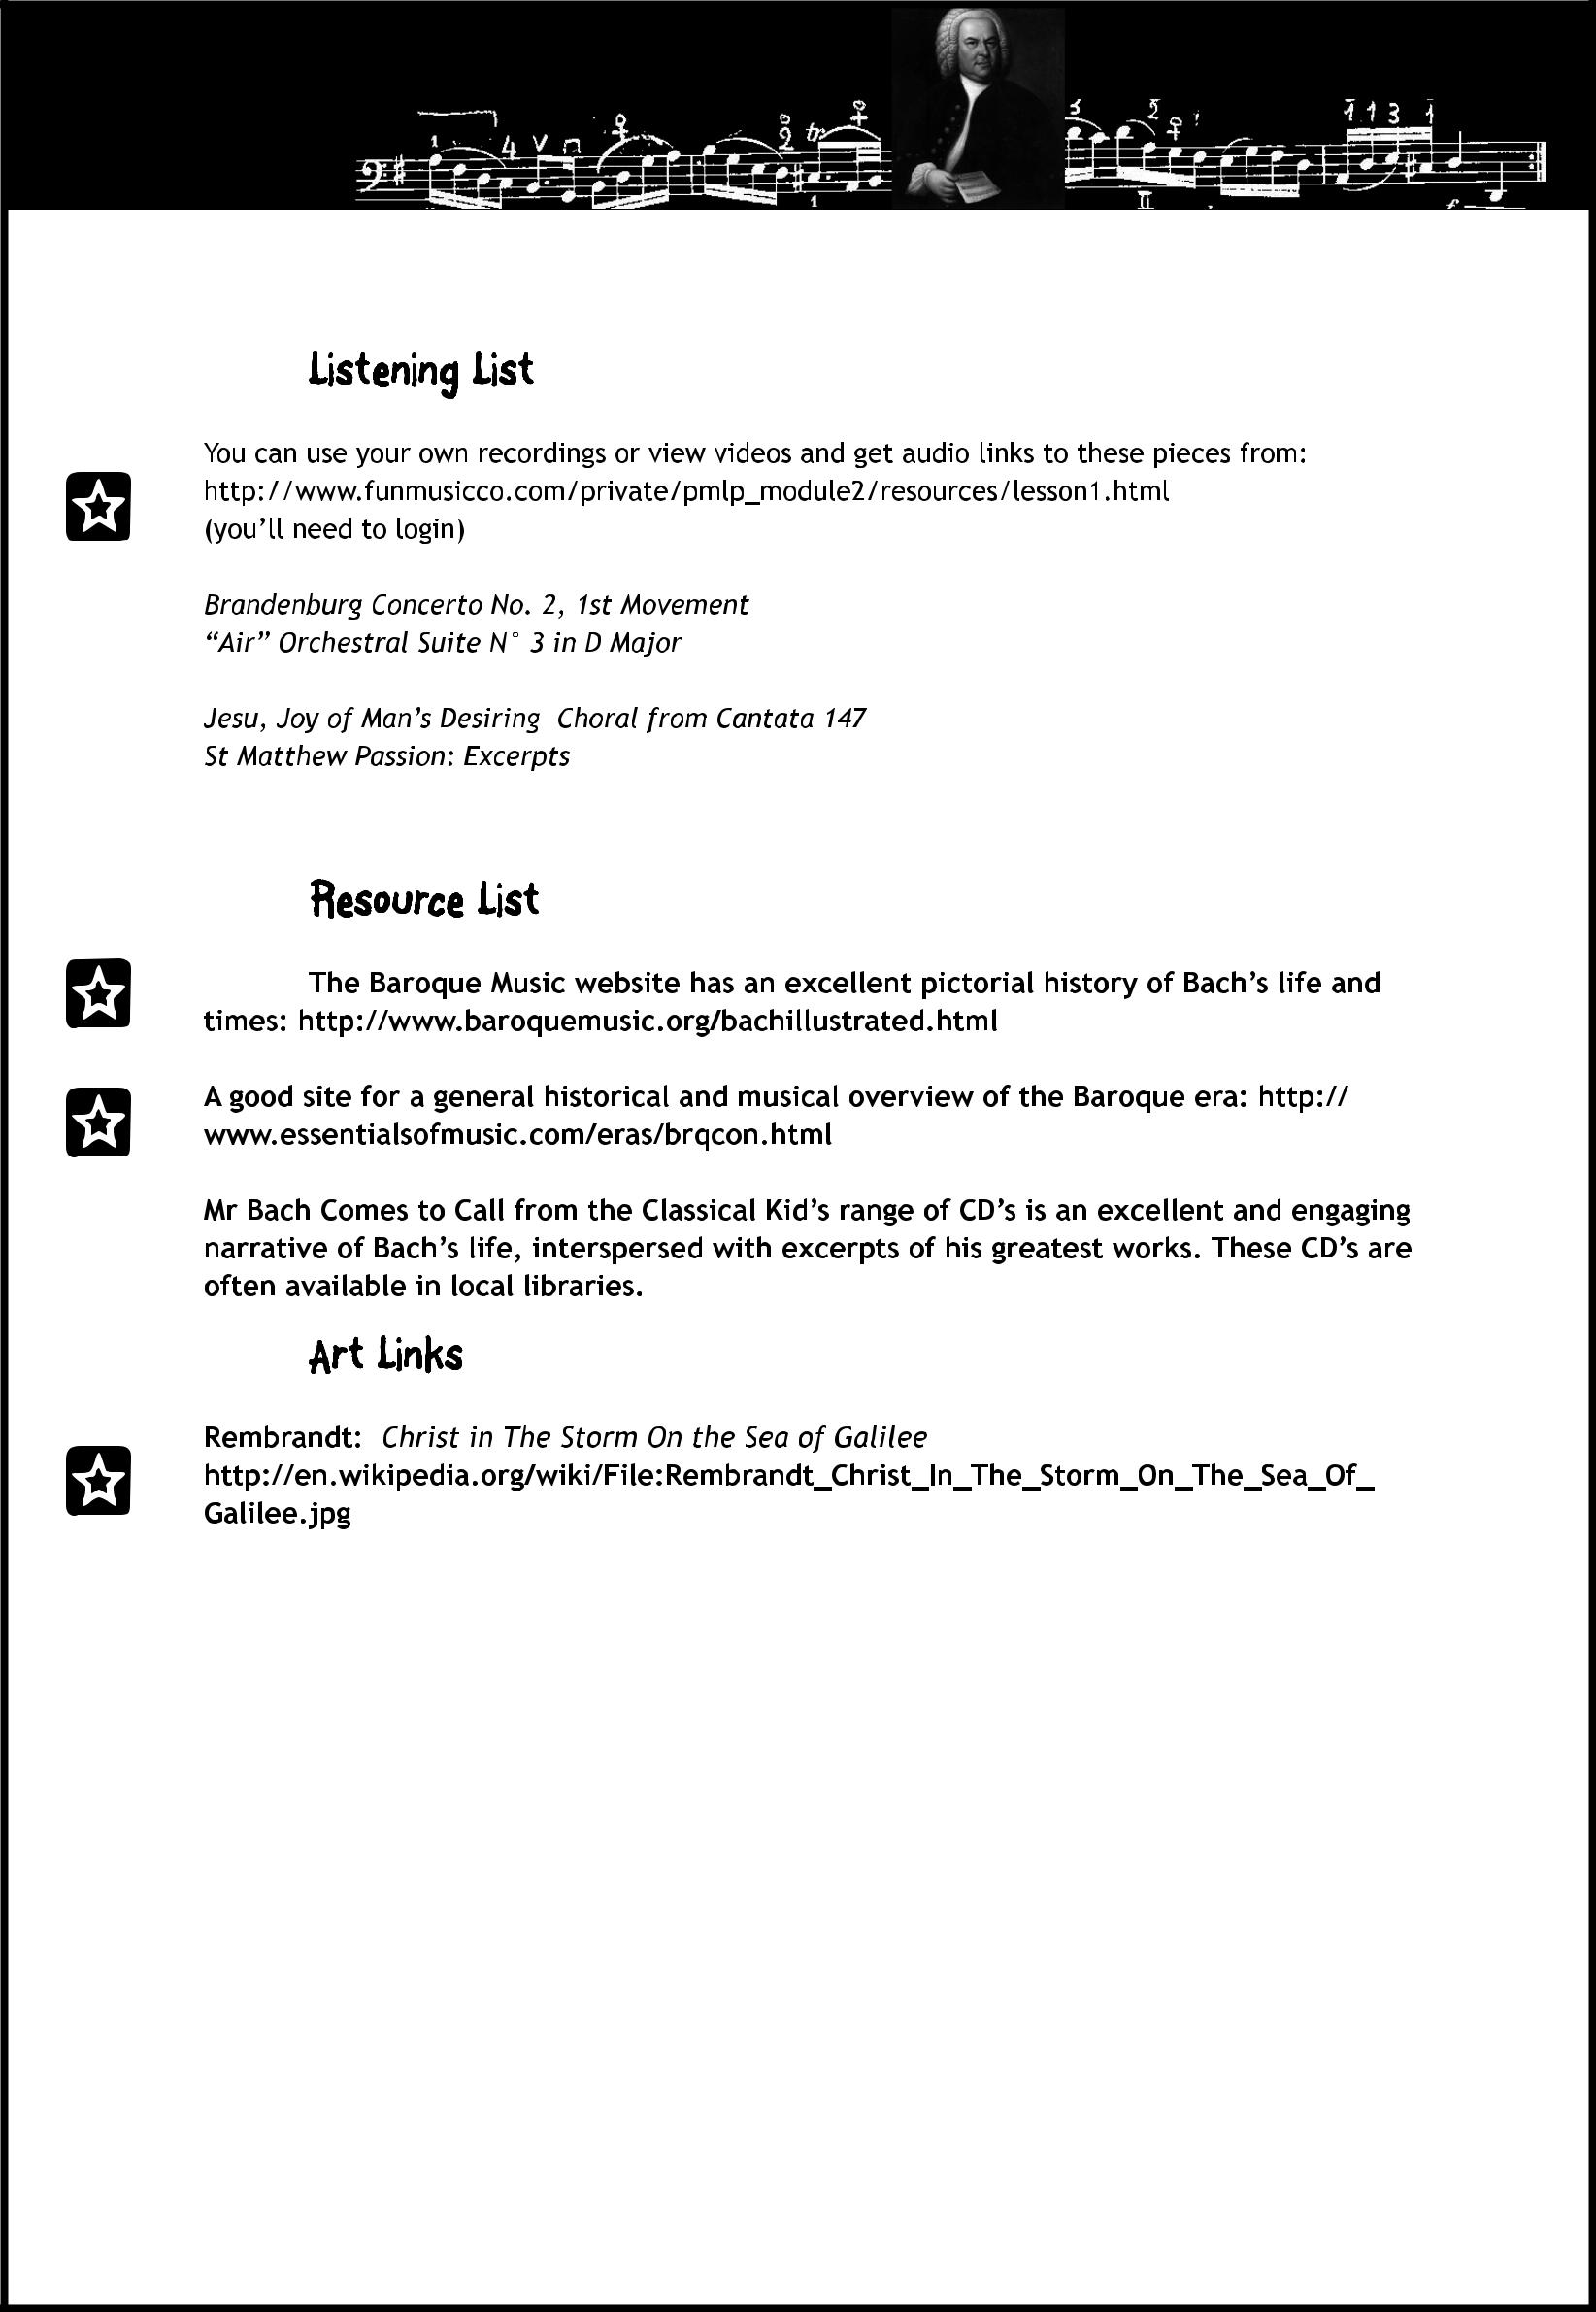
1 JS Bach Lesson Plan

Printable Music Lesson Plans -Great Composers - Lesson Plan 1 © 2009 Fun Music Company

