Fact Sheet | Financial Services


QUARK FUND FACT SHEETS SOLUTION

SPEED UP THE CREATION OF FUND FACT SHEETS AND PUBLISH

AUTOMATICALLY TO PRINT, WEB, AND MOBILE DEVICES

Does your marketing department struggle to produce fund fact sheets, merging narra-tive content — such as investment objec-tives, strategies, and profiles of fund managers — with data from spreadsheets and data repositories?

Are you able to merge all of the required information in a way that complies with regulations and communicates in an attractive way so you can retain existing clients and attract new investors?

If you’re like most fund companies, the way you produce fund fact sheets is a nightmare for your marketing department that diminishes your competitive edge because:

- You rely heavily on cutting and pasting information from various sources into a layout, which means an hour or more of work to create, review, and approve each fund fact sheet.

- A high degree of manual effort creates a drag on the production of fact sheets and makes last-minute changes expensive and time-consuming.

- You cannot easily deliver fact sheets to your clients in both print and digital formats, because publishing fact sheets to multiple media involves more time, effort, and cost.

Create Accurate and Distinctive Fund Fact Sheets, Fast

Using Quark’s content automation platform, your marketing department can improve the speed and lower the cost of creating, formatting, validating, and disseminating distinctive fund fact sheets across multiple types of media — including print, Web, and mobile formats.

Our software connects your marketing department to databases and other business systems, so you can:
- _{Ċ}
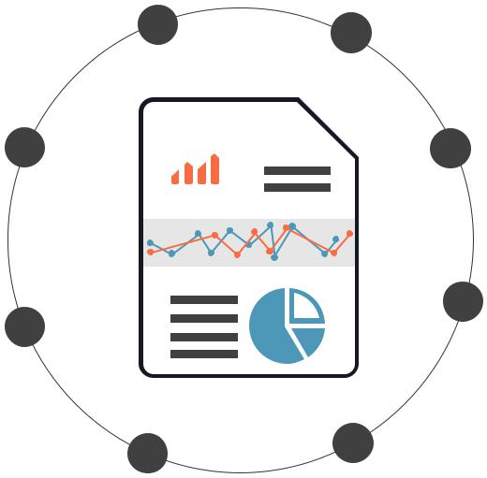
H  ¾

ĸ
1PDF

HTML

- Develop distinctive templates where your marketing team can automatically merge narrative content with content from spreadsheets and data repositories, eliminating error-prone manual work

- Make sure only authorized personnel can edit certain information

- Integrate local and remote writers

- Streamline the content and legal review processes, making it easy to automatically incorporate last-minute changes

- Automate the publishing of fact sheets to print, Web, and other digital devices

With a more efficient process, you can gain a savings of 20 percent or more in the time and cost of authoring and pub-lishing your fact sheets. And with access to better informa-tion that helps your clients to understand your funds’ objectives and track their performance, your clients will reward you with greater loyalty and more business.

Do You Pass the Test?

If you do not agree with one or more of the following state-ments, you may benefit from using a content automation platform for producing fund fact sheets.


www.quark.com/enterprise

INFO SHEET | Financial Services

The way we produce our fund fact sheets:

- Allows us to consistently deliver fund fact sheets on time and within budget

- Allows us to easily make our fund fact sheets available in print, Web, and mobile formats

- Makes it easy to combine information from multiple sources

- Makes compliance with strict corporate
and government rules for disclaimers and disclosures easy

- Makes it easy to maintain accurate information and deliver professional, high-quality material

Our Content Automation Platform Consists of:

Quark Publishing Platform

Integrates the tools your marketing group uses with other business systems and offers publishing automation.

BENEFITS


20% Reduction in Authoring Time

With automated template creation, direct integration of marketing tools with other data sources, and free-dom from formatting

20% Reduction in Reviewing Time

By eliminating redundant or irrelevant reviews

80% Reduction in Cross-media Production

By using information from a single source and automat-ically creating fact sheets for print, Web, and digital for-mats as required

10% Reduction in Cycle Time

Due to elimination of copy/paste and the introduction of a streamlined and automated process

Quark Author

Web-based content creation software that offers your sub-ject matter experts an intuitive online authoring experience for rapidly creating, previewing, publishing and reusing struc-tured content.

Quark XML Author

An add-in to Microsoft Word that helps you address the problems and challenges that are caused by creating unstructured word processing files that cannot support reuse or drive automated publishing.

QuarkXPress

Lets you create design templates for automatically publish-ing professional materials.

Adapters for Content Management Systems

Ready-made adapters that integrate Quark XML Author with Microsoft SharePoint and IBM FileNet Content Manager help you connect your publishing tools to your enterprise content management system so you can easily manage data, XML content, and other assets through a single, connected system.

ABOUT QUARK SOFTWARE INC.

Quark Software Inc. develops a content automation platform that helps large organizations streamline the creation, management, publishing and delivery of business-critical content. Our solutions automate the process with reusable Smart Content components that can be dynamically assembled and delivered with precision in any format and to any channel — web, tablet, mobile, print, and more. As a result, leaders in industries such as finance, manufacturing, energy, and government can reduce costs, save time, improve consistency and make their content brilliant.

To find out more about Quark Enterprise Solutions visit www.quark.com/enterprise or contact us at www.quark.com/contact

Denver | London | Hamburg | Mohali | Dublin

©2016 Quark Software Inc. All rights reserved. Unauthorized use and/or reproduction are violations of applicable laws.
Quark and the Quark logo are trademarks or registered trademarks of Quark Software Inc. and its affiliates in the U.S. and/or other countries. All other marks are the property of their respective owners. US

www.quark.com/enterprise

