**Weatherization Assistance Program Fact Sheet**

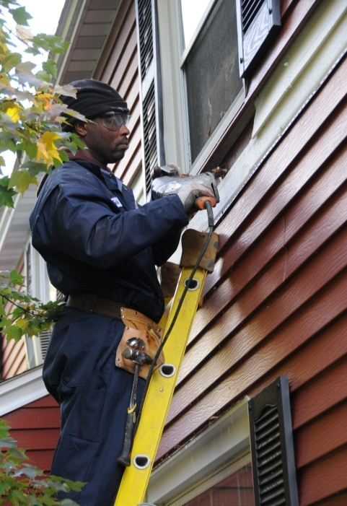

# The (…………..insert State name and office name…………………….) manages the state’s Weatherization Assistance Program for Low Income Persons, using (list all applicable funding sources, which could include U.S. DOE appropriations, LIHEAP fuel assistance funds, utility partnership funding, other). (The State Office name) contracts statewide with (insert number of subgrantees) local community action agencies that (insert applicable term: contract services with local contractors or contract trained weatherization crews) to install residential energy efficiency and conservation measures prescribed by energy audits and diagnostic testing in all (insert # of counties) counties. Examples include, but are not limited to, (list priority measures applicable for your state, may include: installing insulation, reducing air-infiltration, performing heating and cooling tune-ups and modifications, and, when appropriate, replacing units for energy efficiency and safety.) Clients are educated on the proper use and maintenance of the weatherization measures.

# PURPOSE

1. **To increase the energy efficiency of homes, mobile homes, and apartments occupied by low-income persons,** **targeting the elderly, those with disabilities, and families with children, while ensuring their health and safety.** (from US Census data: )

(insert %) of (state name) population live in poverty;

(insert %) of the state’s elderly population live in poverty;

(insert %) of children in (state name) live in poverty.

1. **To reduce the energy burden of low-income (**insert state name**).** Nationally, an average household spends 3.3% of its annual income on energy costs. In (insert state name) (Use your state’s “Home Energy Affordability Gap” data from this website: <http://www.homeenergyaffordabilitygap.com/05_Current_State_Data2.html>), more than (number) households live with incomes at or below 50% of the Federal Poverty Level and face a home energy burden of (HEAG data). More than (#) households live with incomes between (#%) and (#%) of poverty levels and thus face a home energy burden of (#%). More than (#) (state) households live with incomes between (#%) and (#%) of poverty levels with home energy burdens of (#%).
2. **Weatherization makes an important contribution to our national security** by reducing the impact of energy supply disruptions on the nation’s most vulnerable consumers. These groups are the least able to deal with a price explosion or an energy supply disruption. When a low-income home is weatherized, both its energy bill and fuel consumption are reduced each year for many years to come. Weatherization in (state name) also makes contributions to local business sales and product activity, utilizes state-of-the-art residential energy efficiency diagnostic equipment for cost-effective retrofits, and also utilizes well-trained workers to help provide for more community housing energy efficiency.

# OPERATION (insert your priority state program highlight bullets)

1. The Program targets goals for (insert your state goals: 50% of completed units to be elderly clients and 25% of completions for clients with disabilities).
2. With a current statewide backlog of (insert state backlog) qualified applicant households, the average waiting time for energy efficiency assistance can be over (insert year #) in some areas of the state. The 2010 census identifies over (number and state name) households that qualify for weatherization program assistance, while approximately (insert number) homes have received assistance (insert thru date).
3. In a DOE Weatherization Assistance Program Technical Report (March 2010) published by Oak Ridge National Laboratory, evaluation data reflected $437 or more in annual utility bill savings year after year, (based on current prices), reflecting a favorable tax cost-benefit ratio of $1.80 returned in reduced energy bills for every dollar invested.
4. Include other unique state program aspects, utility partnerships, etc.

**(State Name)**

**Weatherization**

**Assistance**

**Program**

For further information, contact:

**(name & title)**

Weatherization Manager

(insert name and full contact address office information for state office, including phone and e-mail addresses if applicable)



(Insert Date Updated)

**WAP Agency Contacts**

(Use this are to list local provider networks with contact information)