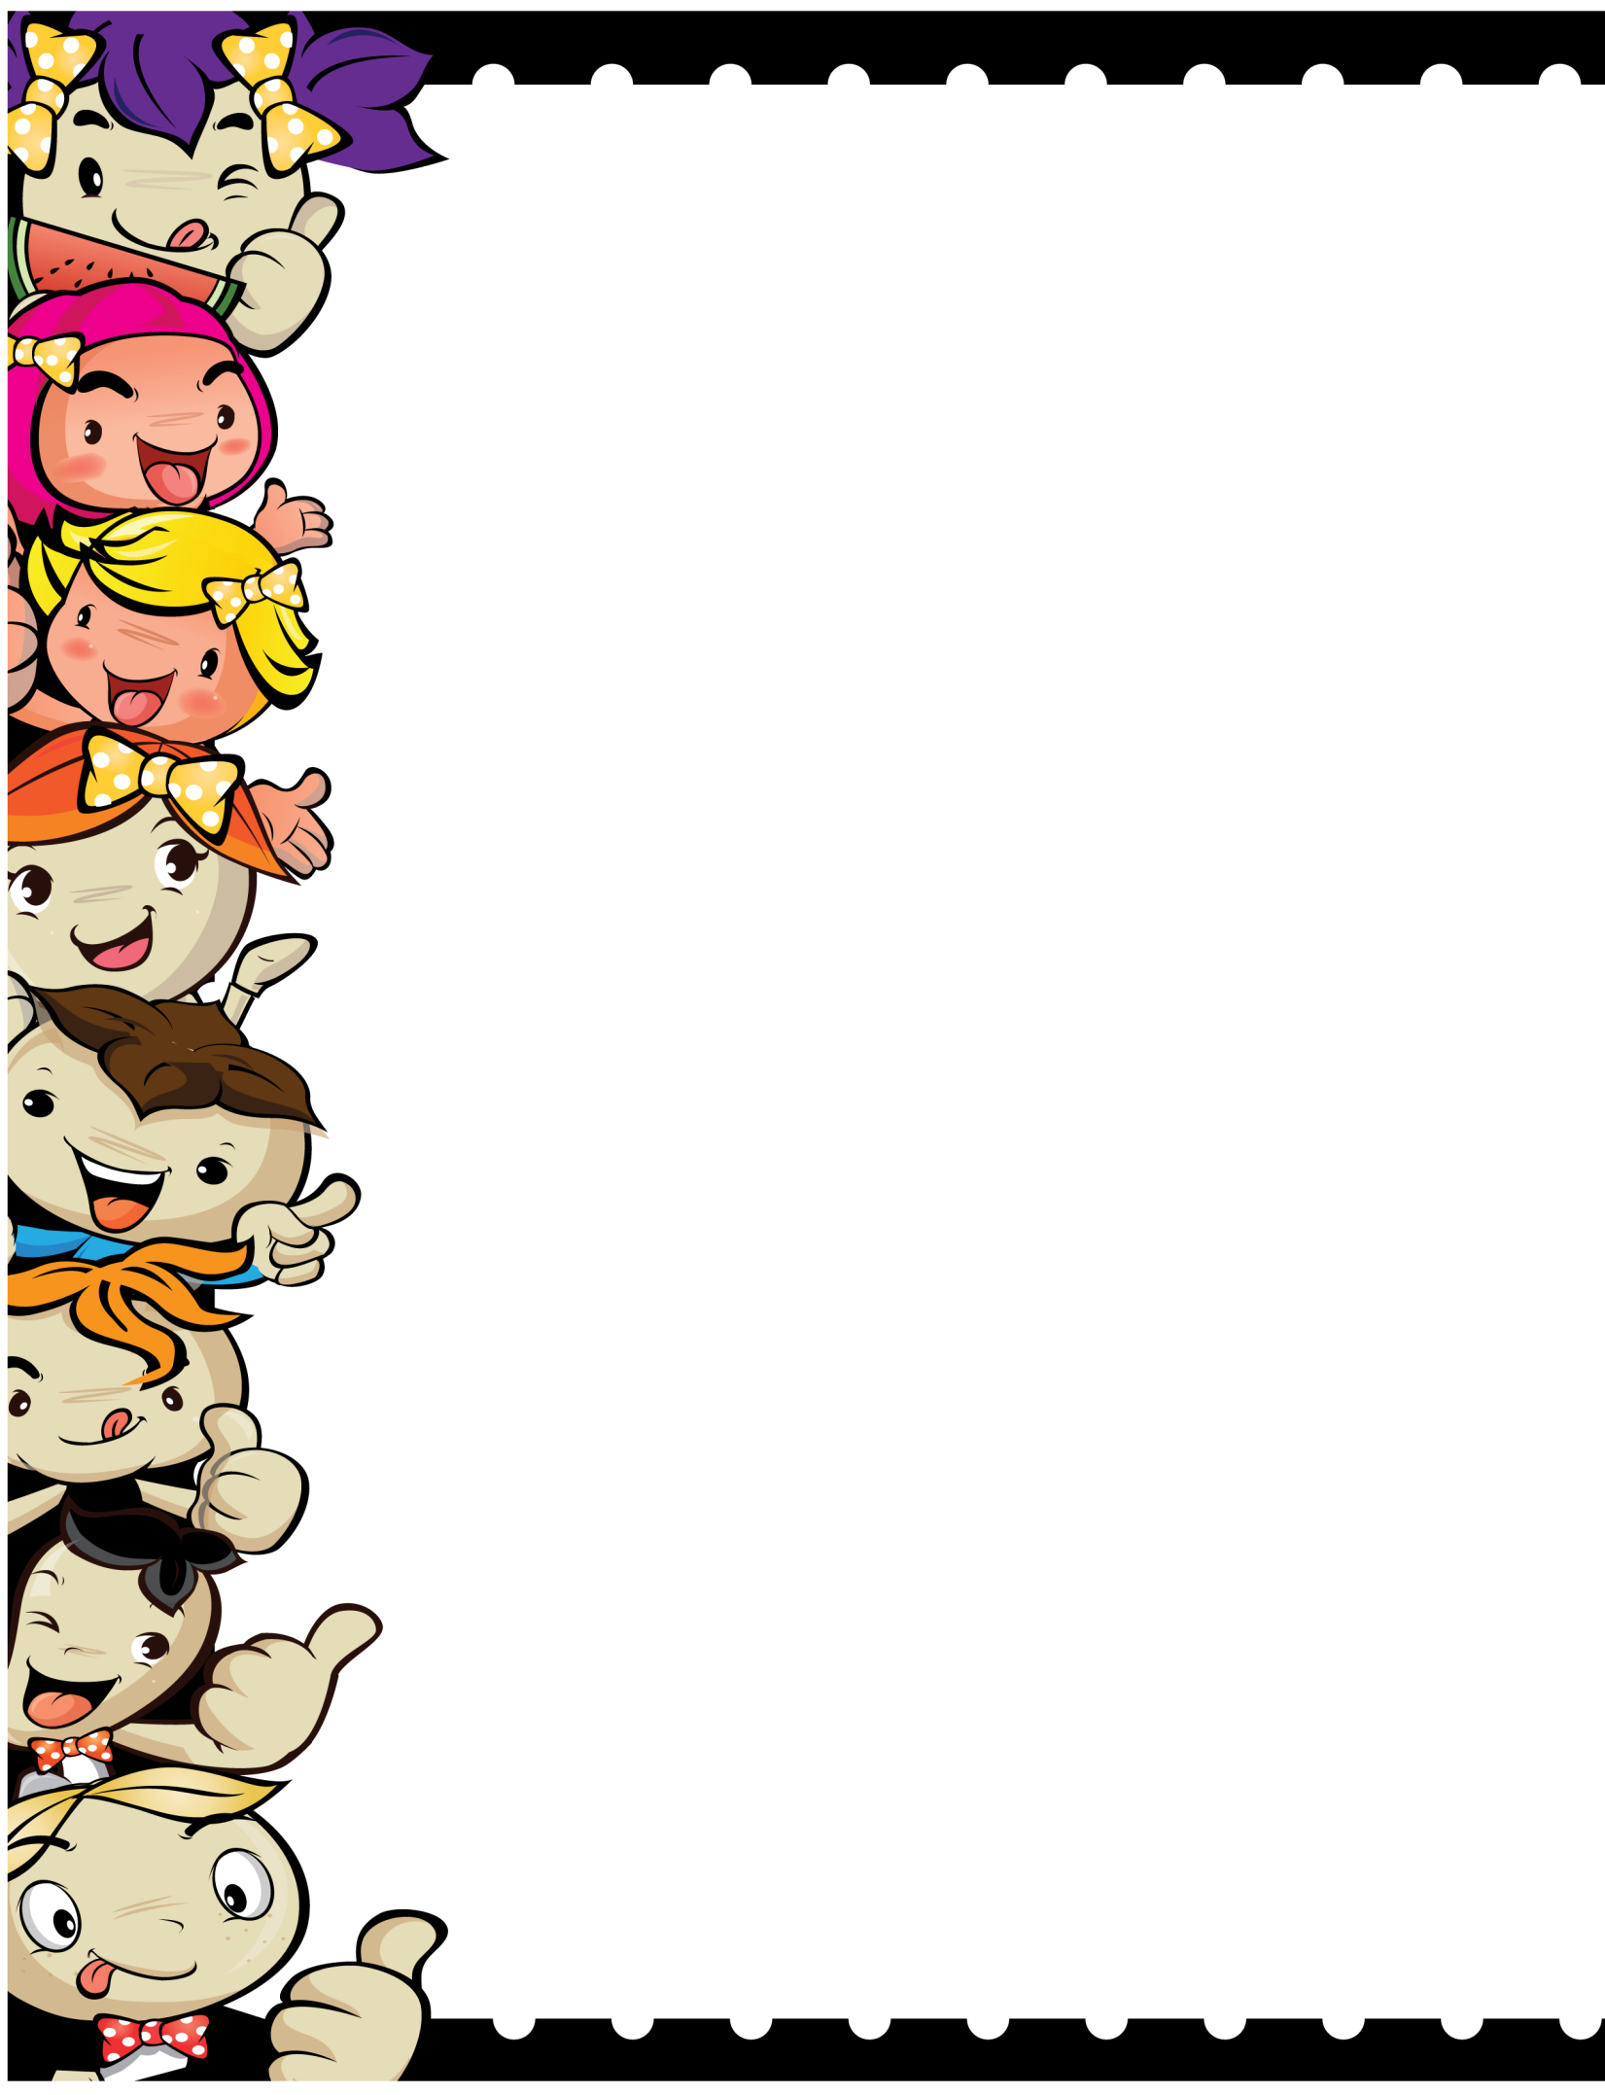

Pictures of my favorite character in the story

Book Report

The Author of the book is_____________________

The main characters of the story are __________________________________________________________________________________________

My favorite part of the story was____________________________________________________________________________________________________________________________________

What was the problem in the story? __________________________________________________________________________________________

Resolution ___________________________________________________________________________________________