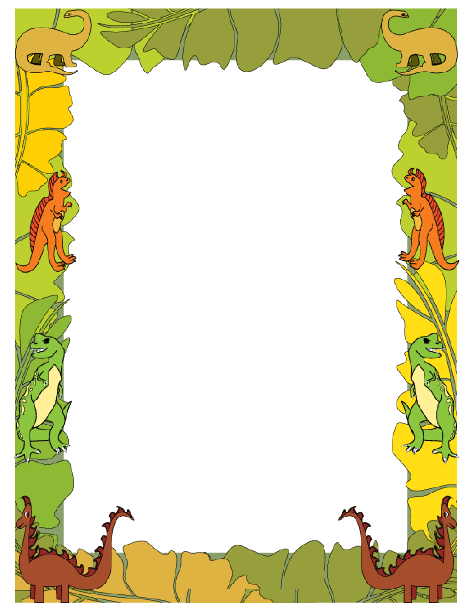

How did the story started?___________________________________________________________________________

How did the story ended?___________________________________________________________________________

Draw Setting then use details to explain

__________________________________________________________________________________________

My Book Report

