
Harvard University Direct Deposit Authorization Form

Name: __________________________ | HUID (first 8 digits on your card): __ __ __ __ __ __ __ __
SSN: __ __ __ - __ __ - __ __ __ __ | Daytime Phone or Email: ____________________________
I hereby authorize the Harvard Central Payroll Office to: | Send completed form to:
Start Direct Deposit | Harvard University Central Payroll
Start Direct Deposit | 1033 Mass. Ave., 2nd Floor
Stop All Direct Deposit | Cambridge, MA 02138
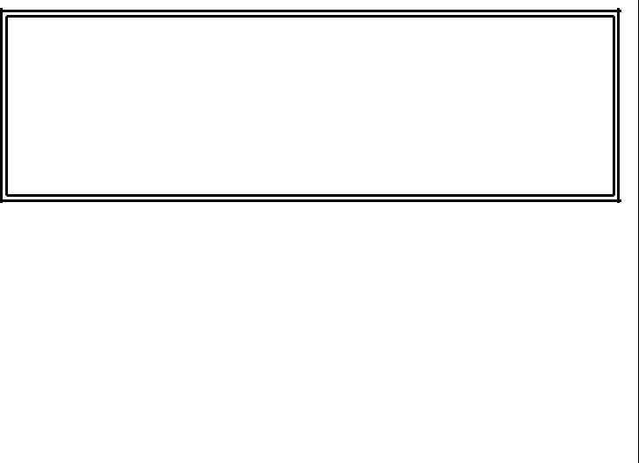
Change my Direct Deposit as follows:

Change all (a change all replaces the direct deposit authorization currently on file. Fill in every line of bank information to show how your check should now be deposited)

Add new account (existing accounts will remain unchanged)
Remove one account (other accounts will remain unchanged, but keep in mind you must have one balance account)

Note: If you are signing up for direct deposit for the first time or have elected “change all” above, you must complete line number 1 below. Line numbers 2, 3 and 4 are optional: use these lines to authorize Harvard to directly deposit fixed dollar amounts or percentages of your pay into additional accounts. Please attach a voided check for each checking account listed below.

YOU MUST HAVE ONE BALANCE ACCOUNT

1. Bank Name: | Routing #: __ __ __ __ __ __ __ __ __ | Checking | Balance Account
 | Routing #: __ __ __ __ __ __ __ __ __ | (attach voided check) | Balance Account
 | 9 digits | or
 | Account #: _______________________ | Savings
2. Bank Name: | Routing #: __ __ __ __ __ __ __ __ __ | Checking | Fixed amount: $ ___________
 | Routing #: __ __ __ __ __ __ __ __ __ | (attach voided check) | Fixed amount: $ ___________
 | 9 digits | or | or Percentage: ___________%
 | Account #: _______________________ | Savings
3. Bank Name: | Routing #: __ __ __ __ __ __ __ __ __ | Checking | Fixed amount: $ ___________
 | Routing #: __ __ __ __ __ __ __ __ __ | (attach voided check) | Fixed amount: $ ___________
 | 9 digits | or | or Percentage: ___________%
 | Account #: _______________________ | Savings
4. Bank Name: | Routing #: __ __ __ __ __ __ __ __ __ | Checking | Fixed amount: $ ___________
 | Routing #: __ __ __ __ __ __ __ __ __ | (attach voided check) | Fixed amount: $ ___________
 | 9 digits | or | or Percentage: ____________%
 | Account #: _______________________ | Savings

I acknowledge that my pay information is online, and I have received instructions on how to access this information. At this time, I choose to receive a paper copy of my pay advice but understand that I can go online at any time and choose to discontinue receiving the paper copy.

I authorize Harvard University to deposit my net pay via direct deposit to my account(s) as indicated above. If funds to which I am not entitled are deposited to my account(s), I authorize the University to direct the financial institution(s) to return said funds.

I understand that it is my responsibility to verify that payments have been credited to my account(s) and that the University assumes no liability for overdrafts for any reason. I understand that in the event that my financial institution(s) is/are not able to deposit any electronic transfer into my account due to any action I take, the University cannot issue the funds to me until the funds are returned to the University by financial institution(s).

I understand this authorization will override any previous authorization and will remain in effect until revoked by my written request. I understand that I must immediately notify the Payroll Office before I close any/all account(s) listed above while this authorization is in effect.

Employee Signature _____________________________________________________ Date ________________________

