
DIRECT DEPOSIT AUTHORIZATION FORM
For PAYROLL and/or EMPLOYEE EXPENSE REIMBURSEMENTS

Submit to: Department of Human Resources / Payroll Service Building
Email: Human.Resources@oberlin.edu
Phone: (440) 775-8430 Fax: (440) 775-8683

Name: |  |  | T Number:
Pay Schedule (select one): Monthly |  | Bi-Weekly |  | Student Bi-Weekly
 |  |  |  | New Account
 |  |  |  | Update Existing Account
 |  |  |  | Terminate Account
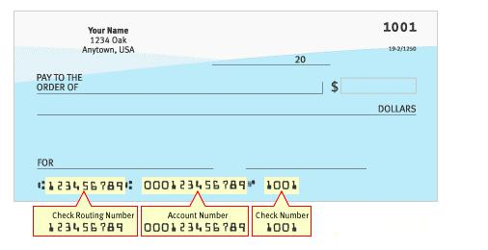

*Primary Account Required for Payroll2SWLRQDOIRU Employee Expense Reimbursements

Bank Name: | Type of Account: Checking |  | Savings
Routing No: | Account No:
Amount to be deposited into this account (select one): Entire | Pay | Flat Amount | Percentage Amount
(Optional) I authorize this account to also be Primary for Employee Expense Reimbursements: YES |  |  |  | NO

*I understand that I am responsible for maintaining accurate banking information in PRESTO Self Service and that I will continue to receive payments by Direct Deposit until I have opted out or have made a change in PRESTO selfservice-. I understand that Advance Payments from the Controller’s Office(Travel or Payroll)

will be issued in the form of a check only and will be available for pick up where indicated either in Controller’s or Human ResourcesOffice. In addition, I understand that a direct deposit notification for expense reimbursementswill be emailed to me as a courtesy prior to the effective date of the deposit. Pay stubs will continue to be available in PRESTO.

*Secondary Account # 2 – Optional partial deposit for Payroll ONLY

Bank Name: |  | Type of Account: Checking ______ Savings ______
Routing No: |  | Account No:
Amount to be deposited into this account (select one): | Entire | Pay | Flat Amount | Percentage Amount
 |  |  | *Secondary Account # 3 – Optional partial deposit for Payroll ONLY
Bank Name: |  | Type of Account: Checking |  | Savings
Routing No: |  | Account No:
Amount to be deposited into this account (select one): | Entire | Pay | Flat Amount | Percentage Amount

I hereby authorize Oberlin College and the depository financial institution named above to initial electronic deposit entries and if necessary withdrawal entries to my account(s) listed above. I acknowledge that the origination of ACH transactions to my account(s) must comply with the provision of US law.
Employee/Student Signature: |  |  |  |  | Date:
Phone Number: |  |  | E Mail Address:
Oberlin College PRESTO Website:
 |  |  | https://presto.cc.oberlin.edu/homepage.htm |  |  |  | REV: 2/2016

