Baker Robbins & Company 2003 Holiday eCard Storyboard v1.0
- Scene 01 -  Fade into view of polar bear cub seemingly trapped in a deep, narrow gully.  Corporate metaphor: an unexpected situation that needs to be readily addressed | - Scene 02 -  Cut to view of mother polar bear desperately trying to find a way to reach her cub  Corporate metaphor: the client (polar bear) takes notice of the situation and tries to immediately resolve it.
- Scene 03 -  Zoom out to view the mother polar bear still trying to save her cub.  Corporate metaphor: the client, after unsuccessfully trying to solve the problem, finds that immediate outside assistance is necessary. | 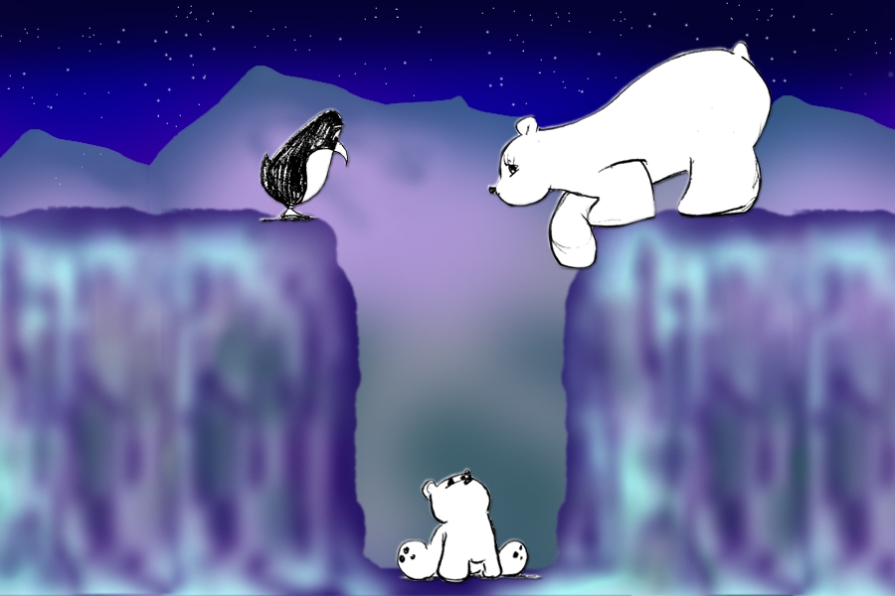  - Scene 04 -  A penguin waddles over to see why the mother polar bear is in such distress.  Corporate metaphor: BRCo (the penguin) assesses the client’s problem and makes an immediate assumption.

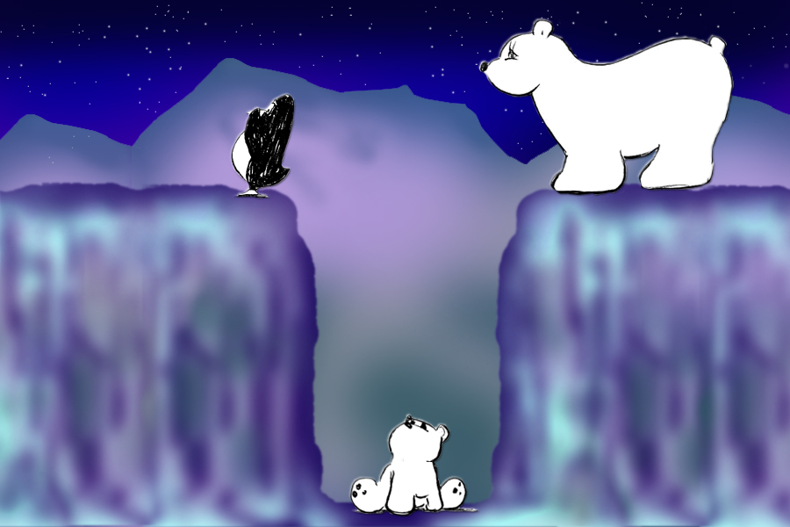  - Scene 05 -  Penguin sees that the cub is trapped in the gully and calls for some backup to assist.  Corporate metaphor: BRCo prepares a team for a client engagement. | 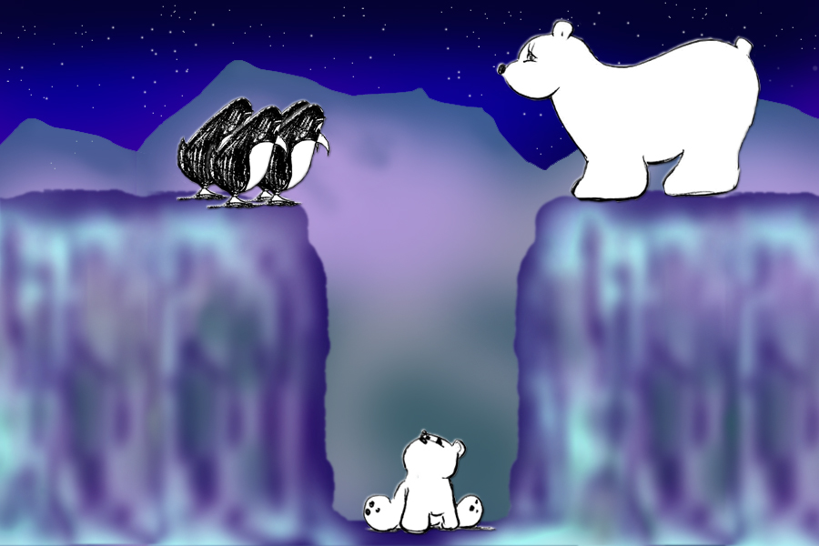  - Scene 06 -  Group of penguins converge on gully ledge to assess the problem.  Corporate metaphor: BRCo team reviews the problem and begins to plan a project methodology.
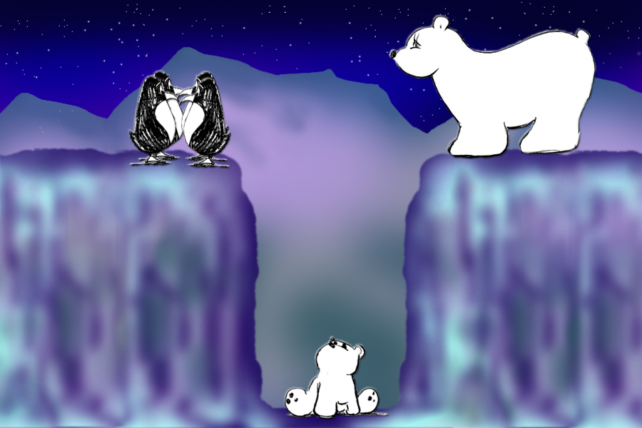  - Scene 07 -  Penguins gather for a group huddle to discuss their plan.  Corporate metaphor: BRCo team has a JAD session to figure out how to best approach the problem effectively and inexpensively. | - Scene 08 -  The mother polar bear watches on and takes notice to their idea.  Corporate metaphor: client impressed with BRCo’s quick turnaround with a project plan and immediate execution.

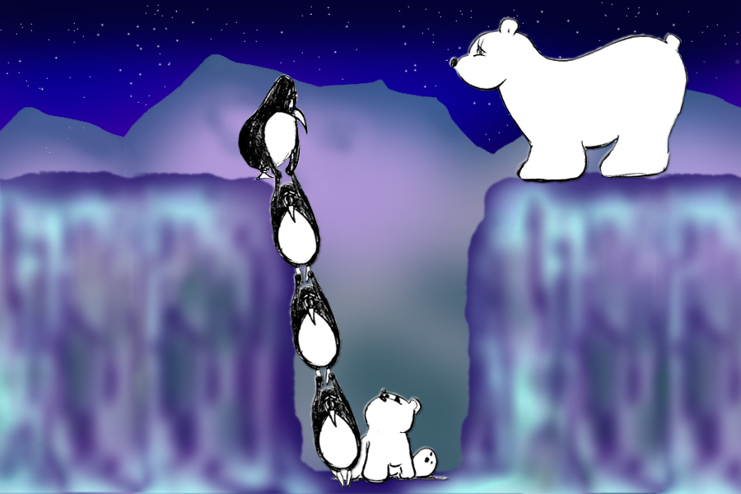  - Scene 09 -  Penguins put their plan into action…  Corporate metaphor: BRCo puts their plan into action. | 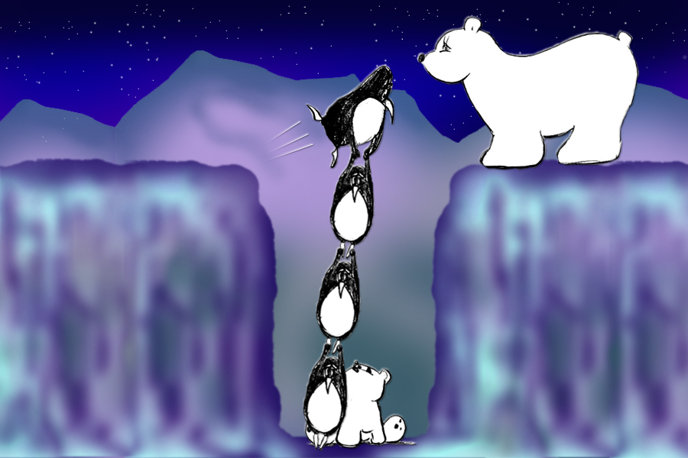  - Scene 10 -  … creating the means…  Corporate metaphor: BRCo will “travel” to great lengths to fulfill its client obligations and conscious of “risk.”
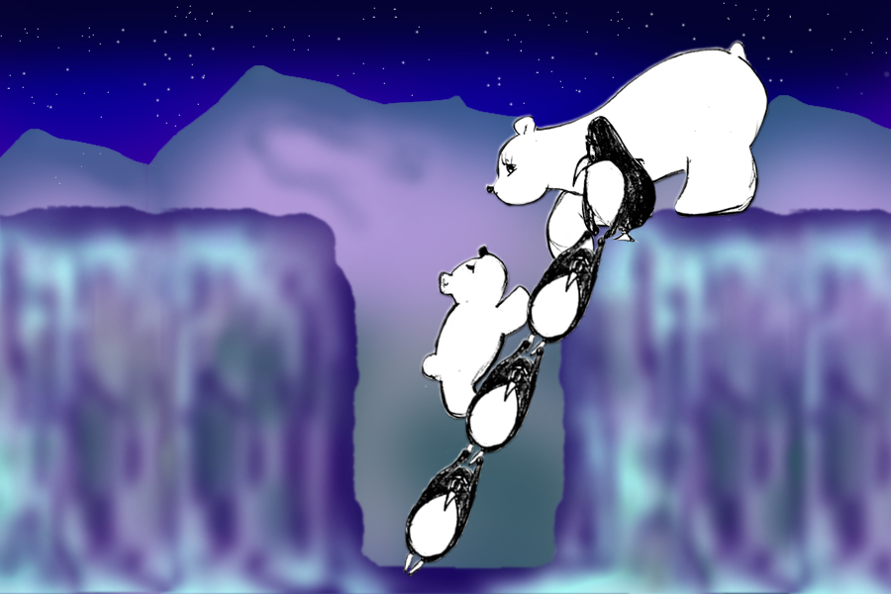  - Scene 11 -  … for the cub to climb out unharmed and into it’s mother’s waiting arms.  Corporate metaphor: Problem is readily resolved in record time and under budget. | 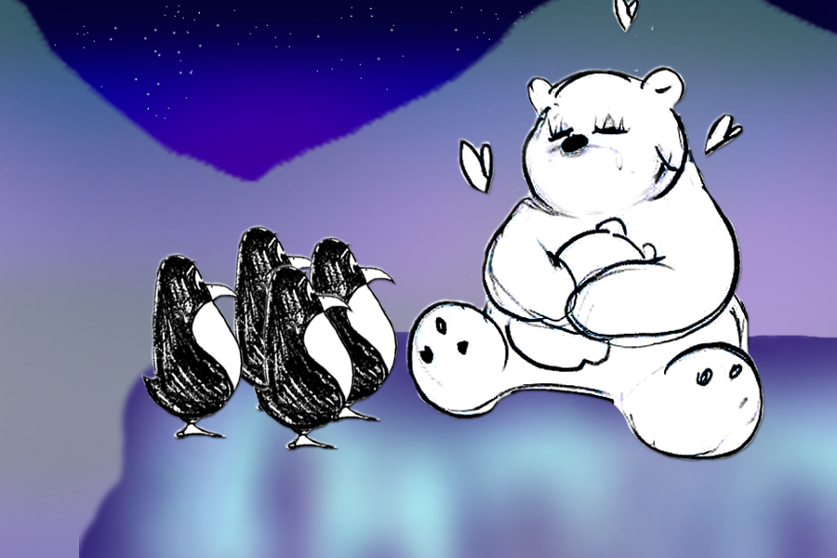  - Scene 12 -  The mother polar bear hugs her cub with a sigh of relief and happiness.  Corporate metaphor: client VERY happy with BRCo’s deliverable.

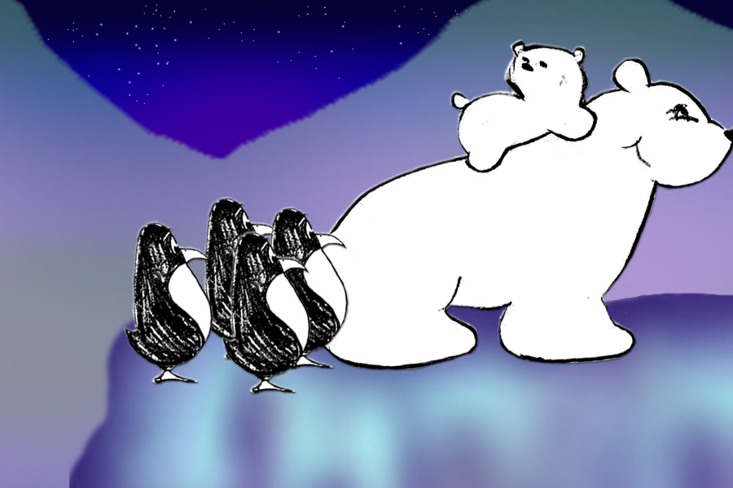  - Scene 13 -  The cub hops on it’s mother’s back, preparing to leave. But before hand…  Corporate metaphor: Post-project due diligence. | 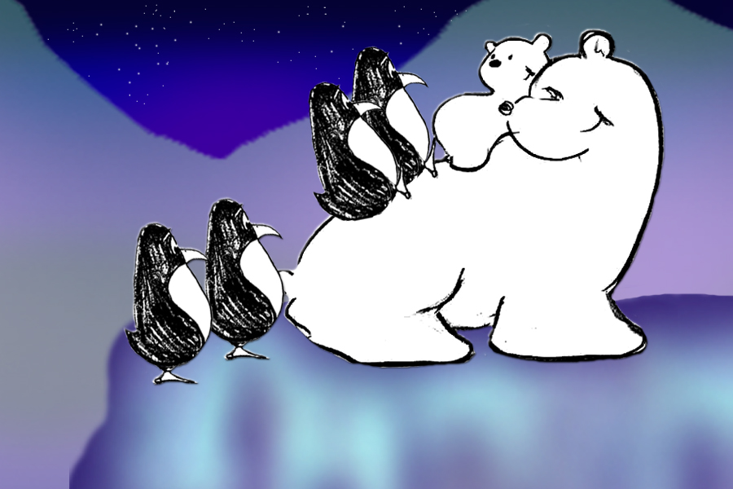  - Scene 14 -  …to express her gratitude, the mother polar bear makes a notion for them to join her. Penguins graciously accept.
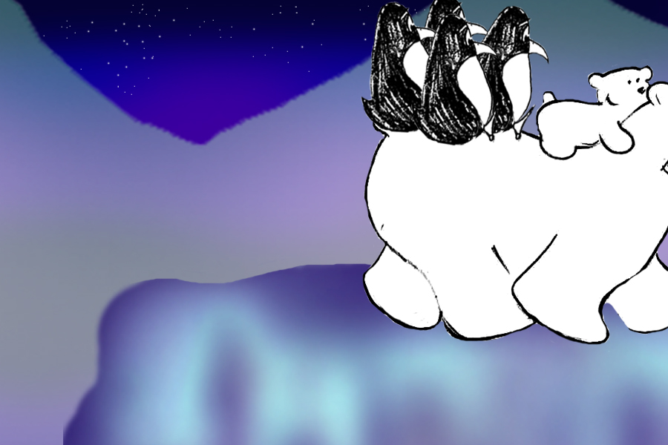  - Scene 15 -  … and off they go together… new friends.  Corporate metaphor: BRCo has made a partnership for life. | 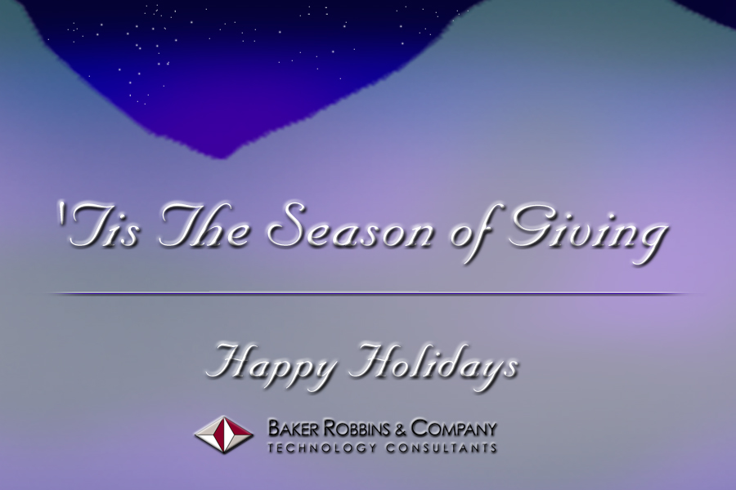  - Scene 16 -  Fade to closing message and holiday greeting.

