

<Client Name>

<Project Name>

PRJ.CH – Project Charter

edited by: | author | approved by: | reviewer
unit: | unit_name | doc ID: | doc ID:
version: | n.m | issue date: | dd/mm/yyyy | doc. model
Confidentiality notes Document is for internal project use only

SMP_RMB.PRJ.CH 2.0

PRJ.CH – Project Charter

<Client Name – Project Name>

Document status
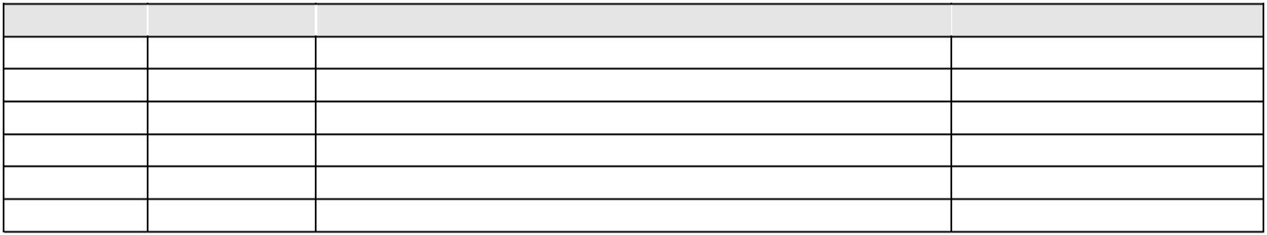
Version date summary of changes (approved by)

Summary of changes
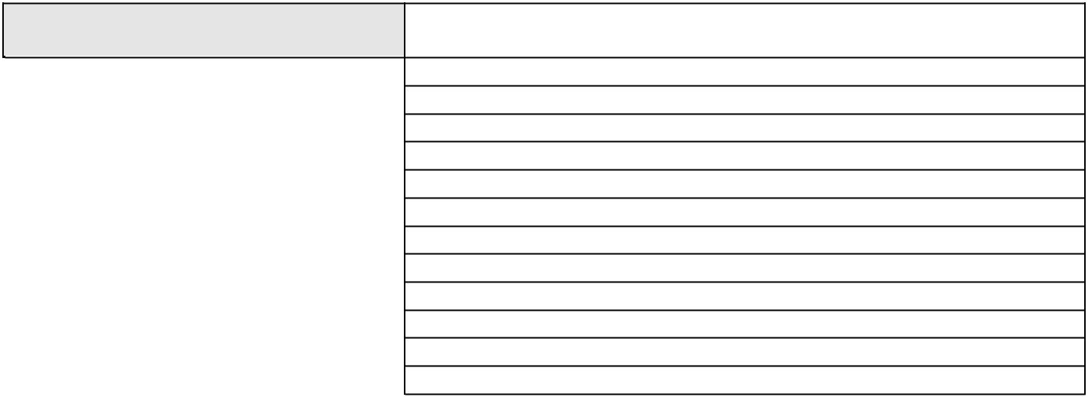
List of main changes applied to previous version:

Attachments:

edited by: |  | author |  |  | approved by: |  | reviewer | version: |  | n.m
unit: |  |  | unit_name |  | issue date: |  | dd/mm/yyyy | pp.: |  | 2/7
confidentiality notes: |  |  | document for internal project use only
SMP_RMB.PRJ.CH 2.0

PRJ.CH – Project Charter

<Client Name – Project Name>

 |  |  | Contents
1 | INTRODUCTION ......................................................................................................... |  |  | 4
 | 1.1 | AIM ................................................................................................................... |  | 4
 | 1.2 | REFERENCES ...................................................................................................... |  | 4
 | 1.3 | CLIENT CONTACT DETAILS ................................................................................... |  | 4
 | 1.4 | DEFINITIONS ..................................................................................................... |  | 4
 | 1.4.1 |  | GLOSSARY .................................................................................................... | 4
 | 1.4.2 |  | ACRONYMS/ ABBREVIATIONS ............................................................................ | 5
2 | 1.5 | ^{DOCUMENT}....................................................................................................................STRUCTURE...................................................................................... |  | 5
2 | Charter |  |  | 6
 | 2.1 | DESCRIPTION ........................................................................................................ |  | 6
 | 2.2 | BUSINESS JUSTIFICATION .......................................................................................... |  | 6
 | 2.3 | PROJECT REQUIREMENTS ........................................................................................... |  | 6
 | 2.4 | ESTIMATED LEVEL OF EFFORT AND SCHEDULE ................................................................... |  | 6
 | 2.5 | RISKS, ASSUMPTIONS AND CONSTRAINTS ....................................................................... |  | 6
3 | 2.6 | KEY ROLES............................................................................................................................................................................................................................ |  | 6
3 | Signatures |  |  | 7

edited by: |  | author |  |  | approved by: |  | reviewer | version: |  | n.m
unit: |  |  | unit_name |  | issue date: |  | dd/mm/yyyy | pp.: |  | 3/7
confidentiality notes: |  |  | document for internal project use only
SMP_RMB.PRJ.CH 2.0

PRJ.CH – Project Charter

<Client Name – Project Name>

1 INTRODUCTION

- AIM

The aim of this document is to provide a statement of the scope, objectives and participants in the project. It provides a preliminary delineation of roles and responsibilities, outlines the project objectives, identifies the main stakeholders, and defines the authority of the project manager. It serves as a reference of authority for the future of the project. The terms of reference is usually part of the project charter.

- REFERENCES

List supporting documentation with appropriate references:

Example:

- [DOC 1]
o “Financial Products” – Excel Document
o Version 1.0 of 22/11/2007

Supporting evidence must also include the minutes of key meetings where necessary.

- CLIENT CONTACT DETAILS

Client contact details for the Project Charter are listed below.

List the contact persons chosen by the Client for these activities, such as:

- Name, Surname and any other useful details

- Role/company position

- Department
- Role and responsibilities

Example:

- Name: Paolo Rossi – Paolo.Rossi@Cliente.it, Tel 011.12312311

- Company role: Marketing manager
- Department Marketing

- Role in project/activity: Functional Requirements Manager

- DEFINITIONS

- GLOSSARY

List any technical words used in the document, with the relevant definition

Example:

edited by: |  | author |  |  | approved by: |  | reviewer | version: |  | n.m
unit: |  |  | unit_name |  | issue date: |  | dd/mm/yyyy | pp.: |  | 4/7
confidentiality notes: |  |  | document for internal project use only
SMP_RMB.PRJ.CH 2.0
PRJ.CH – Project Charter

<Client Name – Project Name>

Record | A record is a contract which has not yet come into force
Funding | Funding refers to…
.. | ..

- ACRONYMS/ ABBREVIATIONS

List acronyms and abbreviations used in the document, with the relevant definition
BAM | Business Activity Monitoring
BPM | Business process management
BPM | Business Process
BRL | Business Rule
EAI | Enterprise Application Integration
EPC | Event Process Chain
KPI | Key Performance Indicator
… | …

- DOCUMENT STRUCTURE

This document is divided into the following sections:

- INTRODUCTION
This section describes the aims, main references and document structure.

- CHARTER
This section contains the core contents of the charter.

edited by: |  | author |  |  | approved by: |  | reviewer | version: |  | n.m
unit: |  |  | unit_name |  | issue date: |  | dd/mm/yyyy | pp.: |  | 5/7
confidentiality notes: |  |  | document for internal project use only
SMP_RMB.PRJ.CH 2.0

PRJ.CH – Project Charter

<Client Name – Project Name>

2 CHARTER

This section contains description, business justification, project requirements, estimated level of effort and schedule, risks, assumptions, constraints and key roles.

- Description

Identify the name of the project and a simple project description.

- Business Justification

Specify why this project is strategic and indicate some sort of metrics by which the sponsor will be able to determine if the project lived up to its expected potential.

- Project Requirements

This can also include the objectives and most importantly, the project’s vision statement— should be a motivator to the team. Summarize the basic requirements.

Feature |  | MH | Description
1 |  | Y | Feature 1 Description
2 |  | N | Feature 2 Description
… |  | … | …
… |  | … | …
… |  | … | …
Legend: In the Must Have (MH) column, type a “Y” if the feature is absolutely required

- Estimated Level of Effort and Schedule

Give a summary of the overall headcount requirements and a rough schedule range. Both need to fit into the overall goals of the project since cost and timing are critical as to whether the project or project phase will be approved.
- Headcount: XX people (by job function)

- Rough schedule range: Delivery in the Q4 timeframe

- Risks, Assumptions and Constraints

It is an understanding of internal and especially external risks, assumption and/or constraints. There can be a time to market assumption, or a budgetary constraint, and so on.

It’s a preliminary analysis, you don’t need to be exhaustive.

- Key Roles

Indicate who the project manager is, where the resources are going to come from, and who will have the overall authority to make decisions – use RACI, if applicable.

edited by: |  | author |  |  | approved by: |  | reviewer | version: |  | n.m
unit: |  |  | unit_name |  | issue date: |  | dd/mm/yyyy | pp.: |  | 6/7
confidentiality notes: |  |  | document for internal project use only
SMP_RMB.PRJ.CH 2.0
PRJ.CH – Project Charter

<Client Name – Project Name>

3 SIGNATURES
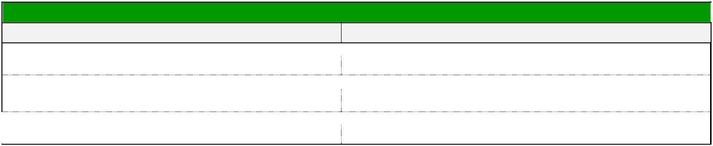

PM

Your name

Your Title

Date Submitted

Sponsor

Sponsor’s name

Sponsor’s Title

Date Accepted
Acceptance

edited by: |  | author |  |  | approved by: |  | reviewer | version: |  | n.m
unit: |  |  | unit_name |  | issue date: |  | dd/mm/yyyy | pp.: |  | 7/7
confidentiality notes: |  |  | document for internal project use only
SMP_RMB.PRJ.CH 2.0

