 |  |  |  | C.J. Rylands
 |  |  | (Mem-Card) | 7 The Precinct
 |  |  | (Mem-Card) | Telephone: 0161 476 2244
 |  |  |  | Castle Street, Edgeley,
 |  |  |  | Stockport, Cheshire
 | Est. 1986 |  |  | SK3 9AJ
 |  |  |  | Fax: 0161 474 1006
 |  |  |  | Email: c.j.rylands@btconnect.com
 |  |  |  | Website: www.cjrylands.co.uk

Order of Service Brochure

Standard & Premium

Standard Order of Service – Front Cover Samples


A Service of Celebration for the Life
– of –

ELEANOR SMITH

Who died on

August 12th, 2011

Service held at
St. John’s Church, Stockport
on

August 23rd, 2011
at 2.00 p.m.
followed by cremation at
Stockport Crematorium

Design 1: ‘Black Cross’


Funeral Service for the late

EUGENE MASON

Who passed away peacefully

on February 1st, 2007

Service held at

St. Augustine’s Church, Croydon

on

February 14th, 2007

at 3.30 p.m.

followed by cremation at
Croydon Crematorium
Design 3: ‘Standard & Photograph’

Funeral Service for the late

SAMUEL JOHNSTON

Who died on

January 10th, 2011

Service held at
St. John’s Church, Stockport
on

Wednesday, January 19th, 2011
at 2.00 p.m.
followed by cremation at

Stockport Crematorium.

Design 2: ‘Cross & Lilies’


- Service of Thanksgiving for the Life

– of –

Barbara Fletcher

Who passed away on

February 12th, 2001

Aged 87 years

Carmountside Crematorium

February 20th, 2001
1.00 p.m.
Design 4: ‘Edwardian Script’

Standard Order of Service – Front Cover Samples
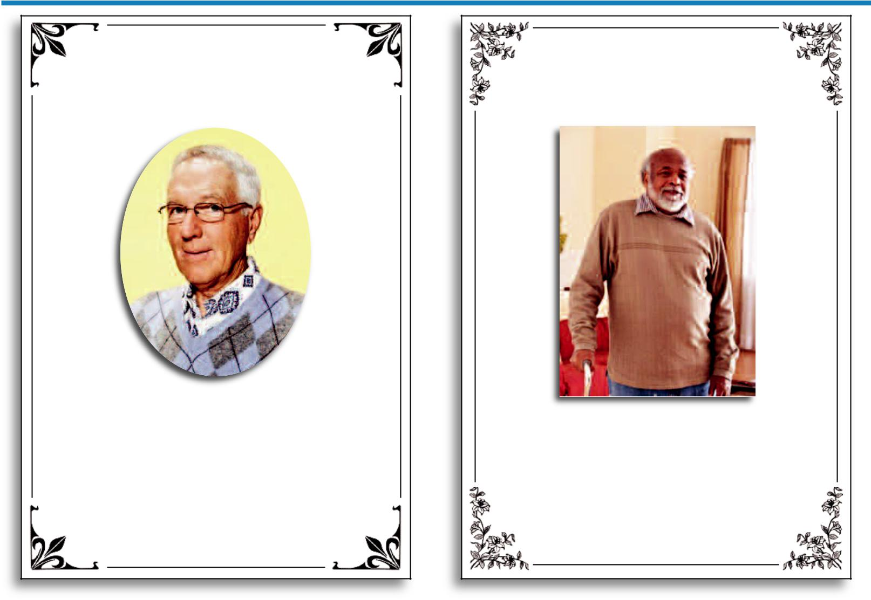

Thanksgiving Service for the Life

– of –

JACK HUGHES

Service to be held at

Manchester Crematorium Chapel,

Barlow Moor Road, Chorlton

on

Friday, 11th November, 2011

at 10.00 a.m.

Officiating Minister:

Revd. A.N. Other

Design 5: ‘Ornate Border’
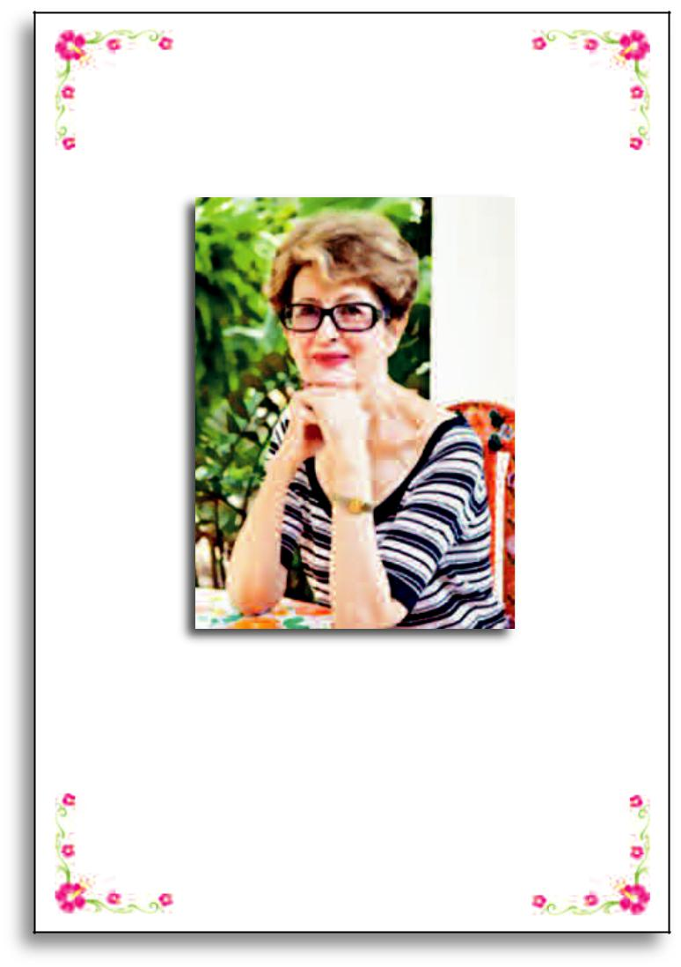

Funeral Service to Celebrate the Life – of –
JULIETTE NOBLE

Service to be held at

Southport Crematorium

on

Friday, 9th December, 2011 at 4.20 p.m.

Officiating – Humanist Minister

Matthew Richardson

Design 7: ‘Floral Border’

Requiem Mass to Celebrate the Life

– of –

EZEKIEL WALKER

Held at

Our Lady’s Catholic Church

Regent Road, Newcastle

on

14th April, 2008

at 3.20 p.m.

followed by interment at

Newcastle Cemetery

Design 6: ‘Flower Border’


In Loving Memory

– of –

AKIRA SASAKI

1st March, 1981 – 20th November, 2009

Service held at

St. Christopher’s Church, Dewsbury

on

Friday, 27th November, 2009

at 9.30 a.m.

Officiating Minister:

Father Michael Grimshaw

Design 8: ‘Traditional Border’

Standard Order of Service – Front Cover Samples
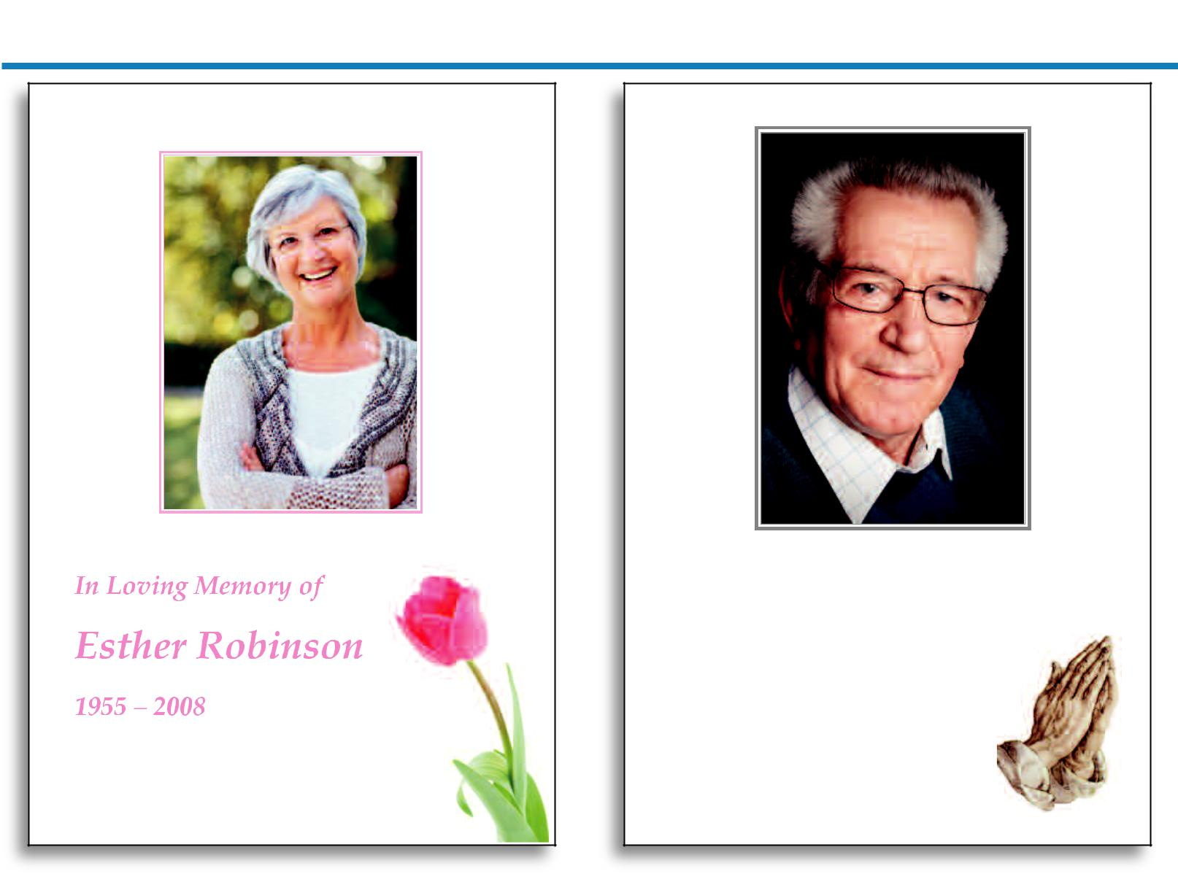

Design 9: ‘Pink Tulip’


Treasured Memories of

Edward Smith

1940 – 2010

Design 10: ‘Praying Hands’


In Celebration of the Life
Funeral Service for the late Phyllis–Matthews^{of–}
Samuel Johnston
ERNEST SAMUELS

10th January, 1920 – 23rd November, 2011
1942 – 2007

Service held at
St. Patrick’s Church, Kirkby
on |  |  |  | Stockport Crematorium
Thursday, September 6th, 2007 |  |  |  | Stockport Crematorium
Thursday, September 6th, 2007 |  |  |  | Wednesday, 30th November, 2011
at 2.15 p.m. |  |  |  | 10.00 a.m.
followed by cremation at
Kirkby Crematorium.
Design 11: ‘Celtic Cross’ |  |  | Design 12: ‘Arum Lily’

Standard Order of Service – Front Cover Samples


A Celebration of the Life

– of –

Lily Wilkinson

Who passed away peacefully

on March 14th, 2011

Carmountside Crematorium

March 29th, 2011

10.00 a.m.

Design 13: ‘Freesias’


Funeral Service for the late

DAVID WORRALL

(Dave)

Who died on

September 4th, 2011

Service held at

Crewe Crematorium

on

September 18th, 2011

at 1.30 p.m.

Design 15: ‘Snowdrops’

Requiem Mass

– for –

Reverend Father
THOMAS FINNIGAN

Peacefully at Rest

1stPeacefullyOctober,at2006Rest

28th October, 2006

St. John’s R.C. Church

Shaftesbury Road, Stockport

on

Friday, 10th October, 2006

at 9.00 a.m.

followed by interment at
Mill Lane Cemetery, Cheadle.
Design 14: ‘Candle & Bible’


A Service to Celebrate the Life
– of –

Sally Hardy

1918 – 2002

Oldham Crematorium

August 12th, 2002

Officiating: Mr. S. Hardy

Design 16: ‘Poppies’

Standard Order of Service – Front Cover Samples


Requiem Mass to Celebrate the Life
– of –

PATRICK TIERNEY

(Paddy)

Who entered into Eternal Rest
Aged 62 years

St. Bernadette’s Catholic Church
West Riding, Yorkshire

on
December 20th, 2011

Design 17: ‘The Sacred Heart’


Thanksgiving Service for the Life

– of –

RACHAEL JACKSON

Service to be held at

Altrincham Crematorium Chapel

on

Friday, 11th November, 2011

at 4.30 p.m.

Officiating Minister:

Reverend Tim Clarke

Design 19: Lilies’‘

Requiem Mass to be Offered

– for –

Bernadette Connolly

1930 – 2008

Mass Celebrated at

St. Patrick’s R.C. Church, Co. Kilkenny

Celebrant: Father Seamus Kiernan
Design 18: ‘Our Lady’


In Loving Memory
– of –

BERT ANDERSON

‘Gone Fishing’

10th November, 2010

Service held at

Beckington Crematorium
on
25th November, 2010

at 11.15 p.m.

Design 20: ‘Gone Fishing’

Standard Order of Service – Front Cover Samples


A Celebration of the Life

– of –

Carl Wilson

1st February, 1984 – 12th October, 2010

Held at

Charnock Richard Crematorium

on

30th October, 2010

at 12.00 Noon

Officiating: Rev. A. Gainsborough

Design 21: ‘Football Fan’


Funeral Service to Celebrate the Life
– of –

Amy Williamson

 | 1910 – 2010
Held at | H d |  | at
Southern Cemetery Chapel
Southern Cemetery Chapel
on |  | on
September 4th, 2010
September 4th, 2010
at 1.30 p.m. | at 1.30 p.m.

Design 23: ‘Carnations’

Funeral Service for the late

Philip Brooks
1988 – 2012

1988 – 2011

Southport Crematorium

January 10th, 2012

10.00 a.m.

Design 22: ‘Motorcycle’


In Loving Memory
– of –

ROSE GALLAGHER

Passed away peacefully
January 14th, 2009

Requiem Mass at

St. Kentigern’s R.C. Church
on
January 25th, 2009

at 9.30 a.m.

Design 24: ‘Red Rose Bouquet’

Standard Order of Service – Front Cover Samples
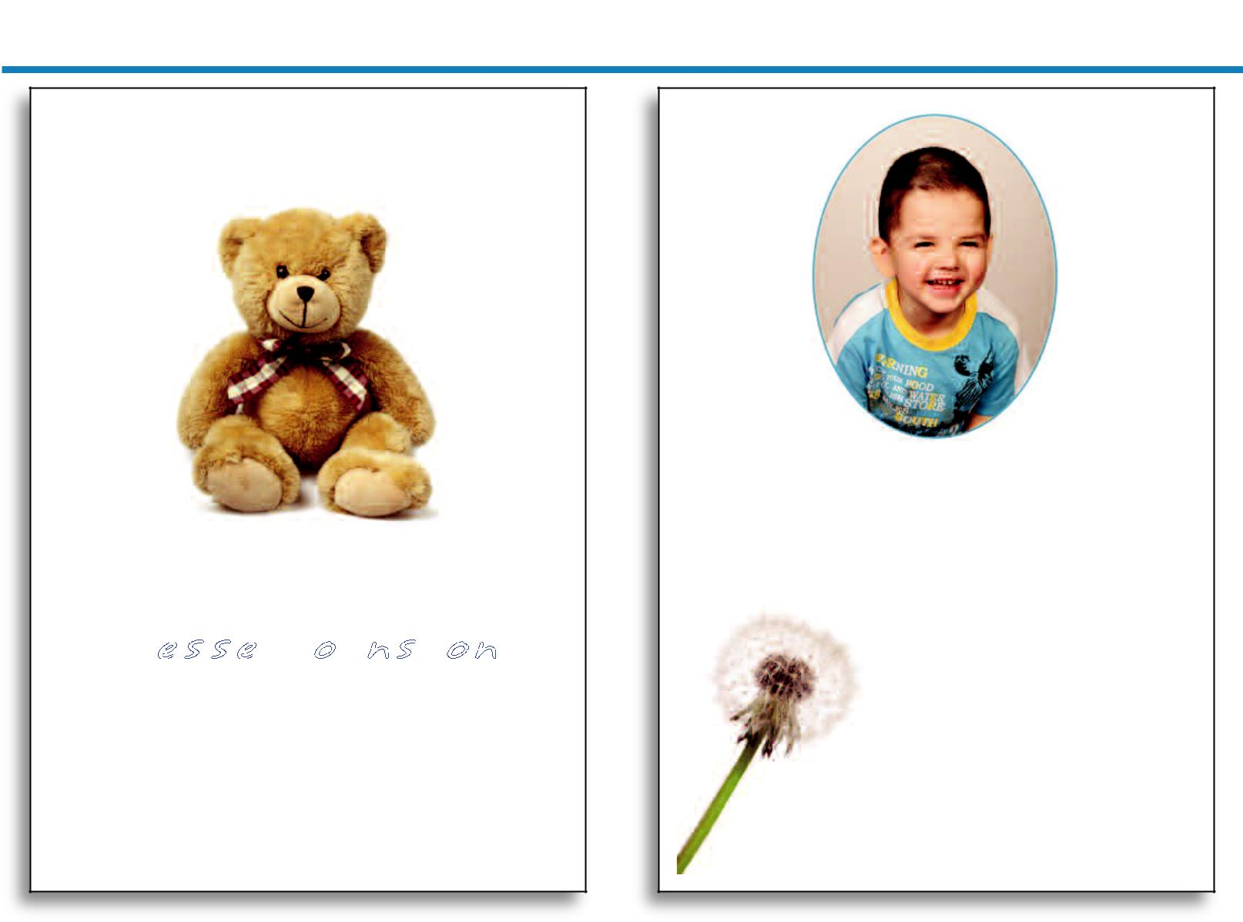

Treasuredd Forever

in our Memories

Our Beautifull Baby

Jesse Johnston

Fell Asleep Peacefully

1stt February, 2011

Stockport Crematorium, Cypress Chapel
Tuesday, 8th February, 2011

Design 25: ‘Teddy Bear’


!"#$%$#&'(&")#&*$+#,-

!"#$$%&'()*&(

10th March, 2004 – 21st July, 2010

Service held at

St. Teresa’s Church, Cornwall

on

5th August, 2010

at 1.30 p.m.

Design 26: ‘Dandelion Clock’


Treasured Memories

– of –

Chloe Jacques

16th May, 2005 – 1st September, 2011

Service at
Runcorn Crematorium
on
20th September, 2011
at 10.45 a.m.

Design 27: ‘Rainbow’

!"#$%&'()%*"+,%&

- ".(-

Molly Sandford
With the Angels

June 4th, 2011

/%+0,1%(2%3$(4'

50%+$43%(6+%*4'"+,7*

"#

87#%(9:'2;(9<==

4'(==><<(4>*>

Design 28: ‘Butterfly’

Standard Order of Service – Inside Page Samples


Order of Service

Entrance Music: “Yantra” – Vanessa-Mae

Welcome & Introduction:

by Rev. Paul Sykes

Hymn: How Great Thou Art

Eulogy

Reading: Ecclesiastes 3: 1 – 14

Hymn: The Lord’s My Shepherd

Commendation & Committal

Exit Music: “Time To Say Goodbye”

– Andrea Bocelli & Sarah Brightman

Inside Page Sample


Poem: Footprints

One night a man had a dream. He dreamed he was

walking along the beach with the LORD.

Across the sky flashed scenes from his life.

For each scene, he noticed two sets of footprints in the sand; one belonging to him, and the other to the LORD.

When the last scene from his life flashed before him,

he looked back at the footprints in the sand. He noticed that many times along the path of his life there was only one set of footprints.

He also noticed that it happened at the very

lowest and saddest times in his life.

This really bothered him and he questioned the LORD about it,

"Lord, you said that once I decided to follow you, you'd walk with me all the way. But I have noticed that during the most troublesome times in my life, there is only one set of footprints. I don't understand why when I needed you most you would leave me."

The LORD replied, "My precious, precious child.

I love you and I would never leave you.

During your times of trial and suffering,

when you see only one set of footprints,

it was then that I carried you."

Reading: John 6: 35 – 40

Address
Inside Page Sample

Order of Service

Entrance Music:

‘Truly, Madly, Deeply’ – Savage Garden

Introduction & Prayer

Hymn: The Lord’s My Shepherd

The Lord's my Shepherd; I'll not want;

He makes me down to lie

In pastures green; He leadeth me

The quiet waters by.

My soul He doth restore again,

And me to walk doth make

Within the paths of righteousness,

E'en for His own name's sake.

Yea, though I walk in death's dark vale,

Yet will I fear no ill;

For Thou art with me, and Thy rod

And staff me comfort still.

My table Thou hast furnished

In presence of my foes;

My head Thou dost with oil anoint,

And my cup overflows.

Goodness and mercy all my life

Shall surely follow me,

And in God's house for evermore
My dwelling-place shall be.
Inside Page Sample


Closing Hymn

Walk with me, O’ my Lord,

Through the darkest night and brightest day.

Be at my side, O’ Lord,

Hold my hand and guide me on my way.

- Sometimes the road seems long, My energy is spent.
Then, Lord, I think of you
And I am given strength.

  - Stones often bar my path, And there are times I fall, But you are always there To help me when I call.

- Just as you calmed the wind And walked upon the sea, Conquer, my living Lord
The storms that threaten me.

  - Help me to pierce the mists That cloud my heart and mind,
So that I shall not fear
The steepest mountain-side.

- As once you healed the lame And gave sight to the blind,
Help me when I'm downcast
To hold my head up high.

Recessional

Inside Page Sample

Standard Order of Service – Back Cover Samples


Eric’s Family wish to sincerely thank all
Relatives and Friends for their kind
expressions of sympathy received
in their sad bereavement.

You are all warmly invited to join
the Family for refreshments at
Heaton Moor Golf Club
following the Service and Committal.

Funeral arrangements by:
A.N. Other Funeral Directors
Funeral_{7The}arran_{Precinct}gements by:
C. Mid_{Castle}dleon_{Street}&Son Ltd.
³⁵⁴ ^{P} E^{rrs}_{dgeley}^{wood Road}
Man_{SK3}ch_{9AJ}ester
Tel: ^{M2}0161⁰ 476^{6JD}2244
016 43 3725
Printed by C. J. Rylands, Stoc_{Back}kport© _{Cover Sample}


Barbara’s Family would like to thank
everybody for attending this
Celebration of her Life.

You are welcome to join them at the

Stalybridge Labor Club for refreshments
following the service and burial.

Printed by C. J. Rylands, StockpBackort© Cover Sample

Samuel’s Family wish to sincerely thank all Relatives and Friends for their kind expressions of sympathy received in their sad bereavement.

Donations, if desired, to:
Cancer Research U.K.

Funeral arrangements by:
A.N.FuneralOtherarrFuneral Directorstsb

Ben Lloyd7TheFunPrecinctralServices

51 Station Road
CheaCastleEdgeleyleStreetHulme
_{Tel:} SK^{Cheshire}39AJ

01618 7476A2244

0161 485 3135

Printed by C. J. Rylands, StockportBack© Cover Sample


David, Paul and Families would like to thank you for your attendance here today and for the kind messages of sympathy they have received during their recent sad loss.

You are warmly invited to join the Family for refreshments and to share your memories of Sandra after the Service at

The Hinds Head, Heaton Chapel.

Printed by C. J. Rylands, StockpoBackrt© Cover Sample

Premium Order of Service Samples – Front & Back Covers


A Celebration of the Life

– of –

David, Heather and Families would like to thank you for your attendance here today and for the kind messages of sympathy they have received during their recent sad loss.

You are warmly invited to join the Family for

refreshments and to share your memories

of Samuel after the Service at

The Hinds Head, Heaton Chapel.

Funeral arrangements by:

A.N. Other Funeral Directors

7 The Precinct

Castle Street

Edgeley

SK3 9AJ

Tel: 0161 476 2244

SAMUEL JOHNSTON

(Sam)

21st January, 1930 – 10th November, 2011

Held at

St. Matthew’s Church, Stockport

on

Friday, 18th November, 2011

at 1.00 p.m.

followed by committal at

Stockport Crematorium

at 1.45 p.m.

Printed by C. J. Rylands, Stockport ©

Design 29: ‘Forest Lagoon’


In Loving Memory

– of –

Bert’s Family would like to thank you for

your attendance here today and for the kind

messages of sympathy they have received

during their recent sad loss.

You are warmly invited to join the Family for

refreshments and to share your memories

of Bert after the Service at

The Conservative Club, Fisher Lane.

BERT SINGLETON

Funeral arrangements by:

A.N. Other Funeral Directors

7 The Precinct

Castle Street

Edgeley

SK3 9AJ

Tel: 0161 476 2244

“Gone Fishing”

12th August, 2010

Service held at

St. Bede’s Church, Stockport

on

30th August, 2010

at 1.30 p.m.

Officiating: Father Tom Parker

Printed by C. J. Rylands, Stockport ©

Design 30: ‘Yachtsman’s Horizon’

Premium Order of Service Samples – Front & Back Covers
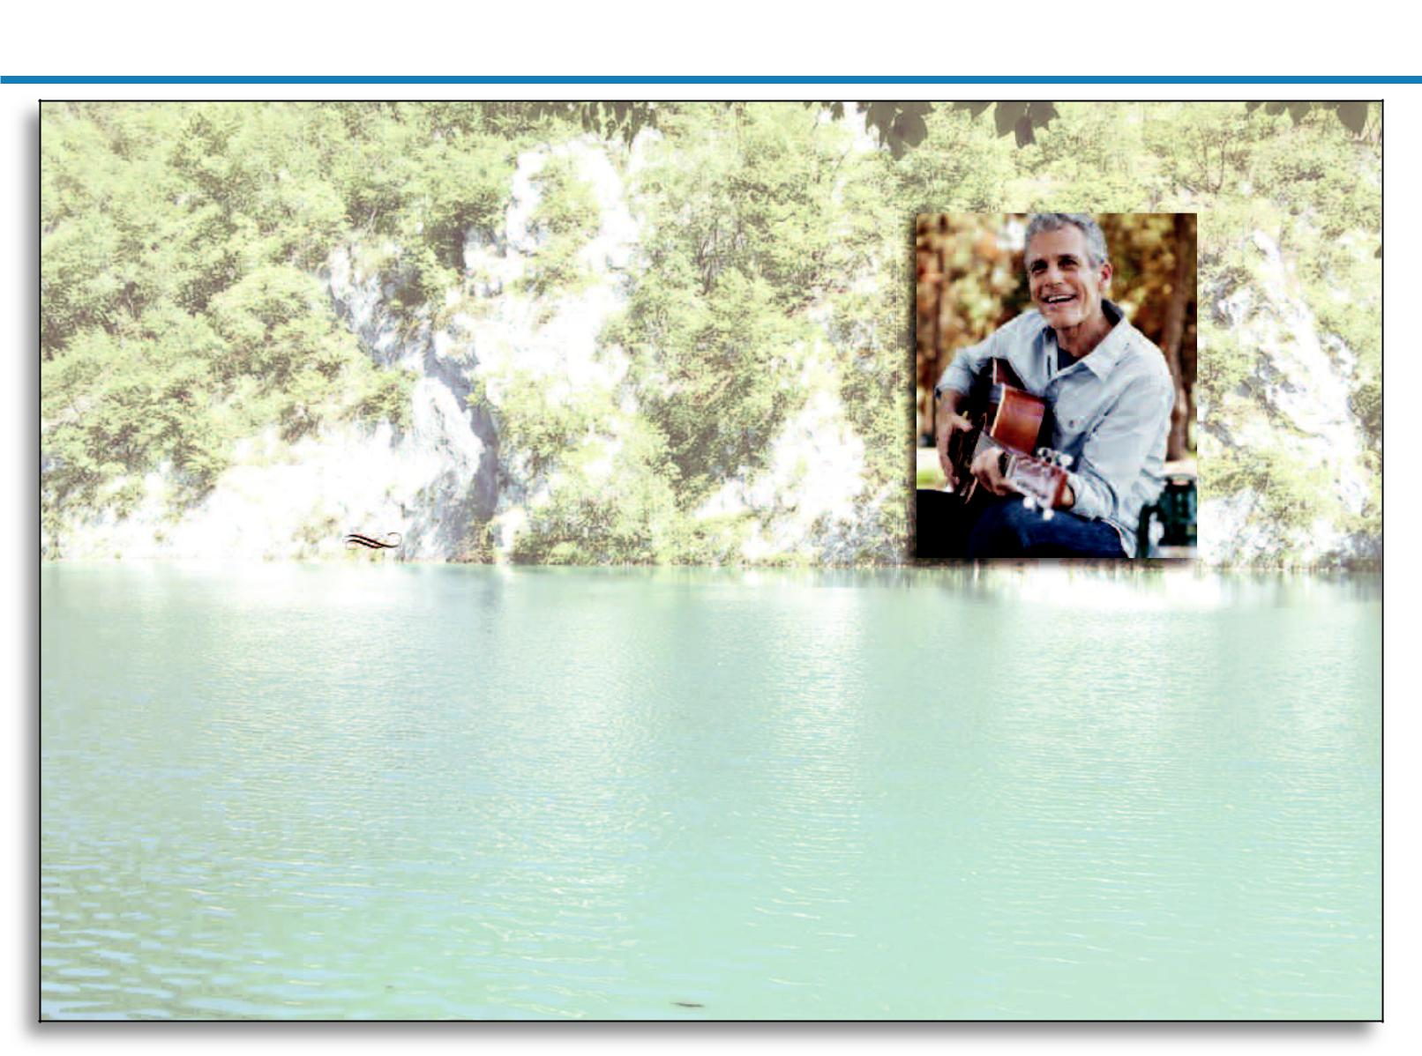

Requiem Mass to Celebrate the Life

– of –

Brian’s Family would like to thank you for

your attendance here today and for the kind

messages of sympathy they have received

during their recent sad loss.

You are warmly invited to join the Family for | BRIAN LAITHWAITE
refreshments and to share your memories | Who passed away peacefully
of Brian after the Service at | on October 28th, 2011
The Green Dragon Inn, Kent. | Aged 60 years

Printed by C. J. Rylands, Stockport ©

The Sacred Heart R.C. Church,

Wilbraham Road, Kent

on

Friday, October 28th, 2011

at 10.00 a.m.

followed by interment at

Greenhill Cemetery

Design 31: ‘Tranquil Lake’
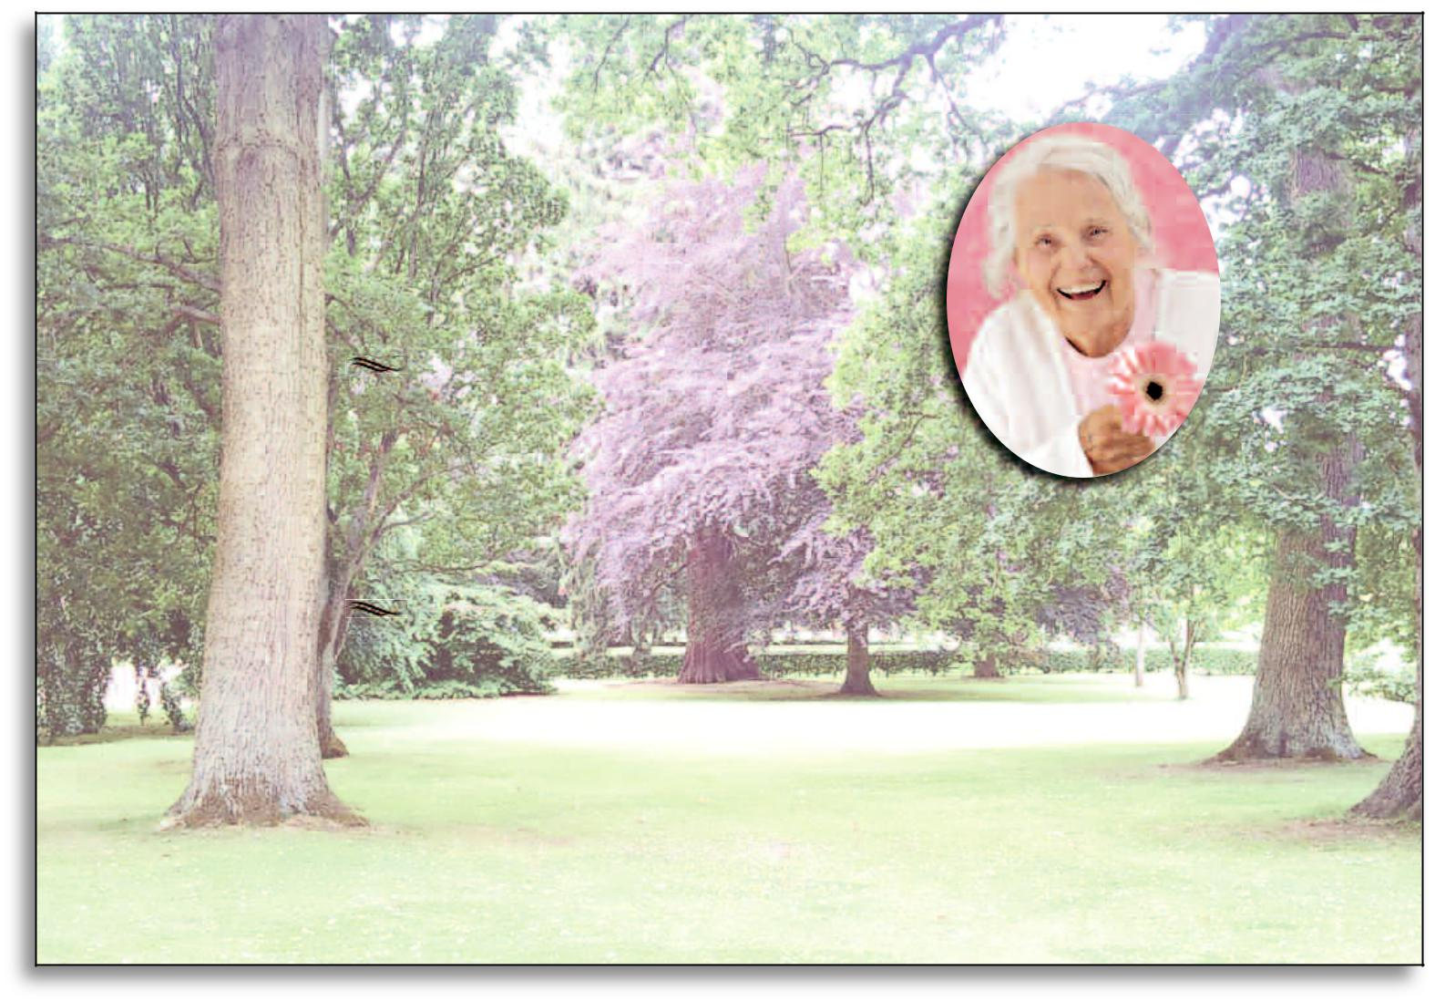

Violet’s Family wish to sincerely thank

all Relatives and Friends for their kind

expressions of sympathy received

in their sad bereavement.

You are all warmly invited to join the Family for

light refreshments at The Oakdene Hotel

following rhe Service and Committal.

Funeral Service for the late

VIOLET THIRLWELL

(Vi)

1st February, 1920 – 6th October, 2011

Funeral arrangements by:

A.N. Other Funeral Directors

7 The Precinct

Castle Street

Edgeley

SK3 9AJ

Tel: 0161 476 2244

Held at

The Manorwell Crematorium

Oakwood Chapel

on

21st October, 2011

at 12.30 p.m.

Printed by C. J. Rylands, Stockport ©

Design 32: ‘Blossom Gardens’

Premium Order of Service Samples – Front & Back Covers
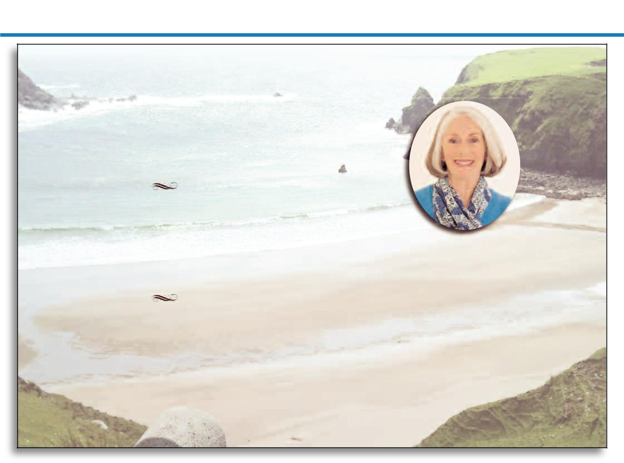

A Celebration of the Life

– of –

Michael, June and Families would like to thank you for your attendance here today and for the kind messages of sympathy they have received

during their recent sad loss.

You are warmly invited to join the Family for

refreshments and to share your memories

of Eleanor after the Service at

The Dog & Partridge, Caverswall.

Funeral arrangements by:

A.N. Other Funeral Directors

7 The Precinct

Castle Street

Edgeley

SK3 9AJ

Tel: 0161 476 2244

ELEANOR HART

(Ellie)

8th July, 1940 – 14th November, 2010

Held at

Caverswall Methodist Church

on

28th November, 2010

at 9.45 a.m.

followed by interment at

Caverswall Cemetery

at 11.30 a.m.

Printed by C. J. Rylands, Stockport ©

Design 33: ‘Serene Beach’


In Loving Memory

– of –

Tracey’s Family wish to sincerely thank

all Relatives and Friends for their kind

expressions of sympathy received

in their sad bereavement.

Also for the donations received

for The Christie.

TRACEY JONES

Who died suddenly on

January 18th, 2011

Aged 48 years

Funeral arrangements by:

A.N. Other Funeral Directors

7 The Precinct

Castle Street

Edgeley

SK3 9AJ

Tel: 0161 476 2244

Funeral Service held at

The Manchester Crematorium

on

January 30th, 2011

at 2.30 p.m.

Printed by C. J. Rylands, Stockport ©

Design 34: ‘Scenic Waterfall’

Premium Order of Service Samples – Front & Back Covers
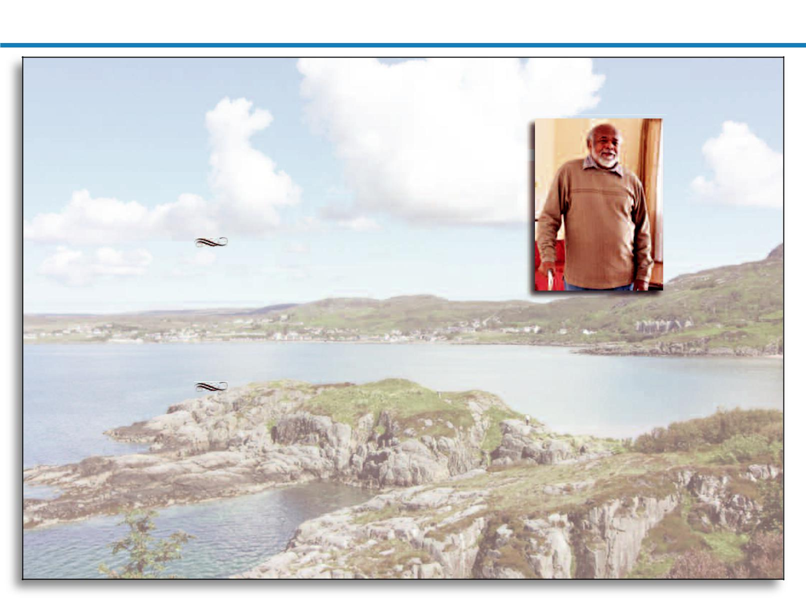

Funeral Service for the late

Ezekiel’s Family would like to thank you for

attendance here today and for the kind

yourmessages of sympathy they have received

during their recent sad loss.

You are warmly invited to join the Family for
refreshments and to share your memories | EZEKIEL WALKER
of Ezekiel after the Service at | EZEKIEL WALKER
The Hinds Head, Heaton Chapel. | Who passed away at home
 | on 1st April, 2008
 | Aged 72 years

Funeral arrangements by:

A.N. Other Funeral Directors

7 The Precinct

Castle Street

Edgeley

SK3 9AJ

Tel: 0161 476 2244

Requiem Mass held at

Our Lady’s Catholic Church

Regent Road, Newcastle

on

14th April, 2008

at 3.20 p.m.

followed by interment at

Newcastle Cemetery

Printed by C. J. Rylands, Stockport ©

Design 35: ‘Beautiful Coast’


A Celebration of the Life

– of –

Pauline and Family would like to thank you for

your attendance here today and for the kind

messages of sympathy they have received

during their recent sad loss.

You are warmly invited to join the Family for
refreshments and to share your memories
of Dave after the Service at | DAVID HICKS
Macclesfield Social Club. | DAVID HICKS
 | (Dave)

Funeral arrangements by:

A.N. Other Funeral Directors

7 The Precinct

Castle Street

Edgeley

SK3 9AJ

Tel: 0161 476 2244
4th February, 1962 – 20th April, 2011

Held at

Macclesfield Crematorium

on

2nd May, 2011

at 12.30 p.m.

Officiating: Rev. Bickerstaffe

Printed by C. J. Rylands, Stockport ©

Design 36: ‘Blue Reef’

Premium Order of Service Samples – Front & Back Covers


In Loving Memory

– of –

Eugene’s Family would like to thank you for

your attendance here today and for the kind

messages of sympathy they have received

during their recent sad loss.

You are warmly invited to join the Family for | EUGENE MASON
You are warmly invited to join the Family for | Who passed away peacefully
refreshments and to share your memories | Who passed away peacefully
of Eugene after the Service at | on February 1st, 2007
Croydon Conservative Club.

Printed by C. J. Rylands, Stockport ©

Service held at

St. Augustine’s Church, Croydon

on

February 14th, 2007

at 3.30 p.m.

followed by cremation at

Croydon Crematorium

Design 37: ‘Sunset Sea’


 | Treasured Memories
 | – of –
Lucie’s Family would like to thank you
all so much for attending the Service.
Your love, support and kindness
has been a comfort to us all.
You are warmly invited to join the Family
at The Farmers Arms, Cheadle | Our Beautiful Daughter
for refreshments. | Our Beautiful Daughter
 | Lucie Newton
Funeral arrangements by: | 30th August, 2004 – 3rd July, 2011
A.N. Other Funeral Directors | Service at
Castle Street | Service at
7 The Precinct | Green Hills Cemetery, Cheadle
Edgeley | Green Hills Cemetery, Cheadle
SK3 9AJ | on
Tel: 0161 476 2244 | 29th July, 2011
 | at 11.00 a.m.
 | “Now With The Angels”

Printed by C. J. Rylands, Stockport ©

Design 38: ‘Rainbow Fields’

Premium Order of Service Samples – Inside Pages


The Lord’s Prayer

Reading: John chapter 14, verses 1 – 9

Hymn:

There Is A Green Hill Far Away

There is a green hill far away,

without a city wall,

where the dear Lord was crucified,

who died to save us all.

We may not know, we cannot tell,

what pains he had to bear,

we believe it was for us
but
he hung and suffered there.

He died that we might be forgiven,

he died to make us good;

that we might go at last to heaven,

saved by his precious blood.

There was no other good enough

to pay the price of sin;

he only could unlock the gate

of heaven, and let us in.

O dearly, dearly has he loved,

and we must love him too,

and trust in his redeeming Blood,

and try his works to do.

Address

Hymn:

O Love That Wilt Not Let Me Go

O Love that wilt not let me go,

I rest my weary soul in thee:

I give thee back the life I owe,

That in thine ocean depths its flow

May richer, fuller, be.

O Light that followest all my way,

I yield my flickering torch to thee:

My heart restores its borrowed ray,

That in thy sunshine's blaze its day

May brighter, fairer be.

O Joy that seekest me through pain,

I cannot close my heart to thee:

I trace the rainbow through the rain,

And feel the promise is not vain

That morn shall tearless be.

O Cross that liftest up my head,

I dare not ask to fly from thee:

I lay in dust life's glory dead,

And from the ground there blossoms red

Life that shall endless be.

Reading: Psalm 23, The Lord’s My Shepherd

- Reflection Prayers

Inside Page Sample – Automatically Matched to your Chosen Design


Funeral Conducted by: Revd. Joseph Jackson

Introductory Sentences

Prayer

Hymn:

The Lord's My Shepherd

The Lord's my Shepherd; I'll not want;

He makes me down to lie

In pastures green; He leadeth me

The quiet waters by.

My soul He doth restore again,

And me to walk doth make

Within the paths of righteousness,

E'en for His own name's sake.

Yea, though I walk in death's dark vale,

Yet will I fear no ill;

For Thou art with me, and Thy rod

And staff me comfort still.

My table Thou hast furnished

In presence of my foes;

My head Thou dost with oil anoint,

And my cup overflows.

Goodness and mercy all my life

Shall surely follow me,

And in God's house for evermore

My dwelling-place shall be.

Committal

Hymn:

Abide With Me

Abide With Me, fast falls the eventide;

the darkness deepens, Lord, with me abide!

When other helpers fail, and comforts flee,

Help of the helpless, O abide with me.

Swift to its close ebbs out life's little day;

Earth's joys grow dim, its glories pass away;

Change and decay in all around I see;

O thou who changest not, abide with me.

I need thy presence every passing hour;

What but thy grace can foil the tempter's power?

Who like thyself my guide and stay can be?

Through cloud and sunshine, Lord, abide with me.

I fear no foe with thee at hand to bless;

Ills have no weight, and tears no bitterness.

Where is death's sting? Where, grave, thy victory?

I triumph still, if thou abide with me.

Hold thou thy Cross before my closing eyes;

Shine through the gloom, and point me to the skies;

Heaven's morning breaks, and earth's vain shadows flee:

In life, in death, O Lord, abide with me!

Blessing

Inside Page Sample – Automatically Matched to your Chosen Design

Premium Order of Service Samples – Inside Pages


The Lord’s Prayer

Reading: John chapter 14, verses 1 – 9

Hymn:

There Is A Green Hill Far Away

There is a green hill far away,

without a city wall,

where the dear Lord was crucified,

who died to save us all.

We may not know, we cannot tell,

what pains he had to bear,

but we believe it was for us

he hung and suffered there.

He died that we might be forgiven,

he died to make us good;

that we might go at last to heaven,

saved by his precious blood.

There was no other good enough

to pay the price of sin;

he only could unlock the gate

of heaven, and let us in.

O dearly, dearly has he loved,

and we must love him too,

and trust in his redeeming Blood,

and try his works to do.

Address

Hymn:

O Love That Wilt Not Let Me Go

O Love that wilt not let me go,

I rest my weary soul in thee:

I give thee back the life I owe,

That in thine ocean depths its flow

May richer, fuller, be.

O Light that followest all my way,

I yield my flickering torch to thee:

My heart restores its borrowed ray,

That in thy sunshine's blaze its day

May brighter, fairer be.

O Joy that seekest me through pain,

I cannot close my heart to thee:

I trace the rainbow through the rain,

And feel the promise is not vain

That morn shall tearless be.

O Cross that liftest up my head,

I dare not ask to fly from thee:

I lay in dust life's glory dead,

And from the ground there blossoms red

Life that shall endless be.

Reading: Psalm 23, The Lord’s My Shepherd

- Reflection Prayers

Inside Page Sample – Automatically Matched to your Chosen Design


Funeral Conducted by: Revd. Joseph Jackson

Introductory Sentences

Prayer

Hymn:

The Lord's My Shepherd

The Lord's my Shepherd; I'll not want;

He makes me down to lie

In pastures green; He leadeth me

The quiet waters by.

My soul He doth restore again,

And me to walk doth make

Within the paths of righteousness,

E'en for His own name's sake.

Yea, though I walk in death's dark vale,

Yet will I fear no ill;

For Thou art with me, and Thy rod

And staff me comfort still.

My table Thou hast furnished

In presence of my foes;

My head Thou dost with oil anoint,

And my cup overflows.

Goodness and mercy all my life

Shall surely follow me,

And in God's house for evermore

My dwelling-place shall be.

Committal

Hymn:

Abide With Me

Abide With Me, fast falls the eventide;

the darkness deepens, Lord, with me abide!

When other helpers fail, and comforts flee,

Help of the helpless, O abide with me.

Swift to its close ebbs out life's little day;

Earth's joys grow dim, its glories pass away;

Change and decay in all around I see;

O thou who changest not, abide with me.

I need thy presence every passing hour;

What but thy grace can foil the tempter's power?

Who like thyself my guide and stay can be?

Through cloud and sunshine, Lord, abide with me.

I fear no foe with thee at hand to bless;

Ills have no weight, and tears no bitterness.

Where is death's sting? Where, grave, thy victory?

I triumph still, if thou abide with me.

Hold thou thy Cross before my closing eyes;

Shine through the gloom, and point me to the skies;

Heaven's morning breaks, and earth's vain shadows flee:

In life, in death, O Lord, abide with me!

Blessing

Inside Page Sample – Automatically Matched to your Chosen Design

Personalised Books of Condolence

Our excellent quality Condolence Books are a bound, leather look design with embossed gold lettering on the cover. The inside front cover of the Condolence Book can be personalised to include the details of your loved one followed by a beautiful verse. A photograph may also be included at no additional cost.

Two different sizes of Condolence Book are now available from C.J. Rylands. Our Traditional Book is approximately 10x7 inches in size and contains room for over 100 signatures and messages, perfect for regular size Funeral Services. Also available is our Premium Book, suitable for larger Funerals. These larger books contain over 300 pages and have room for over 1210 signatures and messages.
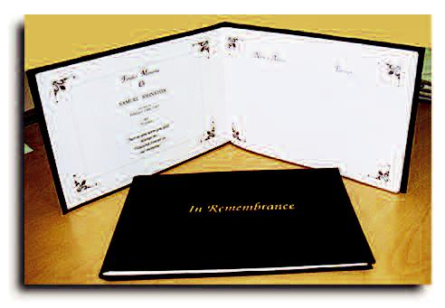

 |  |  |  |  |  | Name & Address | Epitaph
 |  |  |  |  |  |  | Fondest Memories
 |  |  |  |  |  |  | Of
 |  |  |  |  |  |  | SAMUEL JOHNSTON
 |  |  |  |  |  |  | who died on
 |  |  |  |  |  |  | November 1st, 2011
 |  |  |  |  |  |  | ag d
 |  |  |  |  |  |  | 87 years.
 |  |  |  |  |  |  | Just as you were you will
 |  |  |  |  |  |  | always be,
 |  |  |  |  |  |  | Treasured forever in
 |  |  |  |  |  |  | our memories
Traditional Condolence Book Sample
 |  |  |  |  |  | Inside Cover Sample (with photograph)
 |  |  |  |  |  | Name & Address | Epitaph
 | ELEANOR SMITH








Inside Cover Sample (no photograph) | Inside Page Sample


Premium (Large) Condolence Book Sample

Attendance / Pew Card Samples

Our beautifully designed attendance / pew cards are printed specially

to match your chosen Order of Service booklet.

We can also print cards based on your own personal specifications

and can use an image / photograph of your choice.

The Family_{Samuel}inviteyouto_{Johnston}shareyourMemories of


Name ...........................................................................................

Representing ...............................................................................

Plain Design with Space for Epitaph


Thank you for attending the Funeral of
Jack Williamson

Name ...........................................................................................

Representing ...............................................................................

‘Snowdrops’ (to Match Design 15)

The Family_{Samuel}inviteyouto_{Johnston}shareyourMemories of


Name ...........................................................................................

Representing ...............................................................................

‘Forest Lagoon’ (to Match Design 29)

Thank you for attending the Funeral of


The Family would appreciate knowledge of your presence here today.

Name .............................................................

..........................................................................

Representing .................................................

...........................................................................

‘Pink Tulip’ (to Match Design 9)

Thank_{Rachael}youforttnding_{Jackson}theFuneralof


The Family would appreciate knowledge

of your presence here today.

Name .........................................................

......................................................................

Representing ............................................

......................................................................

Lilies’‘ (to Match Design 19)

_{Barbara}Thankyouforattending_{Fletcher}theFuneal of
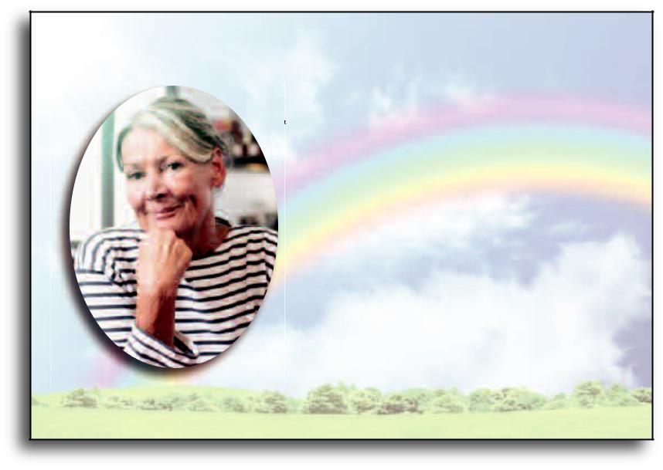

The Family would appreciate knowledge of your presence here today.

Name ........................................................

.....................................................................

Representing ...........................................

.....................................................................

‘Rainbow Fields’ (to Match Design 38)

Other Products from C.J. Rylands (Mem-Card)

C.J. Rylands design and produce many types of
Commemorative Stationary, including:
In-Memoriam / Memorial Cards

(Single or Folding)

In-Grateful Appreciation Cards

Commemorative Obituary Cards

(taken from the Obituary Notice)

Bookmark Cards

For further information or to request a sample brochure,

please do not hesitate to contact us via email or telephone.

C.J. Rylands also print Business Stationary, including Letterheads, Compliment Slips, Business Cards, Flyers and Posters (A4 to A1).


