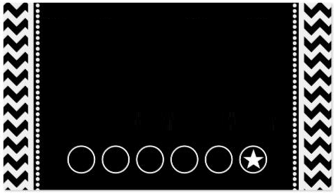

This card entitles the hold of this card to all the privileges and benefits of the Preferred Customer Program and check cashing privileges. Please use this card every time you shop with us to take advantage of special offers and card benefits.

On your 6th visit it’s FREE

Company Name