Adoption Certificate
Pet Owner'� Name: ___________________________________________________________________

ha� offlcially adopted
_______________________________________________________________.
(name of pet)

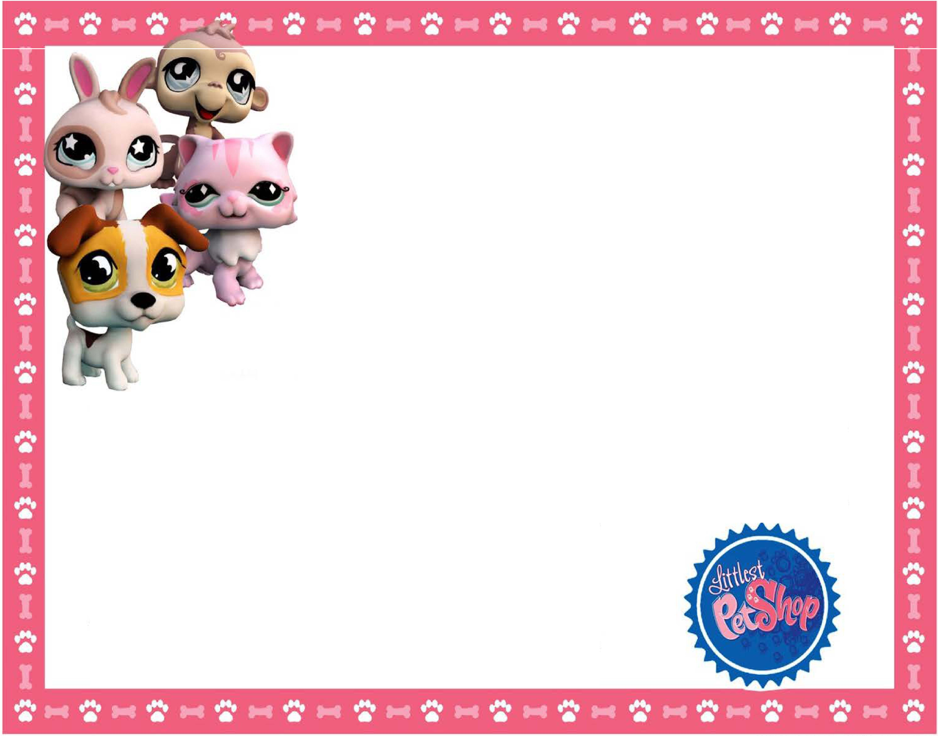and ha� welcomed them into their home!

Date: _.

