**[LOGO]**

**FROM: Mr. Adam Smith**  Shipping Date: 21June15

[YOUR COMPANY NAME] Weight: 190lbs

[STREET ADDRESS] **SAMARTA WEIGHT**

[CITY, STATE, ZIP CODE]

**TO: [Type Recipient Name Here]**

[STREET ADDRESS]

[CITY, STATE, ZIP CODE]

Tracking#: 20001-992-62295

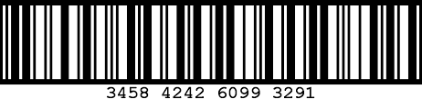

**[LOGO]**

**FROM: Mr. Adam Smith**  Shipping Date: 21June15

[YOUR COMPANY NAME] Weight: 190lbs

[STREET ADDRESS] **SAMARTA WEIGHT**

[CITY, STATE, ZIP CODE]

**TO: [Type Recipient Name Here]**

[STREET ADDRESS]

[CITY, STATE, ZIP CODE]

Tracking#: 20001-992-62295

