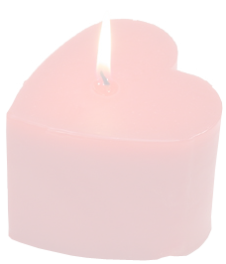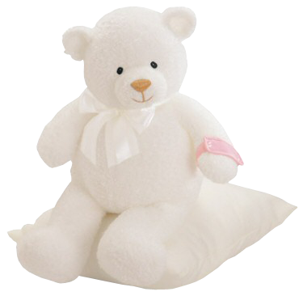

**Happy Birthday Card**

To Wish You a Very Happy Birthday

I may not be by your side ……

Celebrating your special day

With you…..

But I want you to know that

I am Thinking of you and

Wishing you a

Wonderful

Birthday

**_____________________**

To

From

**____________________**

**Happy Birth Day**