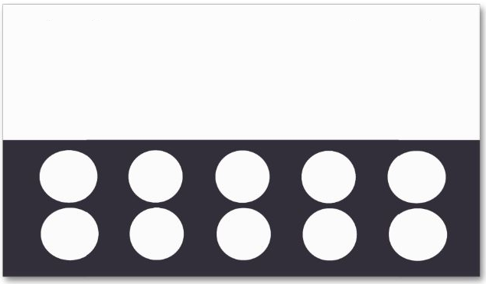

LOGO

LOGO

LOGO

LOGO

LOGO

LOGO

LOGO

LOGO

LOGO

FREE

Buy 1 and get the 10th FREE

Company Name

Address